**Project Deliverable 2 – Documentation and Coding**

**Faculty Name:** Information Technology

**Module Code:** ITECA3-B12

**Module Name:** Web Development and e-Commerce

**Content Writer:** Kariboba Mpwampu

**Copy Editor:** Mr Kyle Keens

**Submission Date:** Block 2 Week 4

|  |  |
| --- | --- |
| **Student Name** | Lea Thumbiran |
| **Student Number** | LMTPQFTH6 |
| **Project Title** | Lights Out Loadshedding E-Commerce Website |
| **Submission Date** | 7 June 2023 |

**Eduvos**

**Web Development and e-Commerce**

**(ITECA3-B12)**

**Project Deliverable 2**

**Mr. Aruleba. I.**

**Lea Thumbiran LMTPQFTH6  
7 June 2023**

**Table of Contents**

2.1 Introduction 1

2.2 Prototyping 1

a. Prototype 1 1

Desktop view of the website: 1

Mobile view of the website: 15

b. Prototype 2 15

Desktop view of the website: 15

Mobile view of the website: 30

2.3 Designing 31

a. Class Responsibility Collaborator (CRC) cards 31

b. Enhanced Entity Relationship Diagram (EERD) 32

c. Context Diagram 33

d. Data Flow Diagram (DFD) 33

e. Use Case Diagram 35

f. Database Design 36

2.4 Coding 40

a. Screenshots 40

Link To the Hosted Website: 40

Guest User View of The Website: 41

User View of The Website: 52

Administrator/Vendor View of The Website: 64

b. Sample PHP Code 72

c. Sample HTML Code 75

d. Sample JavaScript Code 79

e. Sample CSS Code 81

f. Sample MySQL Table Screenshots 95

Vendor Table: 95

Users Table: 95

Products Table: 96

Blog Post Table: 96

Cart Table: 97

Cart Product Table: 97

Feedback Table: 98

Reference Numbers Table: 98

Orders Table: 99

Order Details Table: 99

g. Security Features for The Website 99

SQL prepared statements: 99

Hash Functions: 100

TLS certificates: 102

2.5 Conclusion 104

2.6 Sign-Off 105

Bibliography 106

# 2.1 Introduction

Lights Out is a company that provides products to businesses and individuals that experience the effects of load-shedding. They have requested that a database driven e-commerce website be developed. The prototypes, design diagrams, code samples, screenshots of the potential look of the final website, screenshots of the database tables and security features will be covered in the next sections.

# 2.2 Prototyping

## Prototype 1

### Desktop view of the website:

<https://www.figma.com/proto/uS2z276olUCDMOdts1vYqx/Lights-Out-Prototype-1?type=design&node-id=1-3&scaling=min-zoom&page-id=0%3A1&starting-point-node-id=1%3A3>

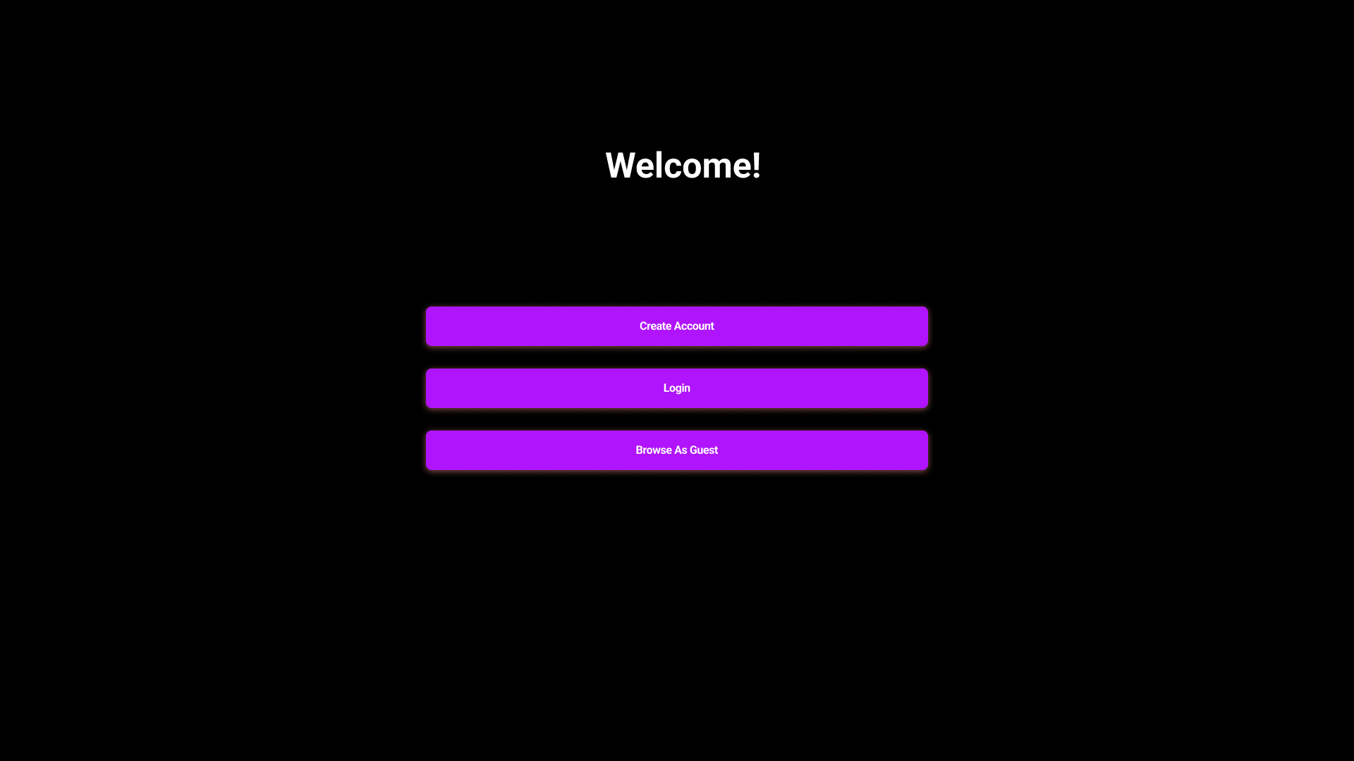

*Figure 1 - Landing Page.*

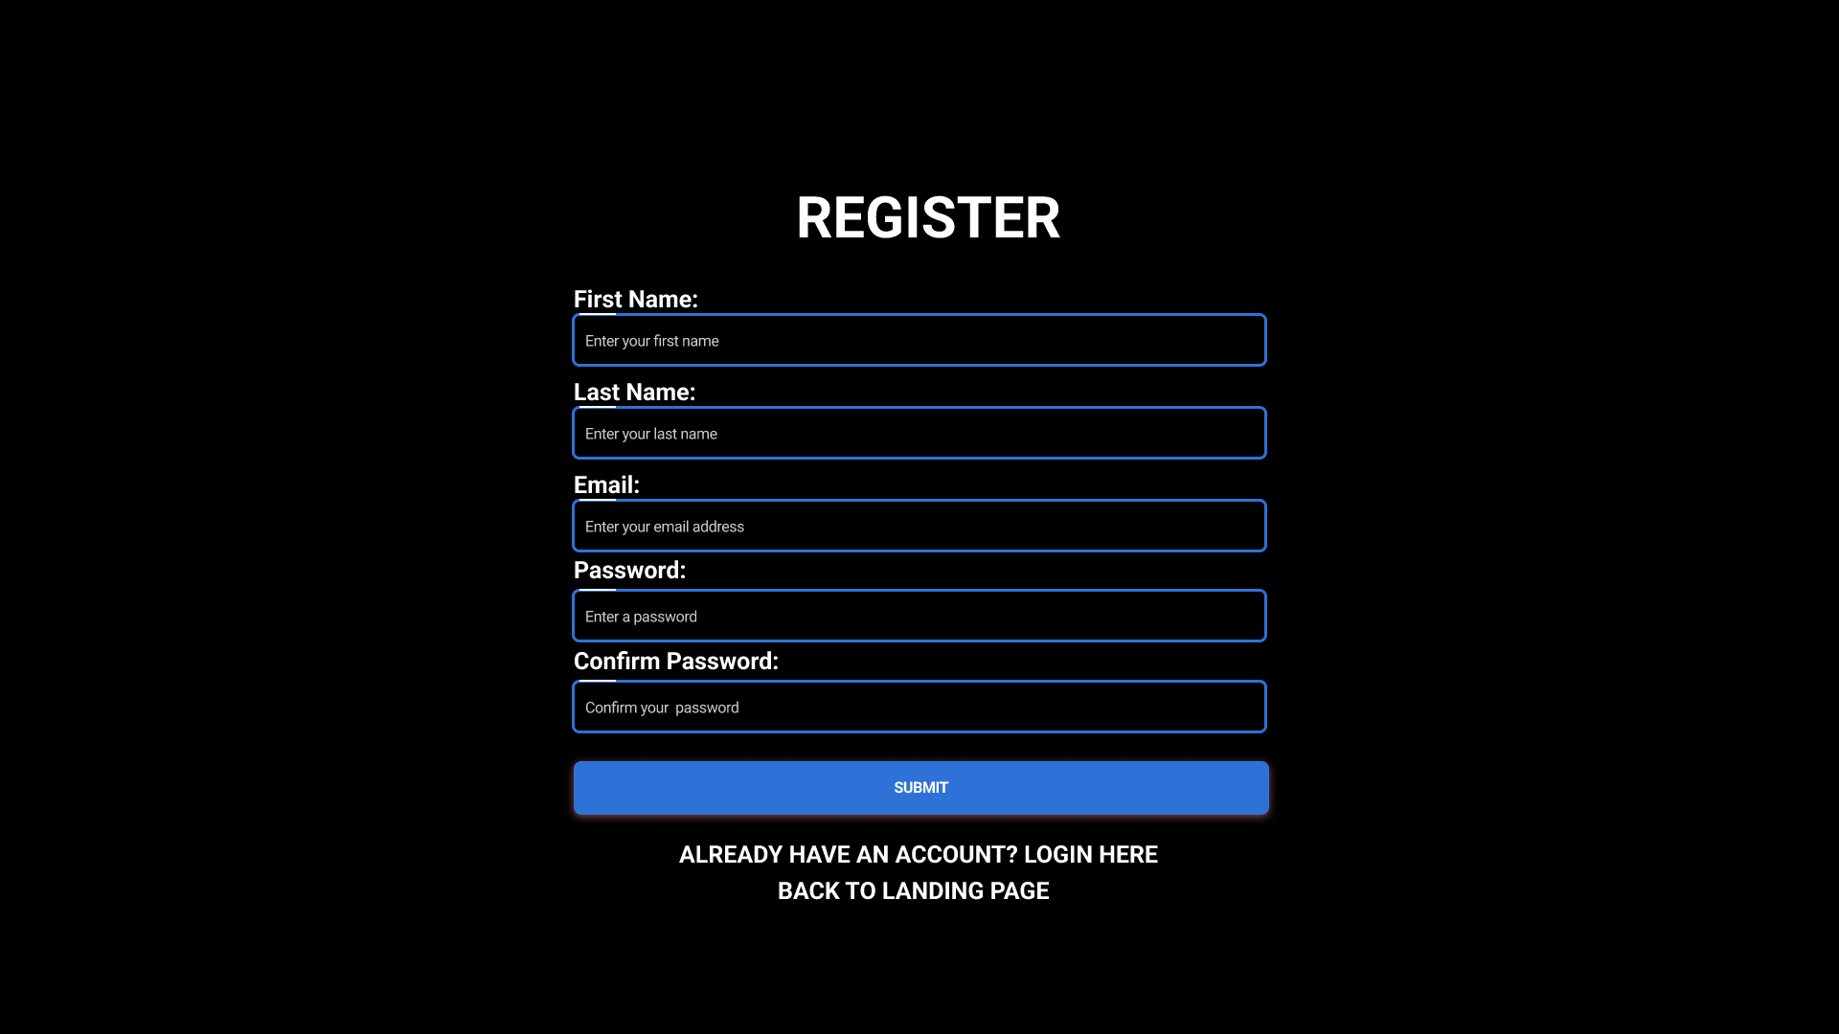

*Figure 2 - Registration Page.*

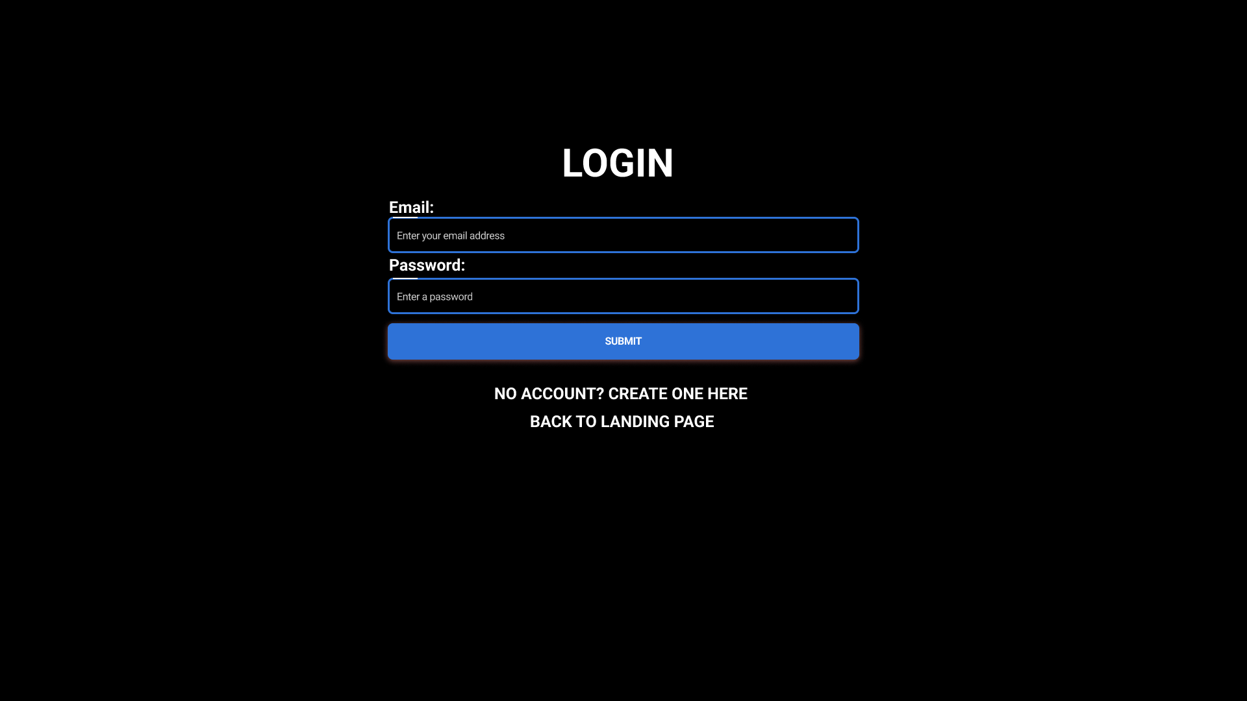

*Figure 3 - Login Page.*

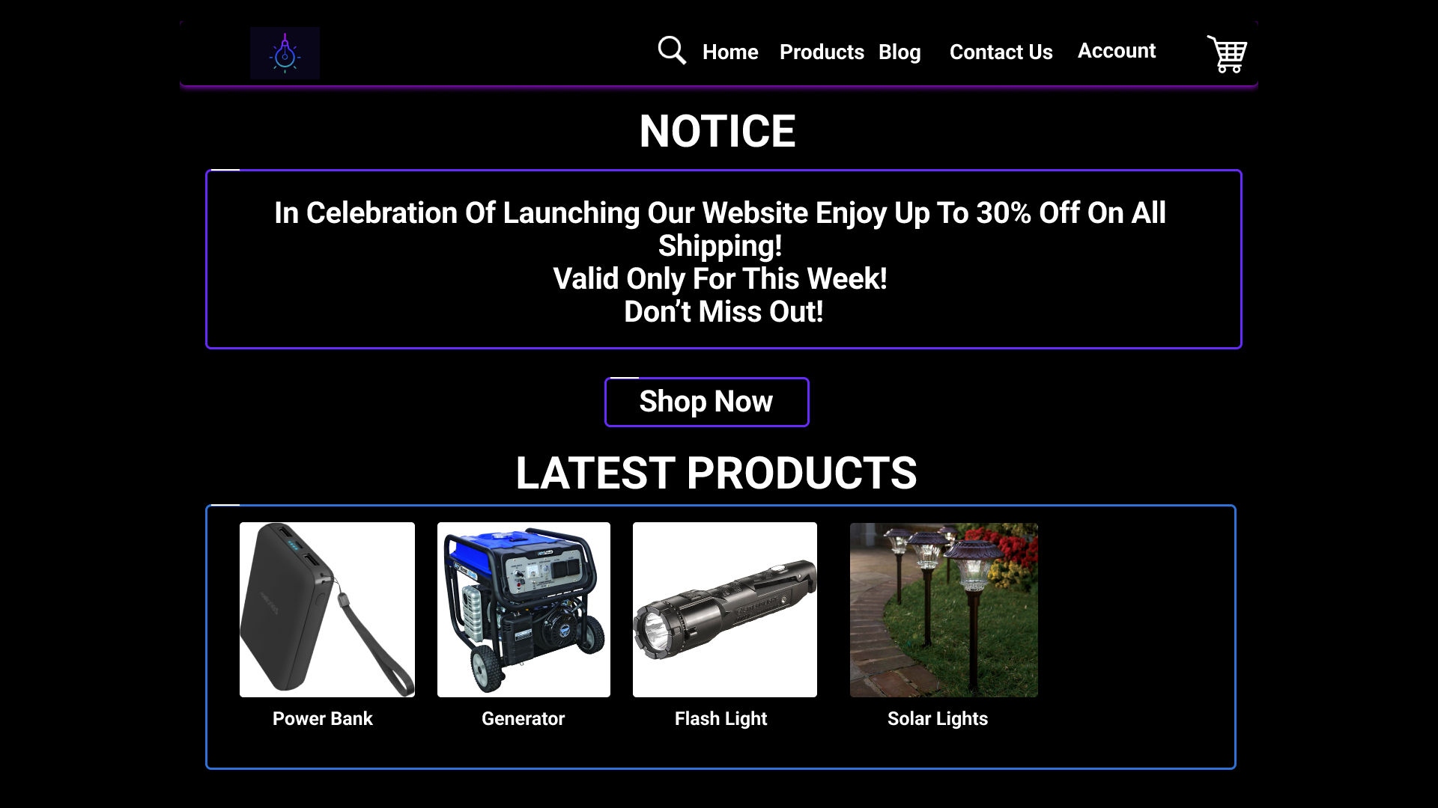

*Figure 4 - Home Page.*

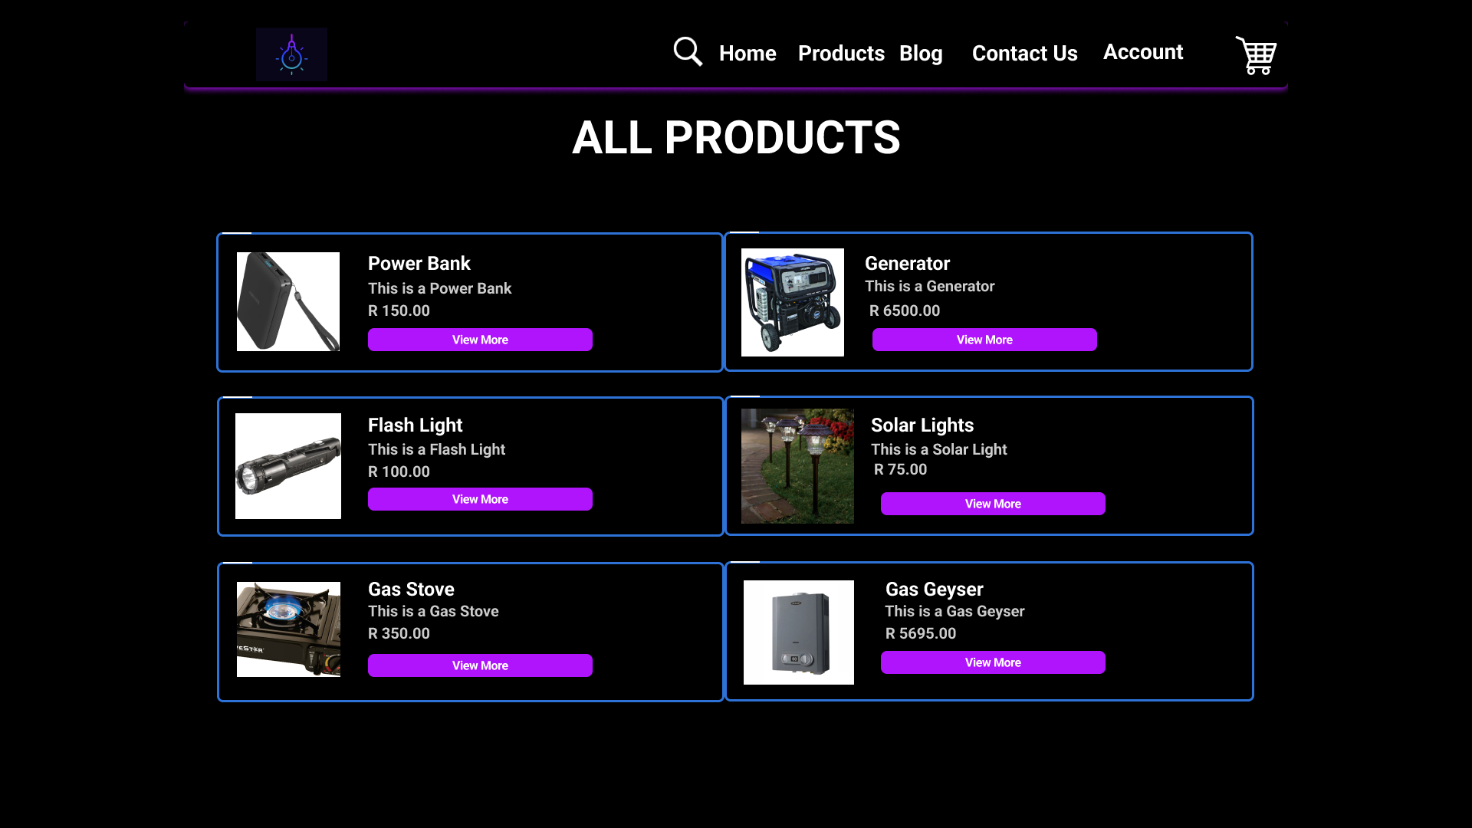

*Figure 5 - Products Page.*

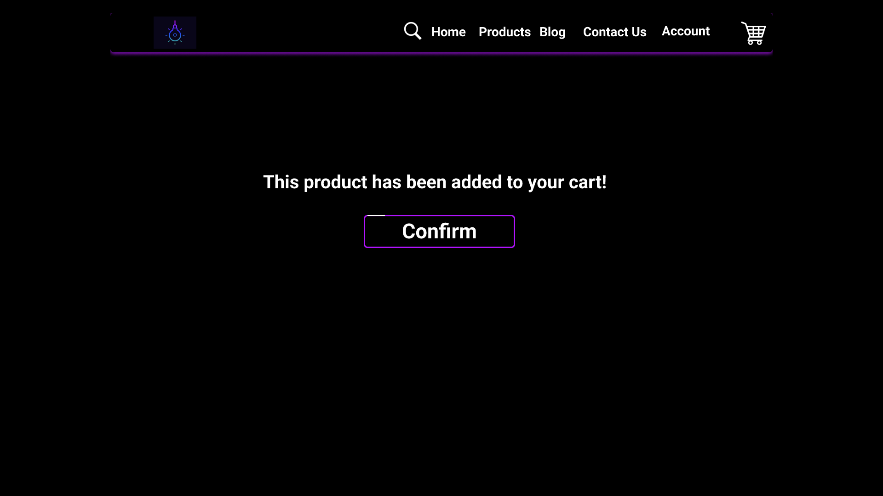

*Figure 6 - Adding A Product to Cart Page.*

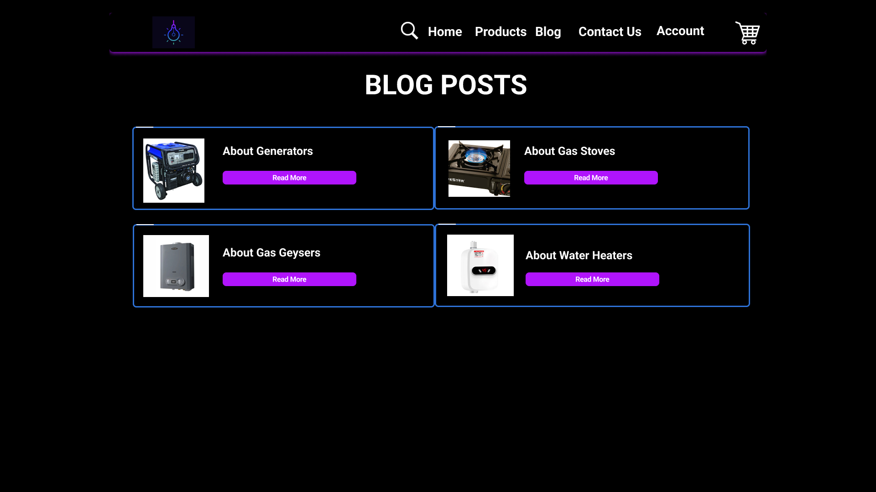

*Figure 7 - Blog Posts Page.*

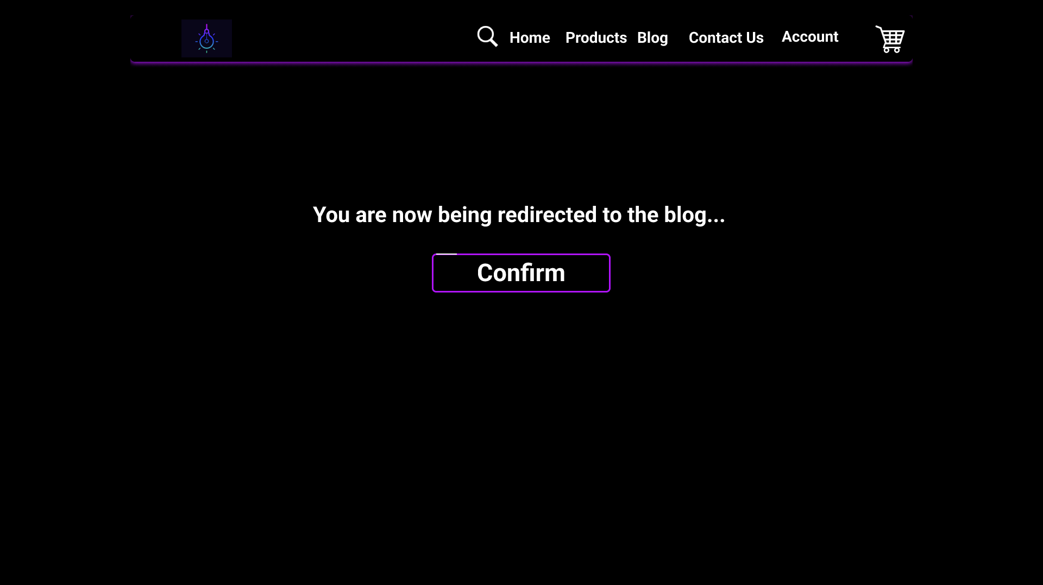

*Figure 8 - Clicking on A Blog Post Page.*

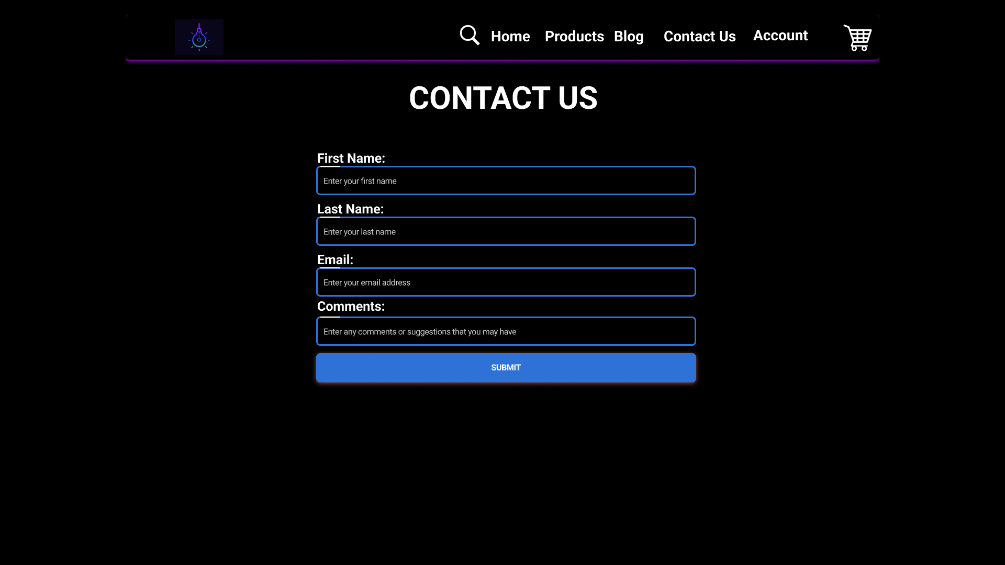

*Figure 9 - Contact Us Page.*

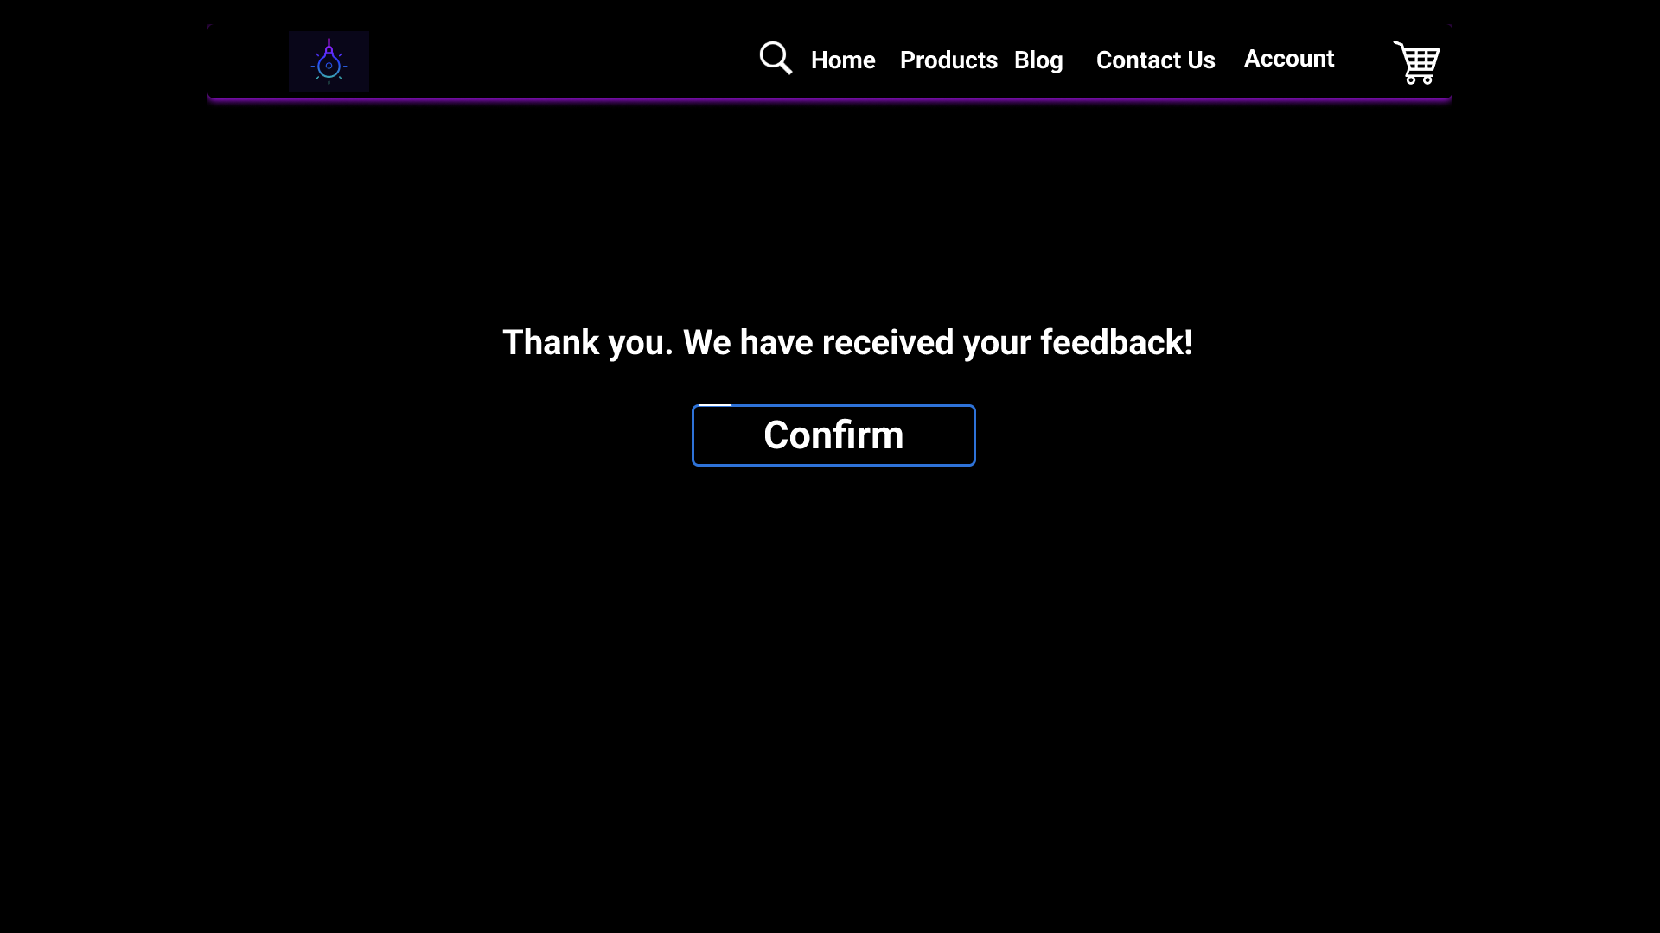

*Figure 10 - After Submitting a Feedback Form Page.*

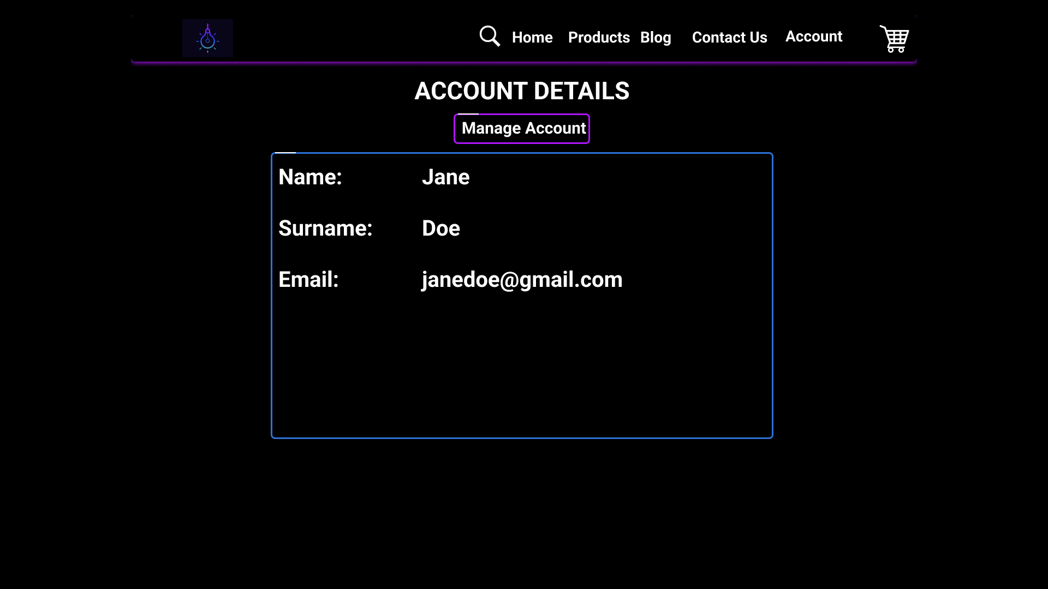

*Figure 11 - Account Page.*

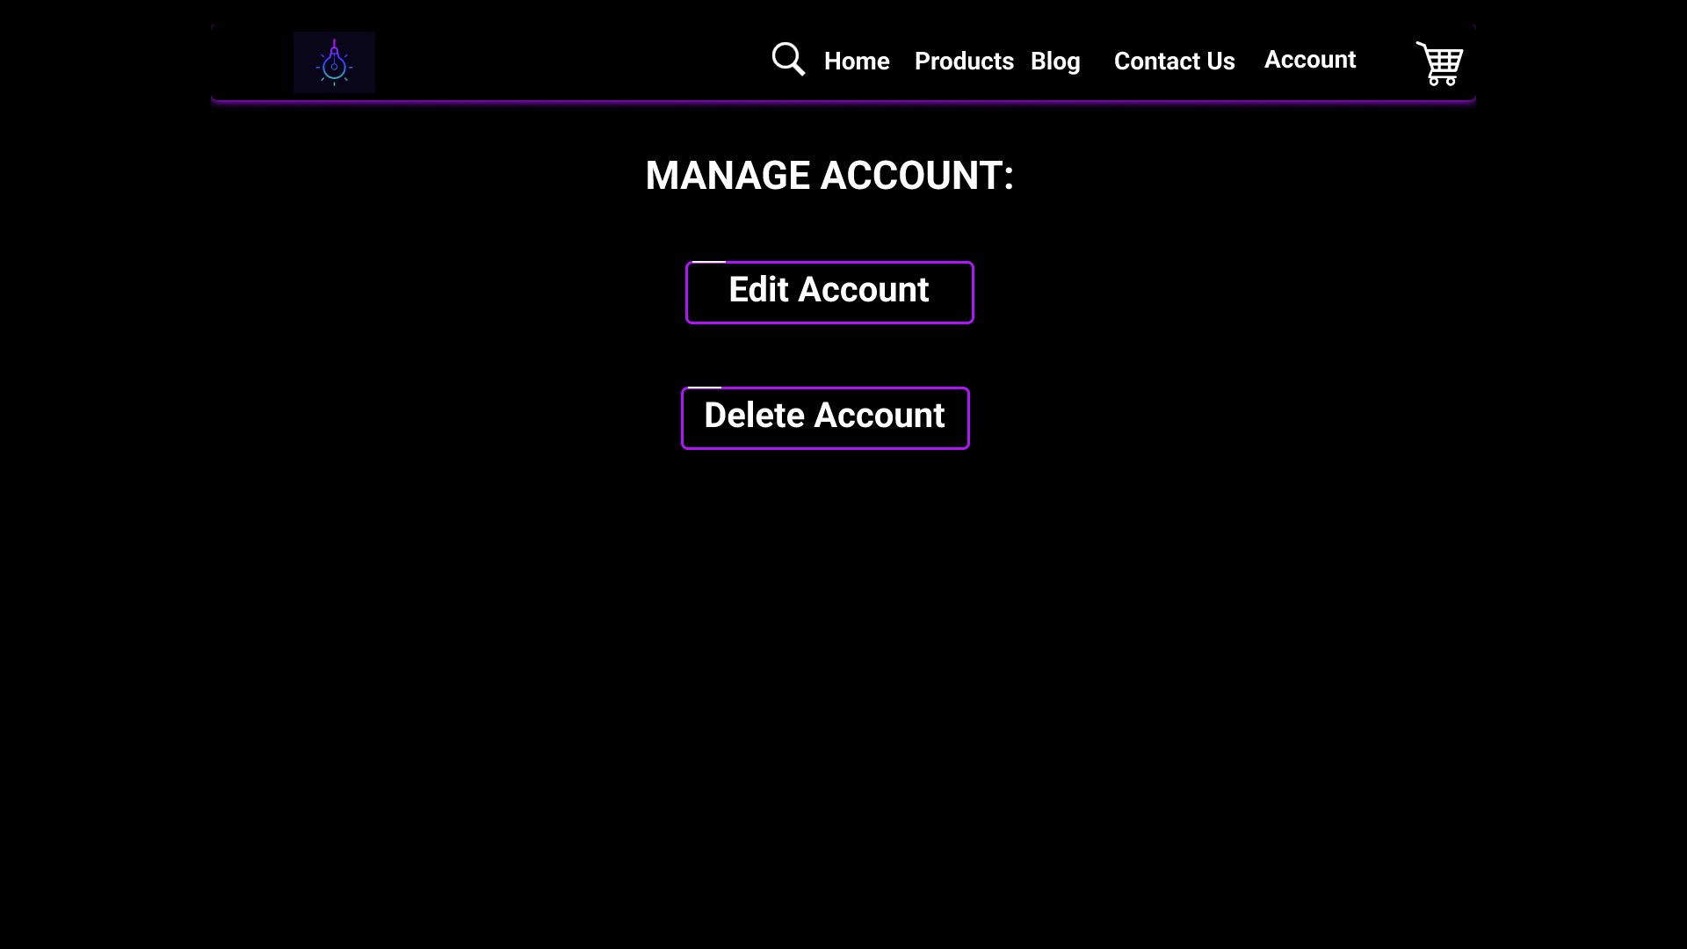

*Figure 12 - Manage Account Page.*

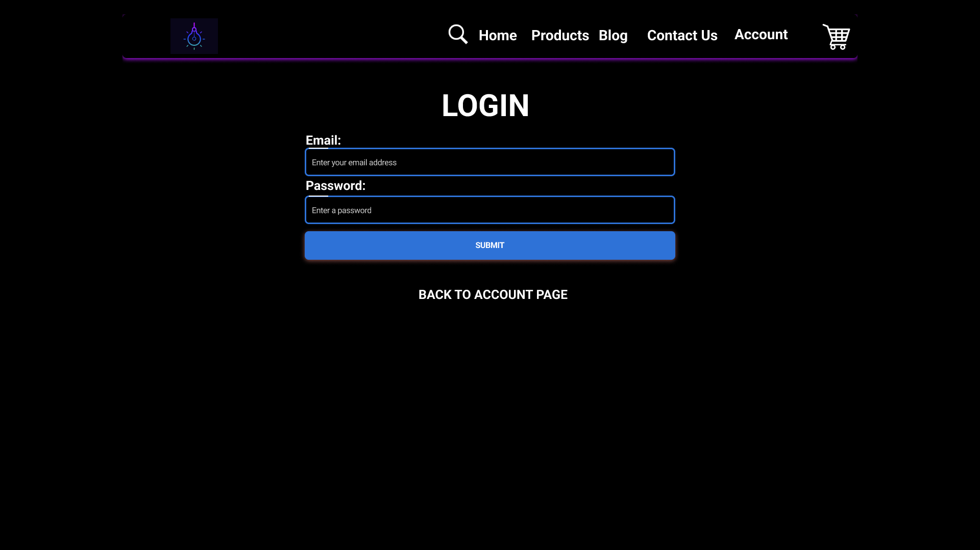

*Figure 13 - Logging in Before Editing Account Details.*

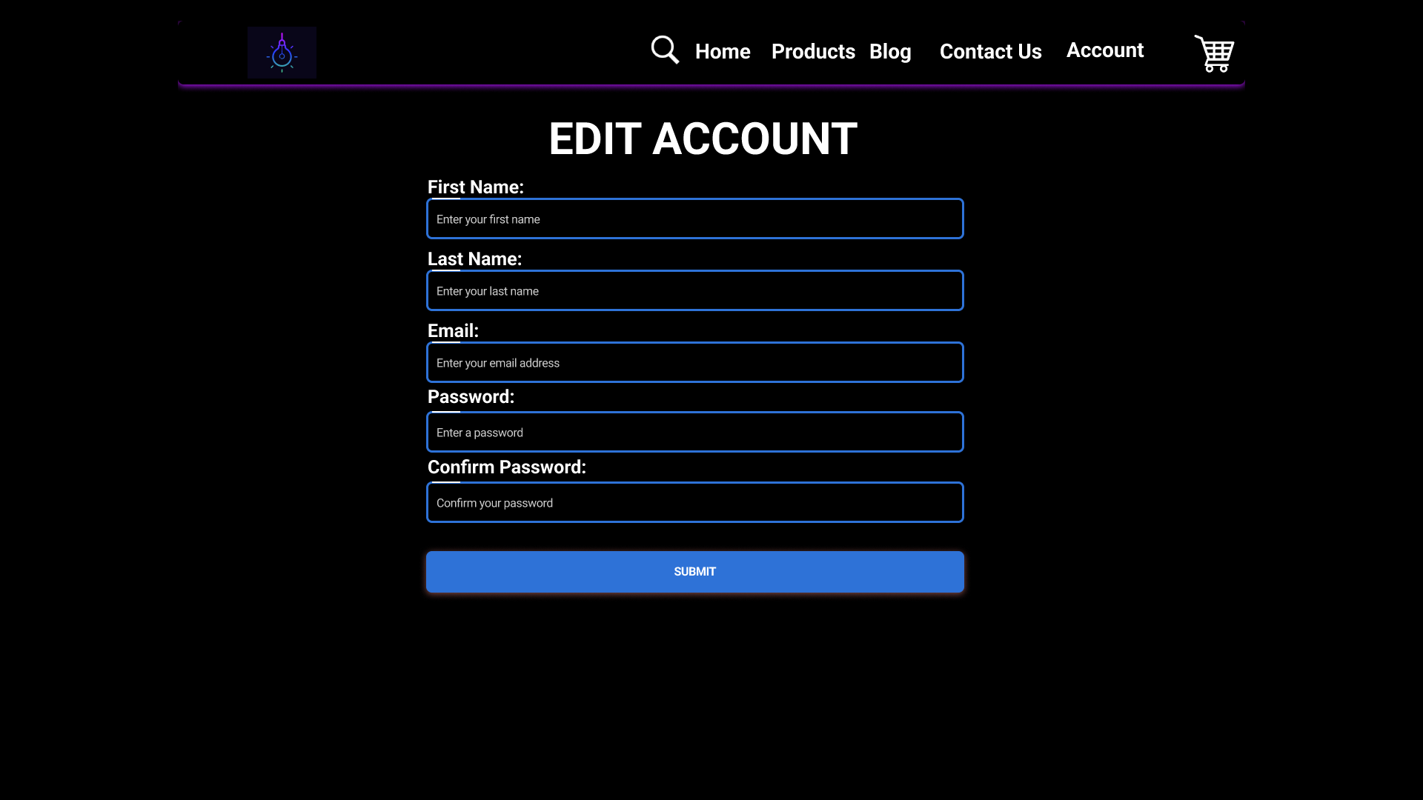

*Figure 14 - Edit Account Details Page.*

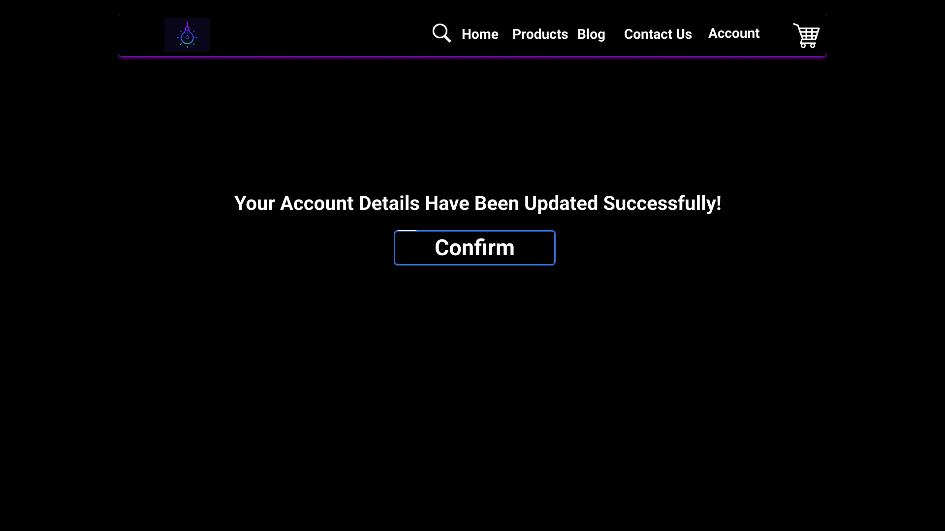

*Figure 15 - Confirmation After Editing Account Details.*

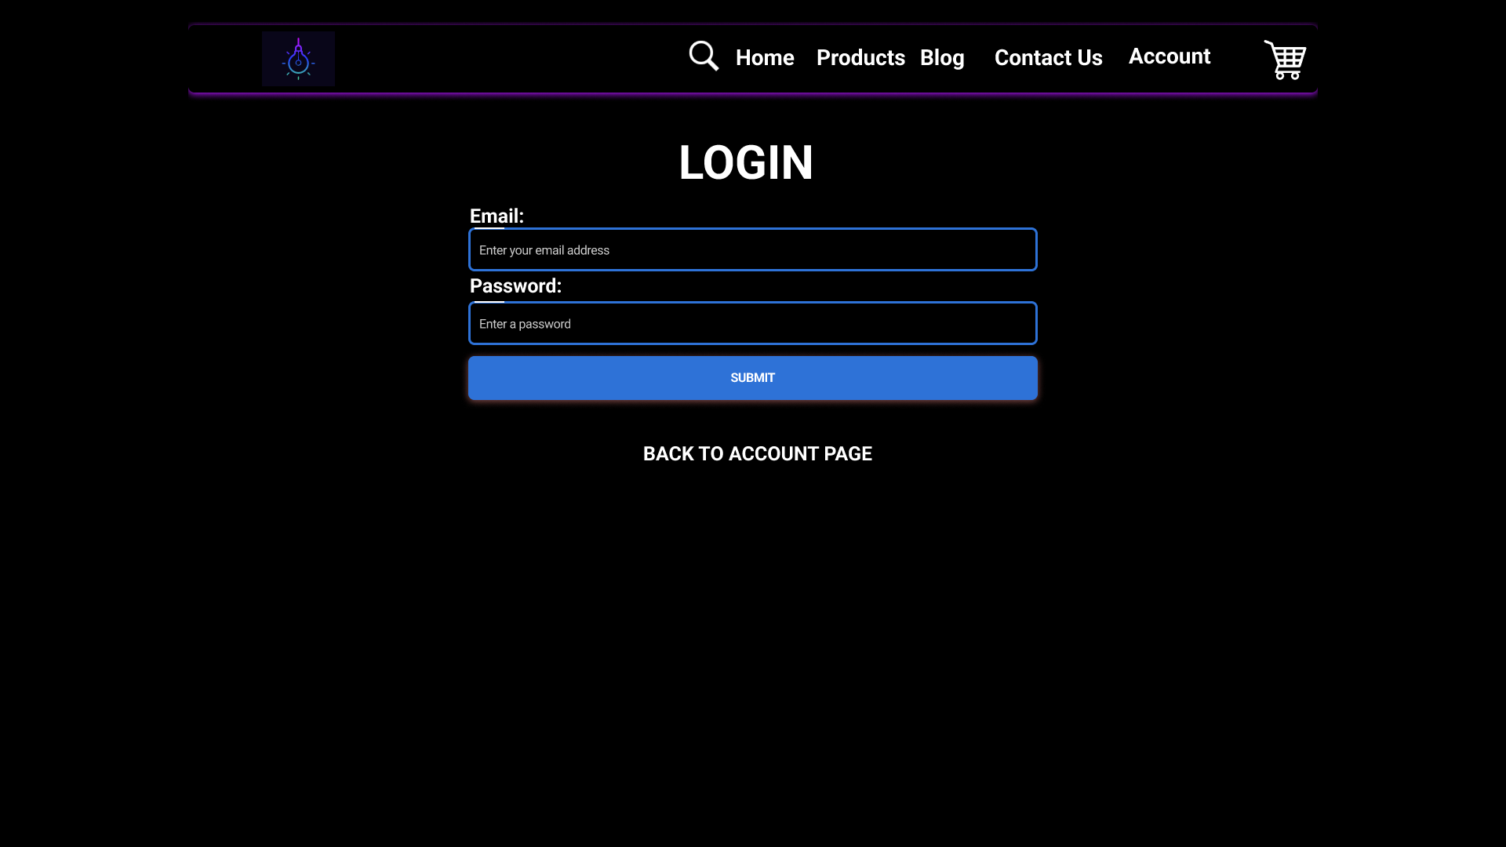

*Figure 16 - Logging in Before Deleting Account.*

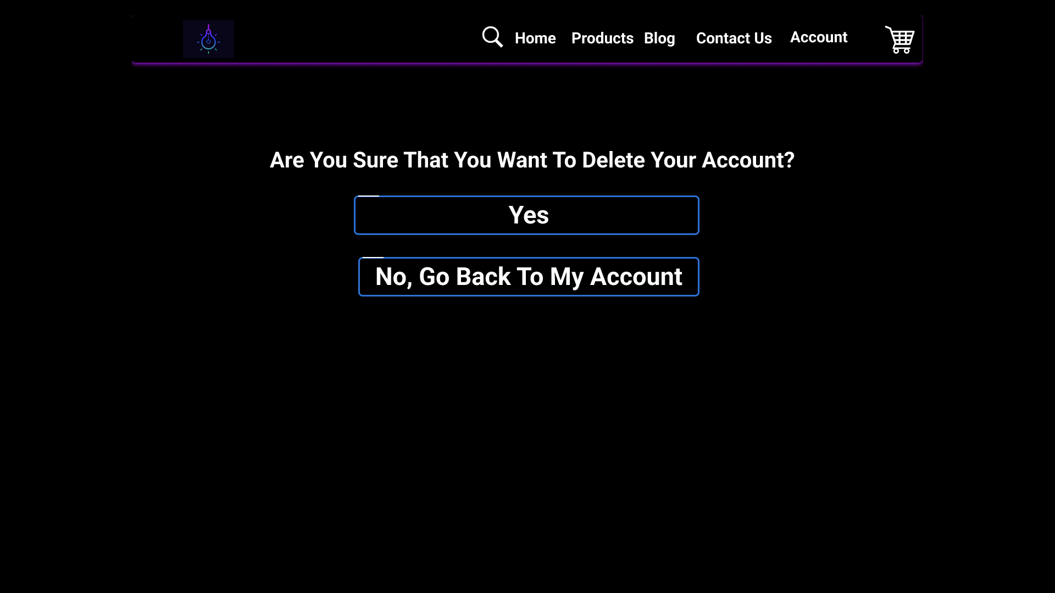

*Figure 17 - Prompting the User to Confirm If They Want to Delete Their Account.*

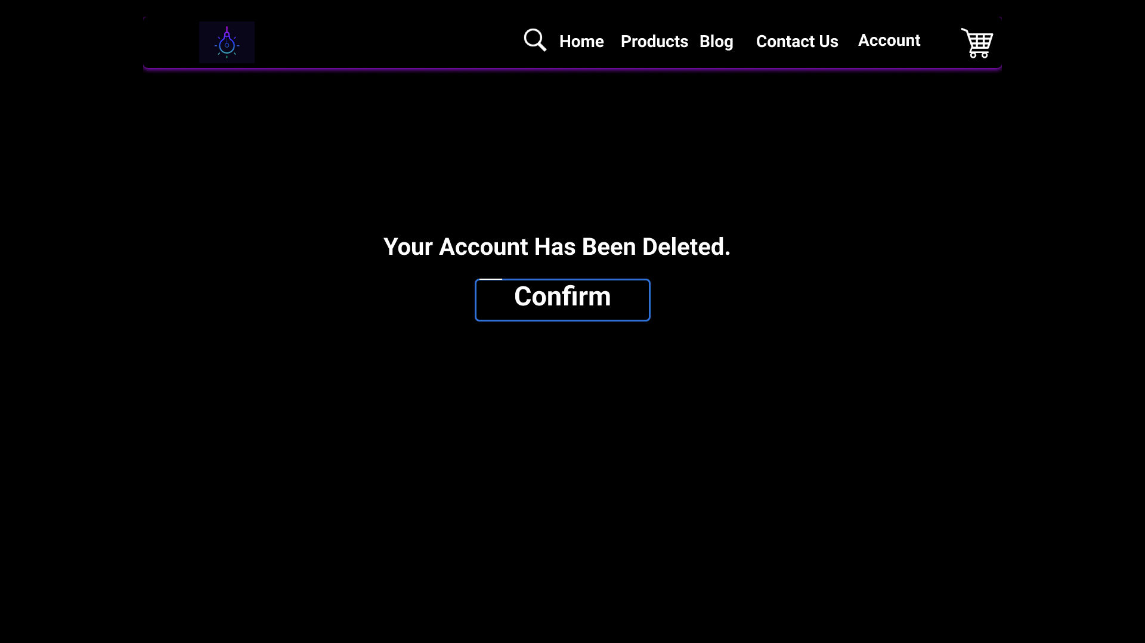

*Figure 18 - Confirmation After Deleting Account Page.*

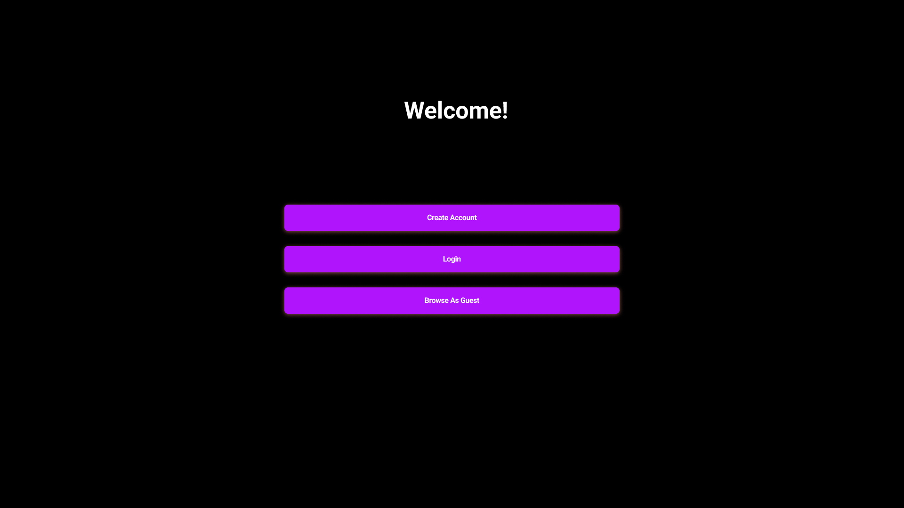

*Figure 19 - Navigating Back to The Landing Page After Deleting Account.*

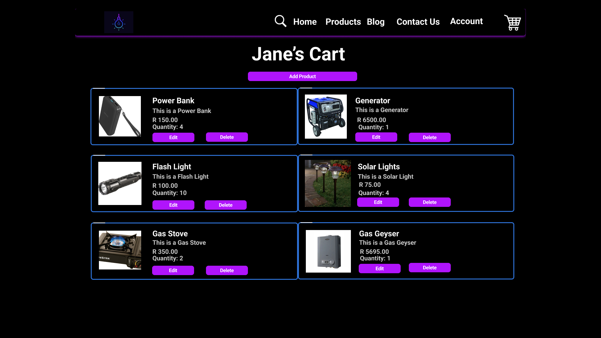

*Figure 20 - Cart Page.*

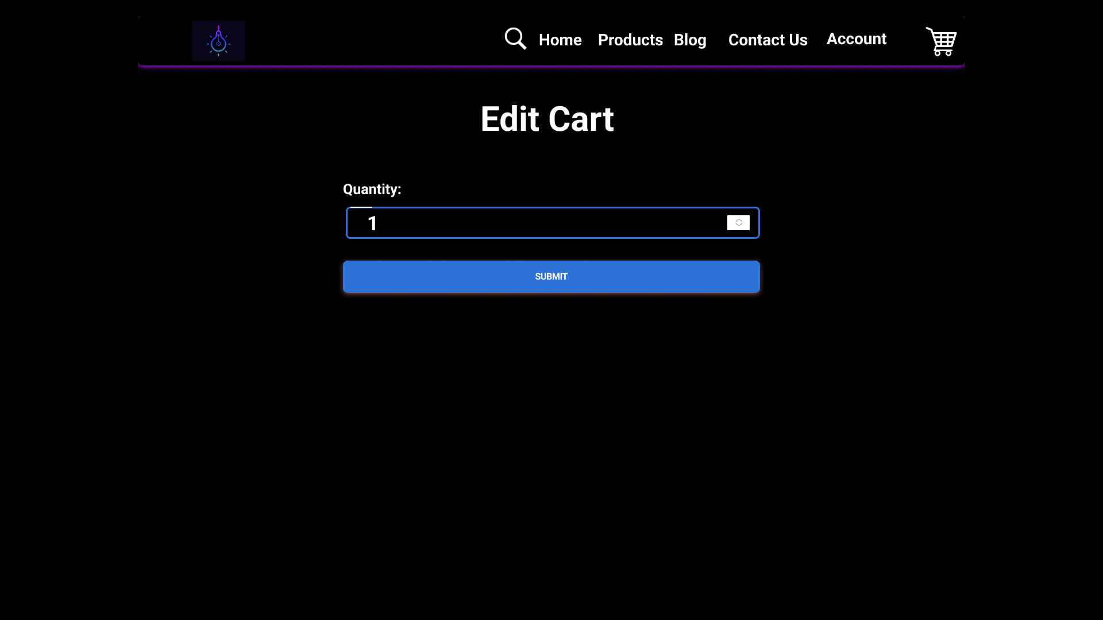

*Figure 21 - Editing A Product in Cart Page.*

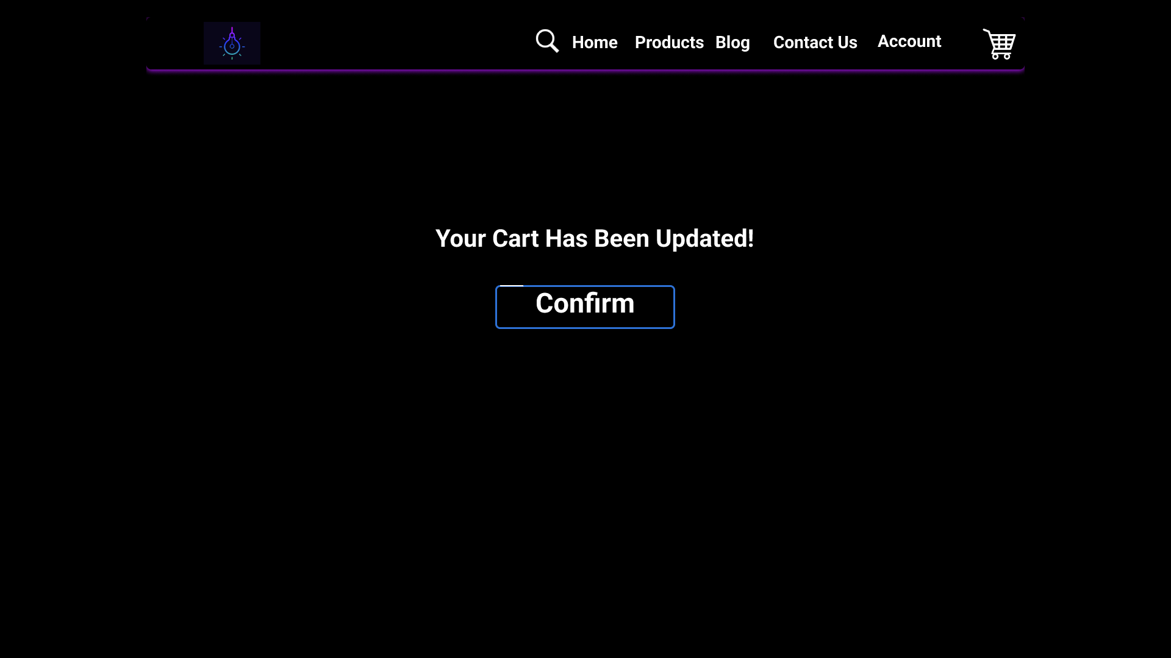

*Figure 22 - Confirmation After Editing a Product in Cart Page.*

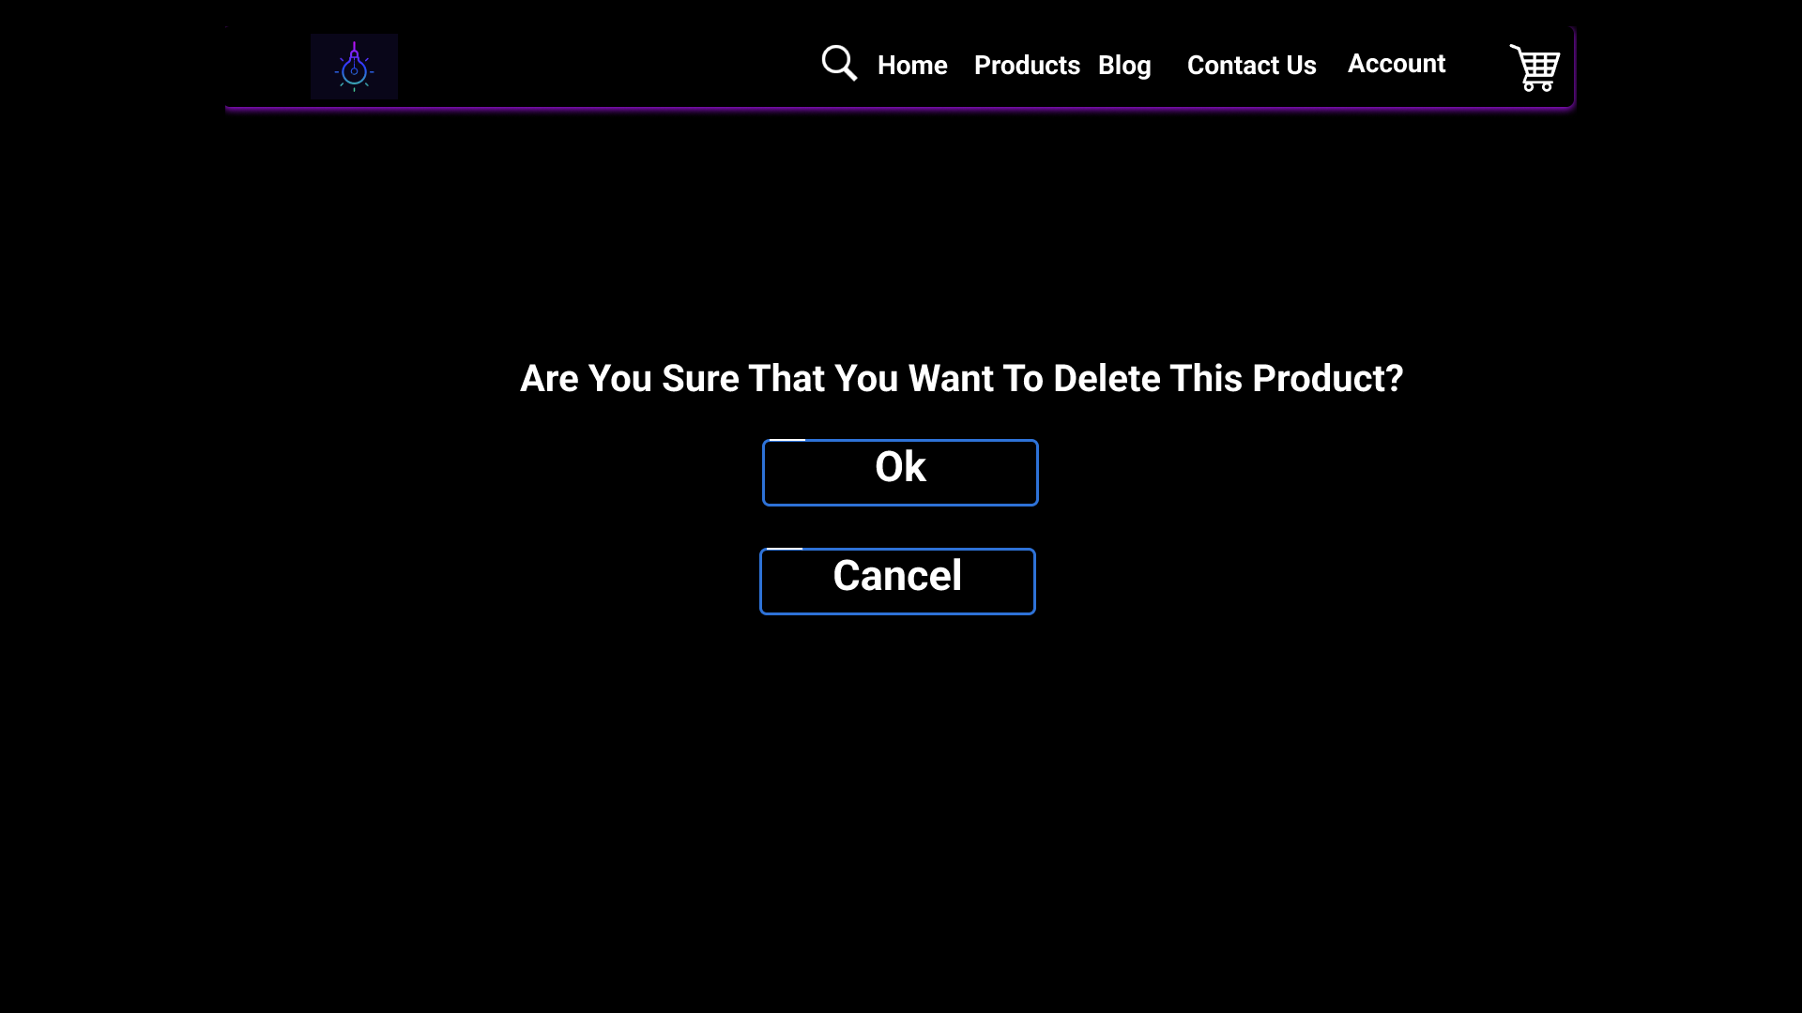

*Figure 23 - Prompting the User If They Want to Delete a Product In Their Cart.*

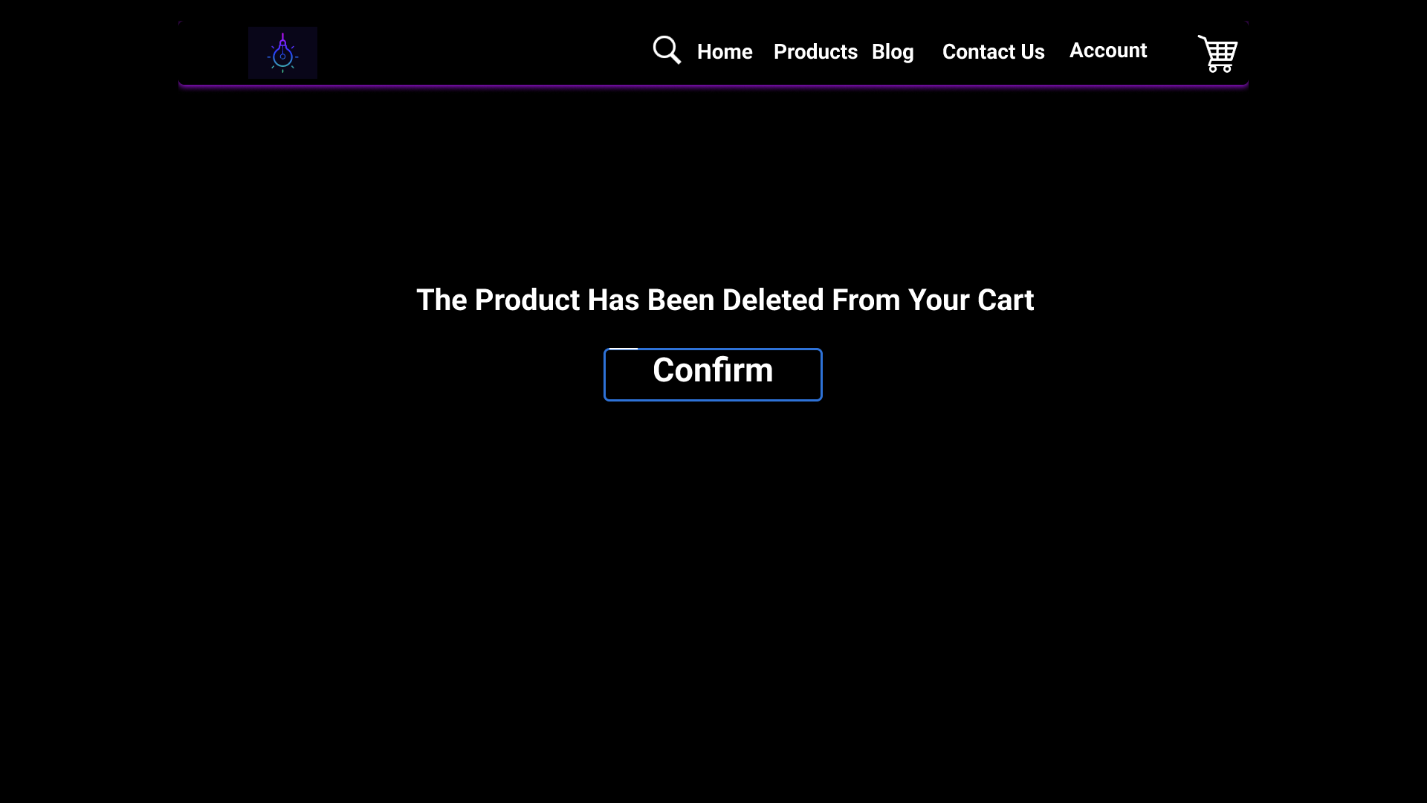

*Figure 24 - Confirmation After the User Has Deleted a Product in Their Cart Page.*



*Figure 25 - Navigating to The Products Page When the User Clicks Add on The Cart Page.*

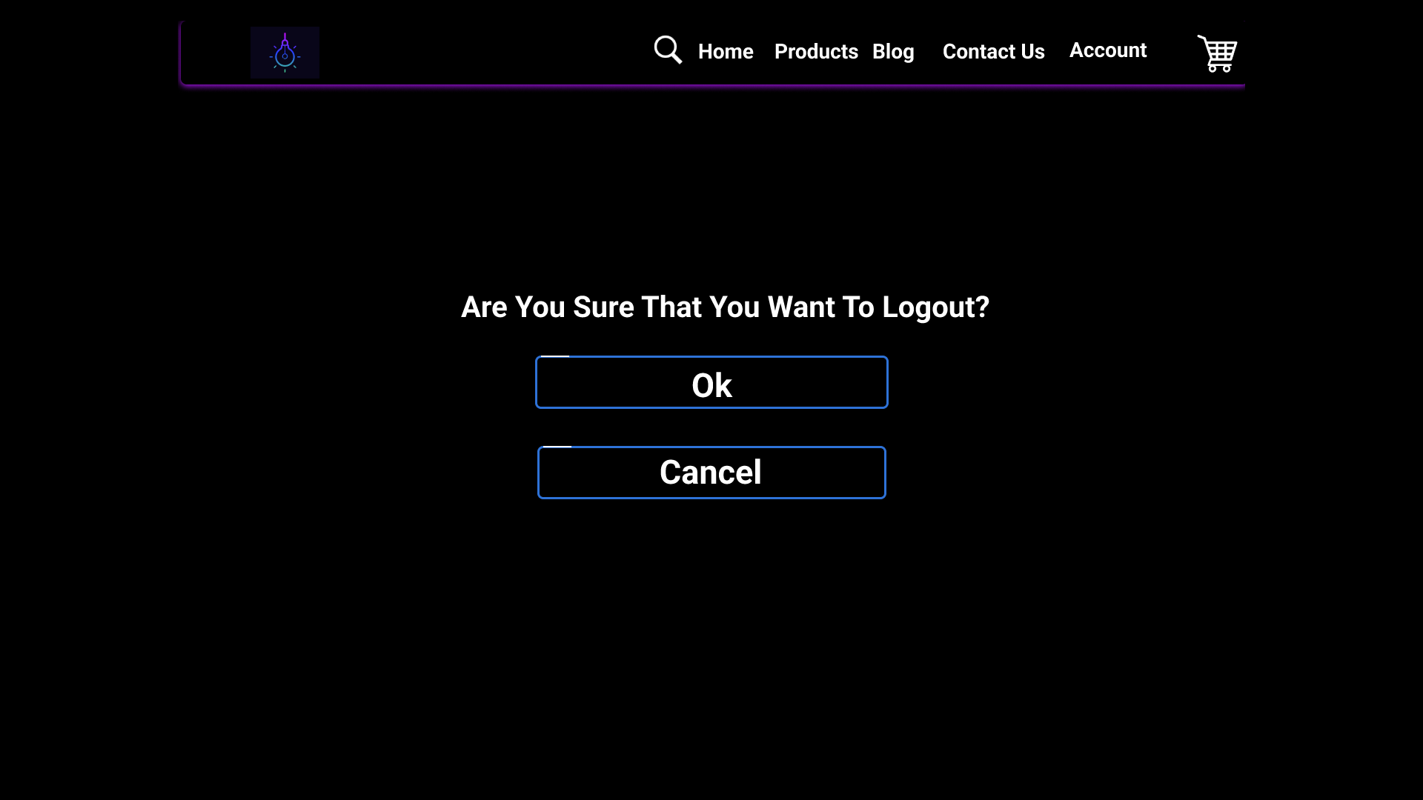

*Figure 26 - Prompting the User to Logout or Cancel.*

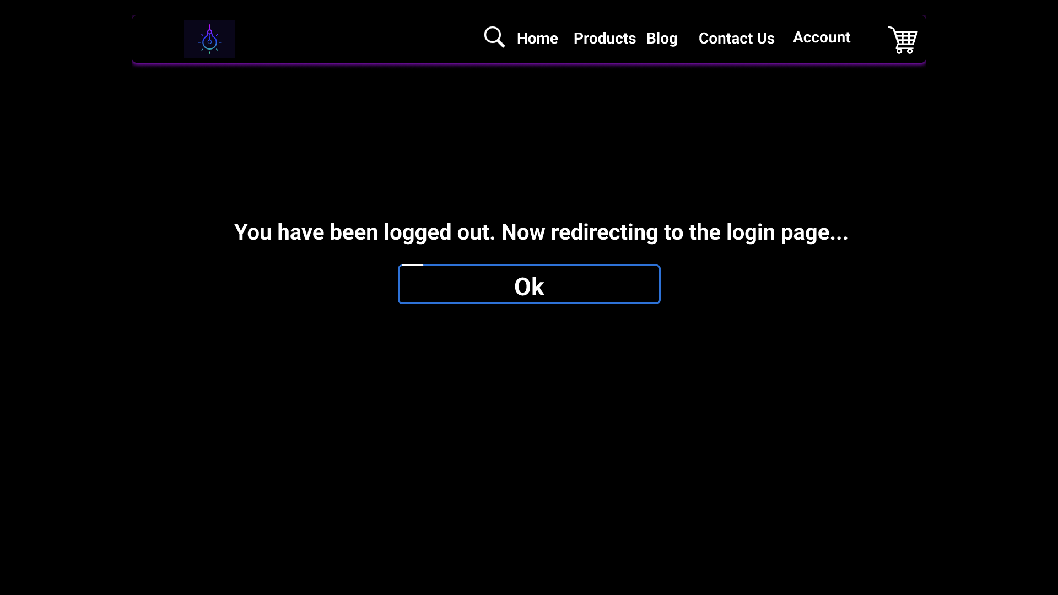

*Figure 27 - Logging out the user.*

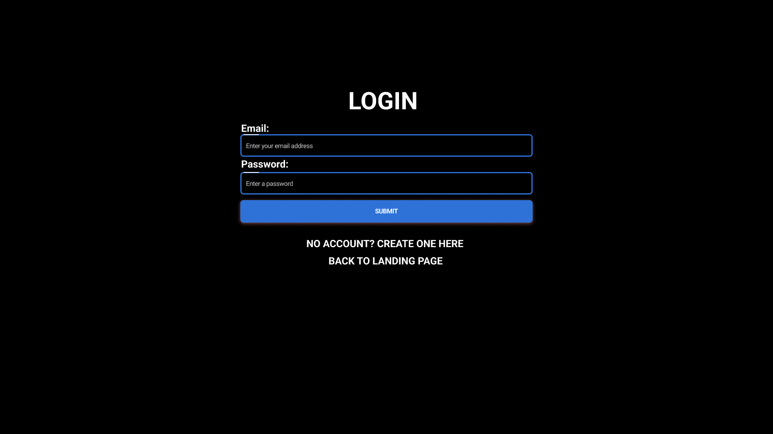

*Figure 28 - Navigating back to the login page after logging out.*

### Mobile view of the website:

<https://www.figma.com/proto/uS2z276olUCDMOdts1vYqx/Lights-Out-Prototype-1?type=design&node-id=115-748&scaling=min-zoom&page-id=115%3A745&starting-point-node-id=115%3A748>

## Prototype 2

### Desktop view of the website:

<https://www.figma.com/proto/FV4Fr3QZqHhorygER0PKpR/Lights-Out-Prototype-2?type=design&node-id=6-1856&scaling=min-zoom&page-id=0%3A1&starting-point-node-id=6%3A1856>

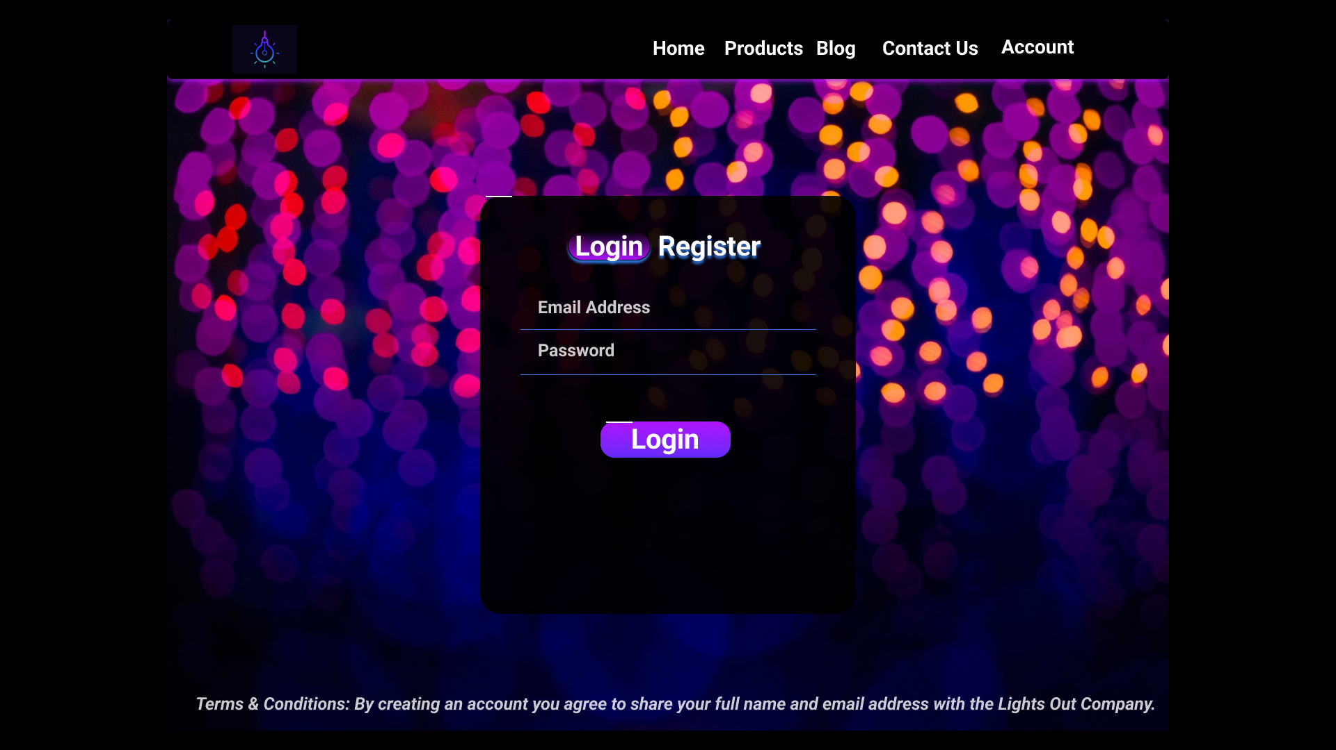

*Figure 29 - Login Page.*

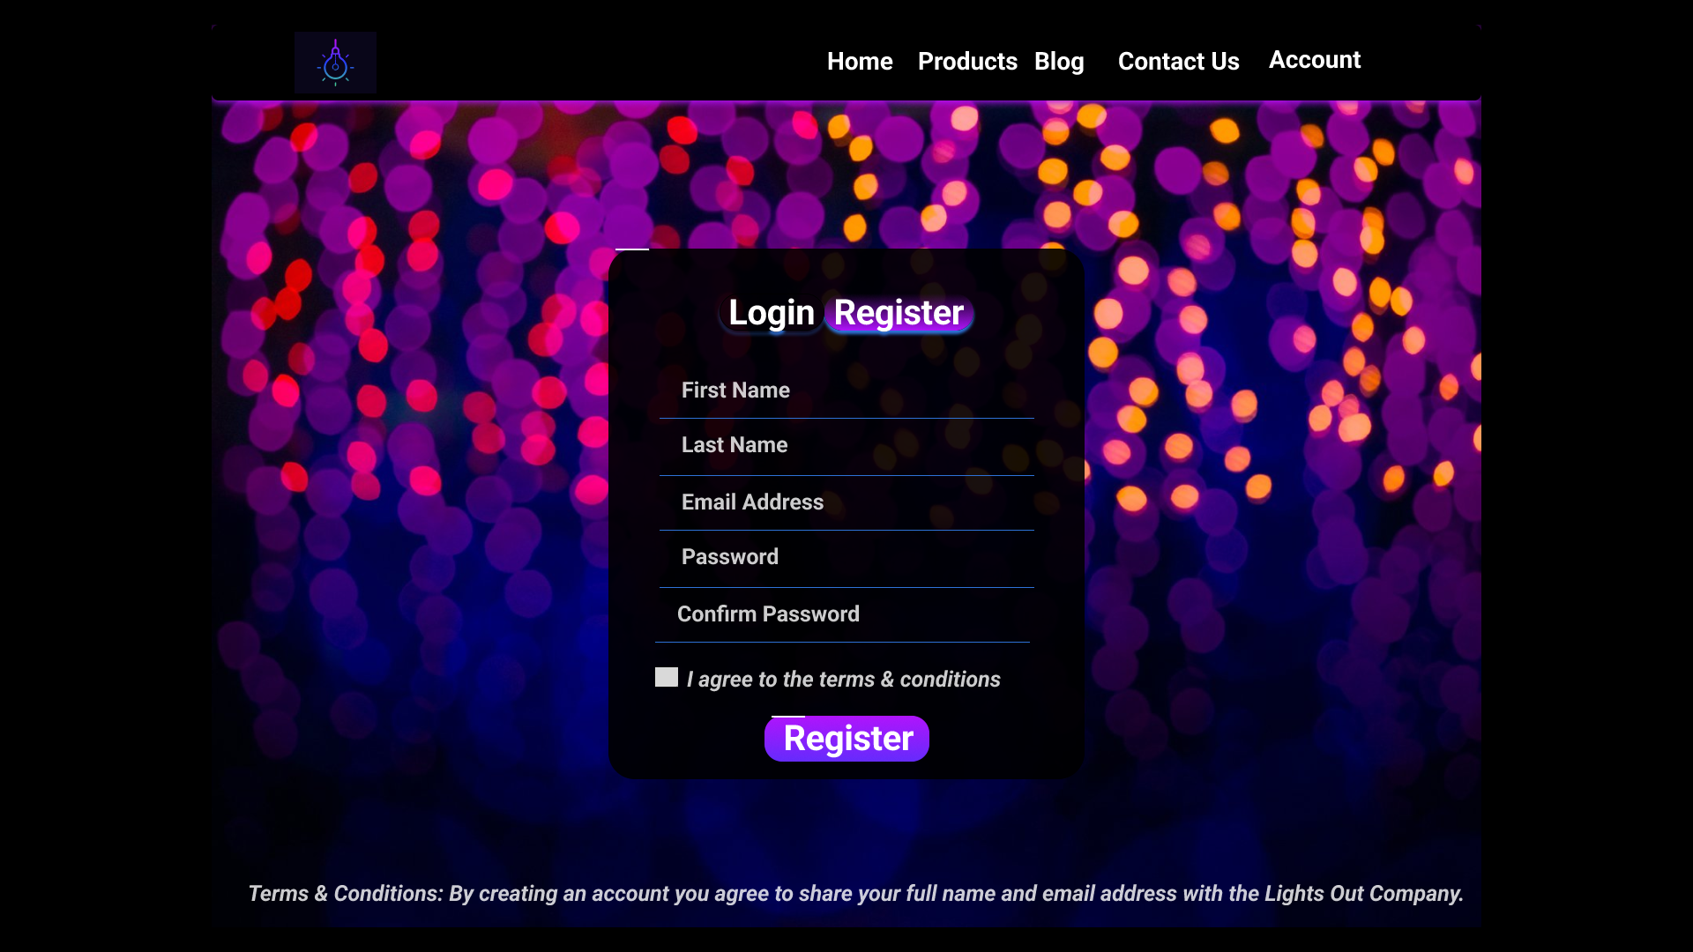

*Figure 30 - Register Page.*

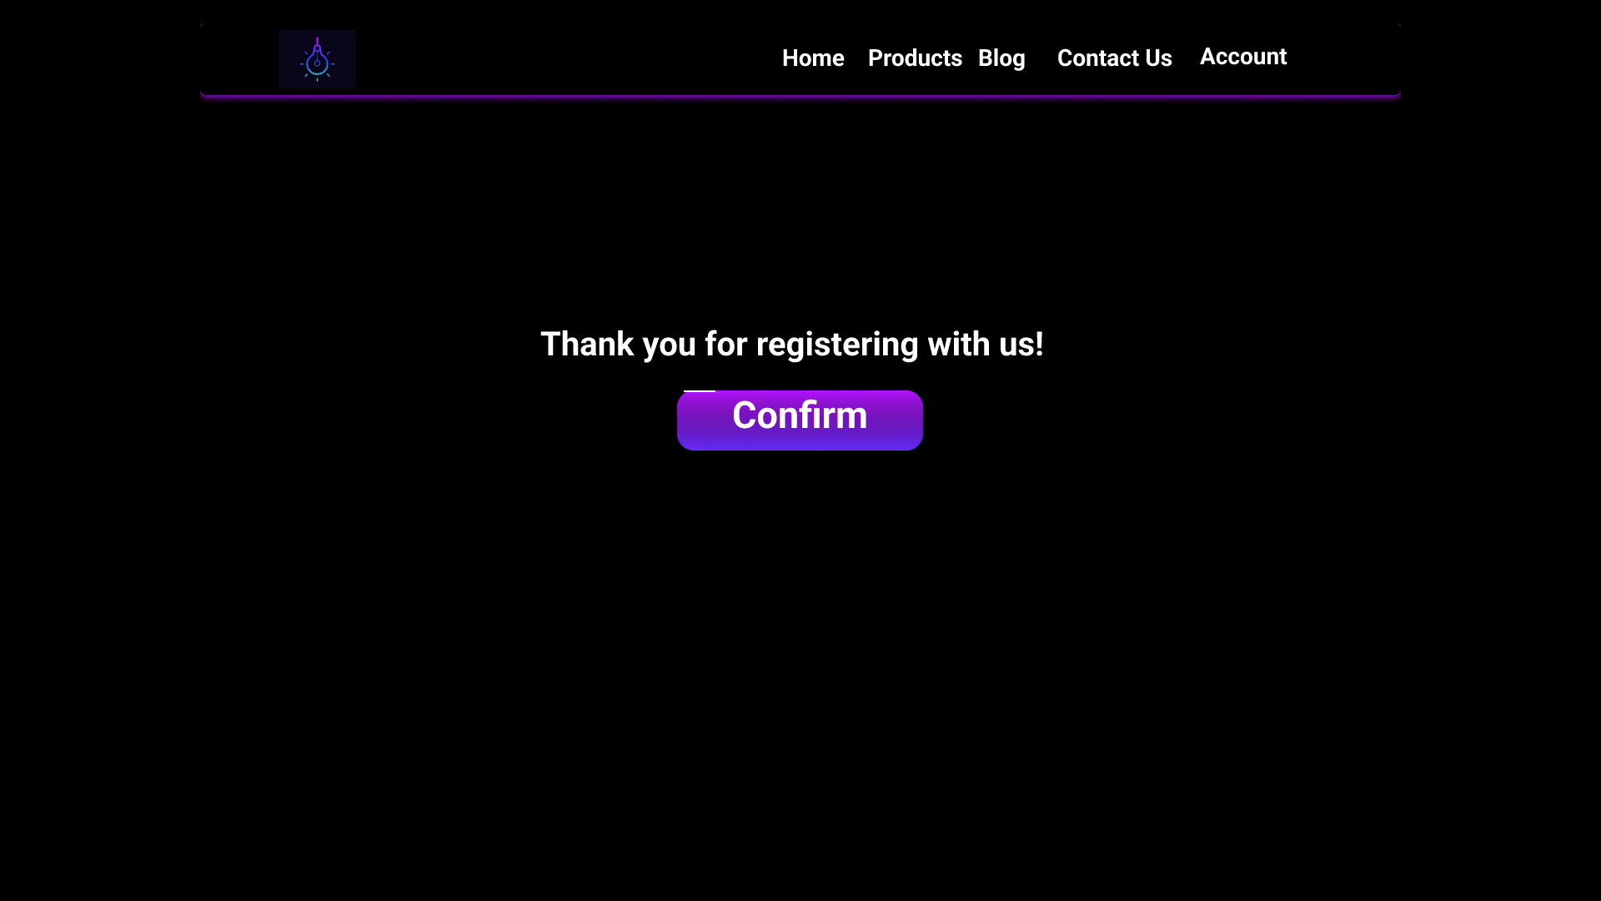

*Figure 31 - Thanking the user after registering an account.*

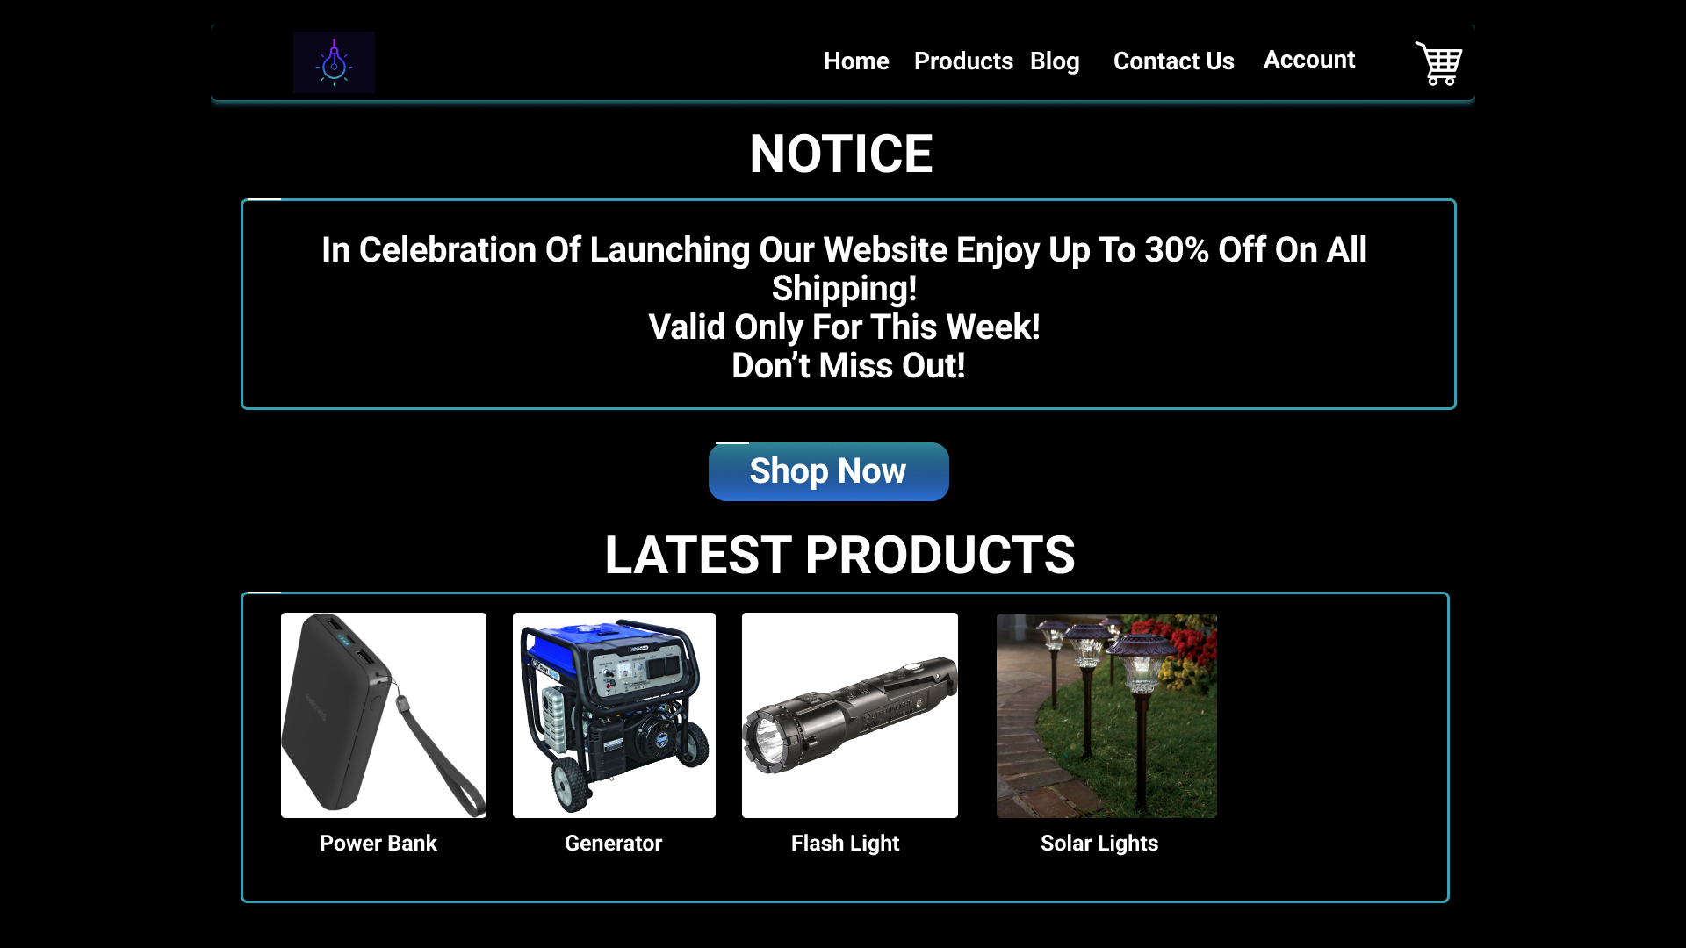

*Figure 32 - Home Page.*

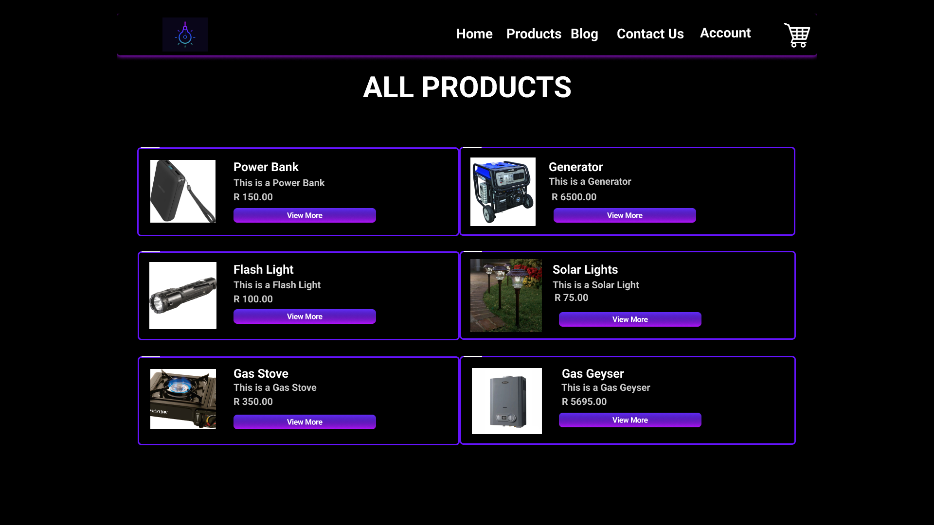

*Figure 33 - Products Page.*

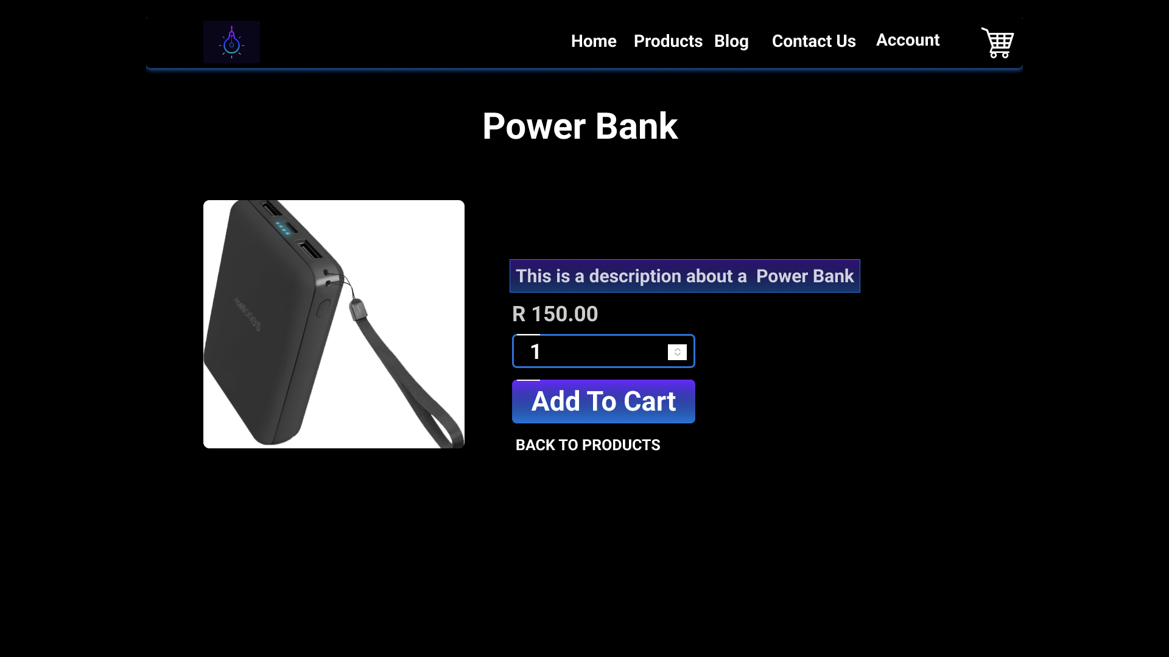

*Figure 34 - Product Details Page.*

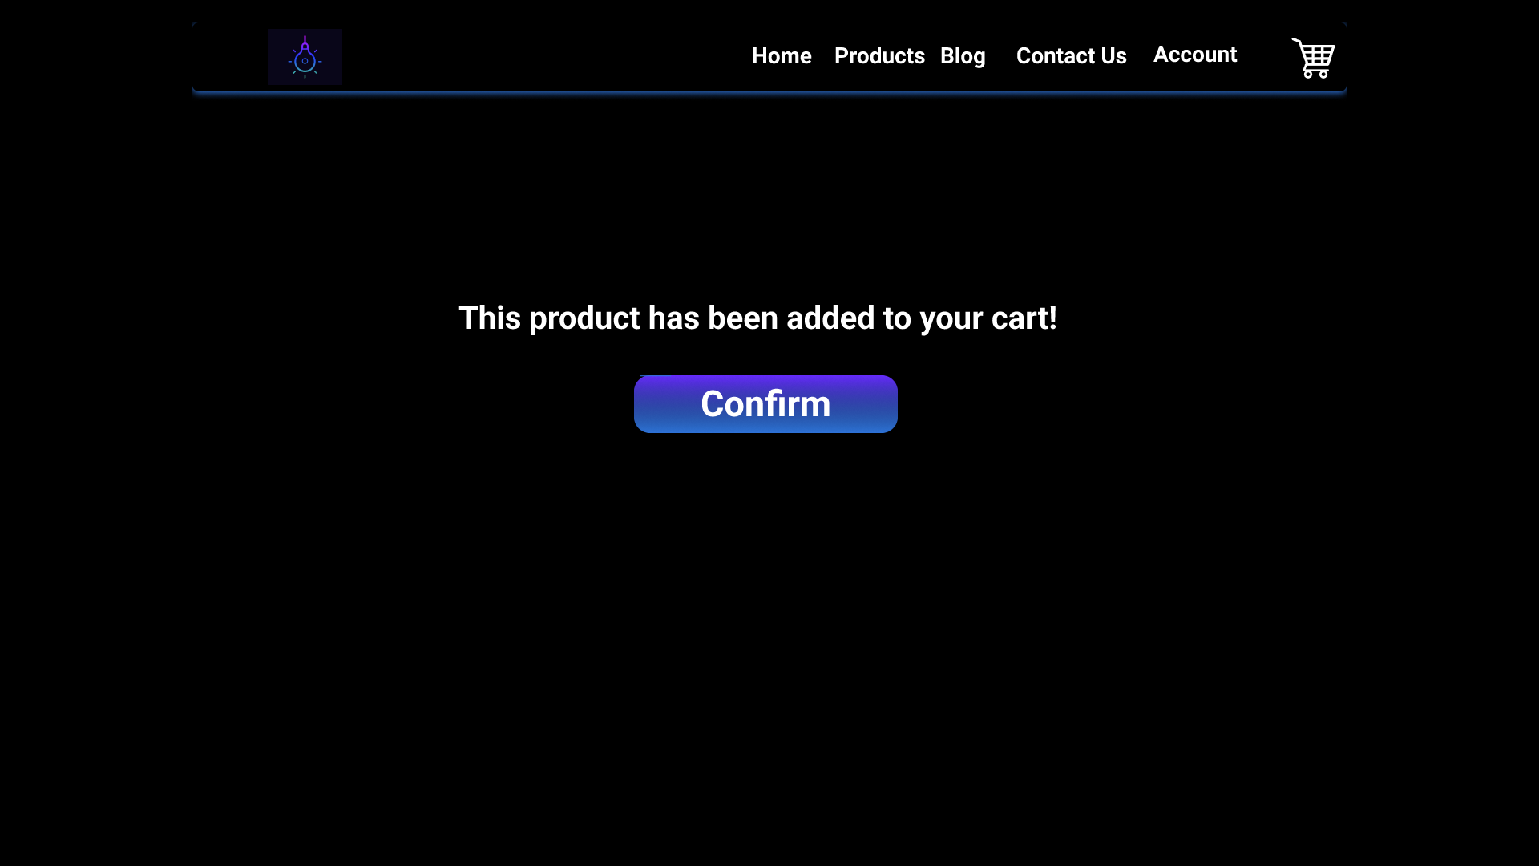

*Figure 35 - Product Added to Cart Page.*

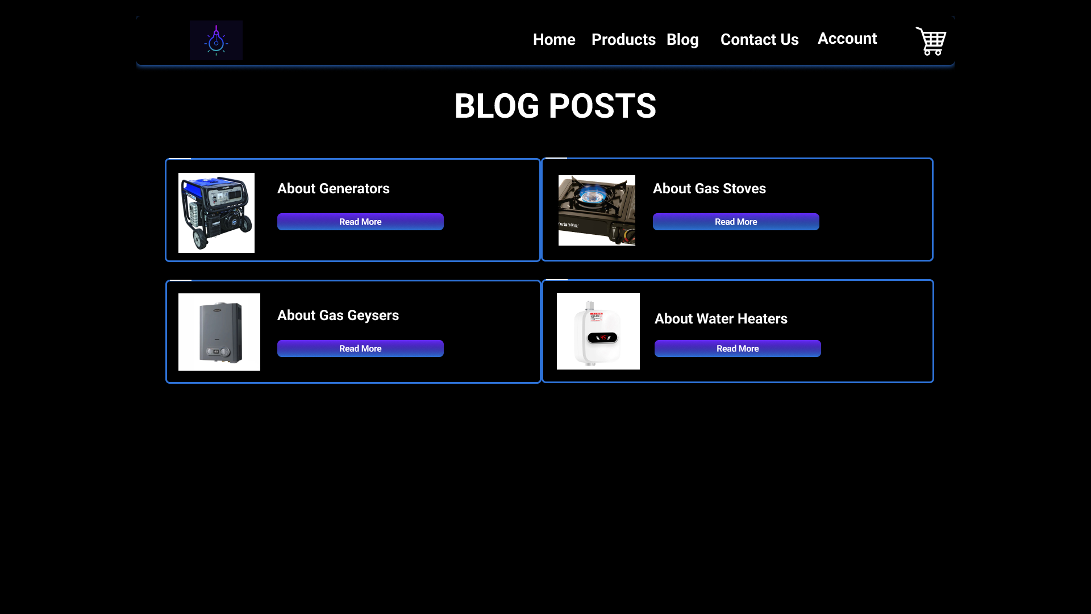

*Figure 36 - Blog Posts Page.*

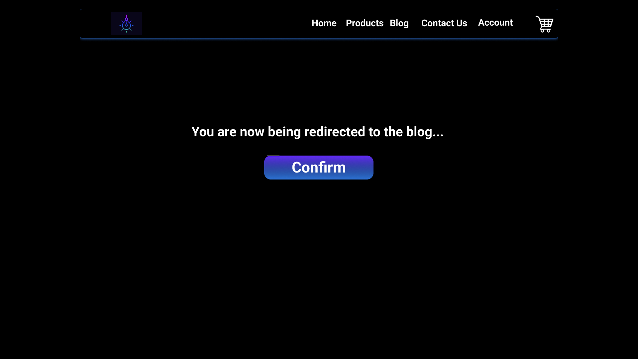

*Figure 37 - Redirecting to the Blog Post Page.*

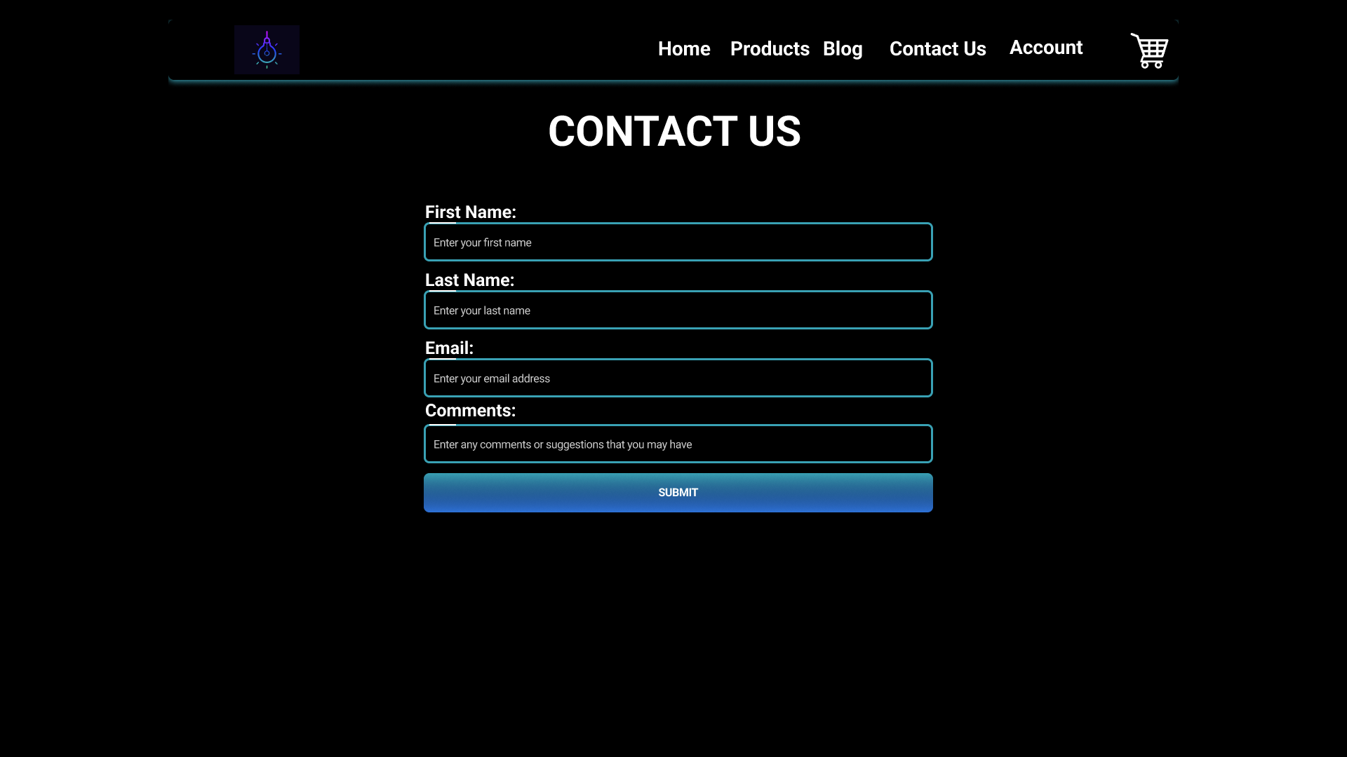

*Figure 38 Contact Us Page.*

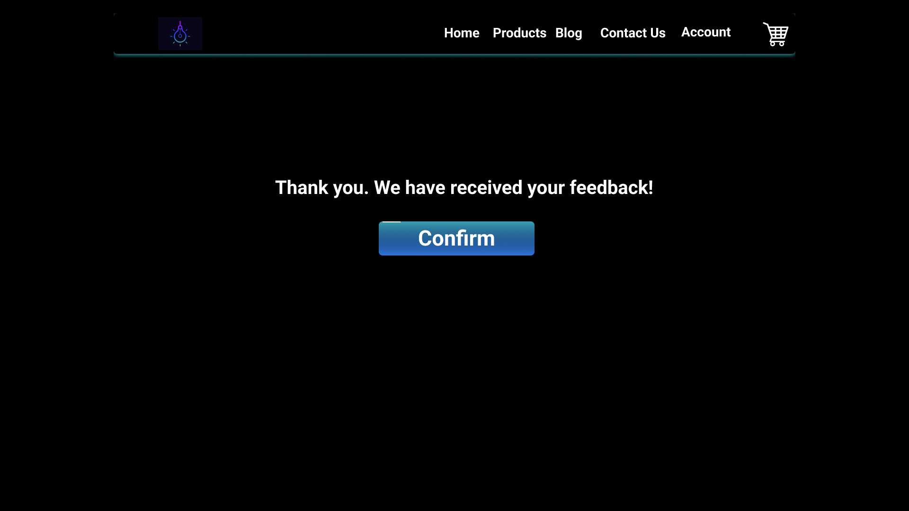

*Figure 39 - Thanking the user for filling out the Contact Us Form.*

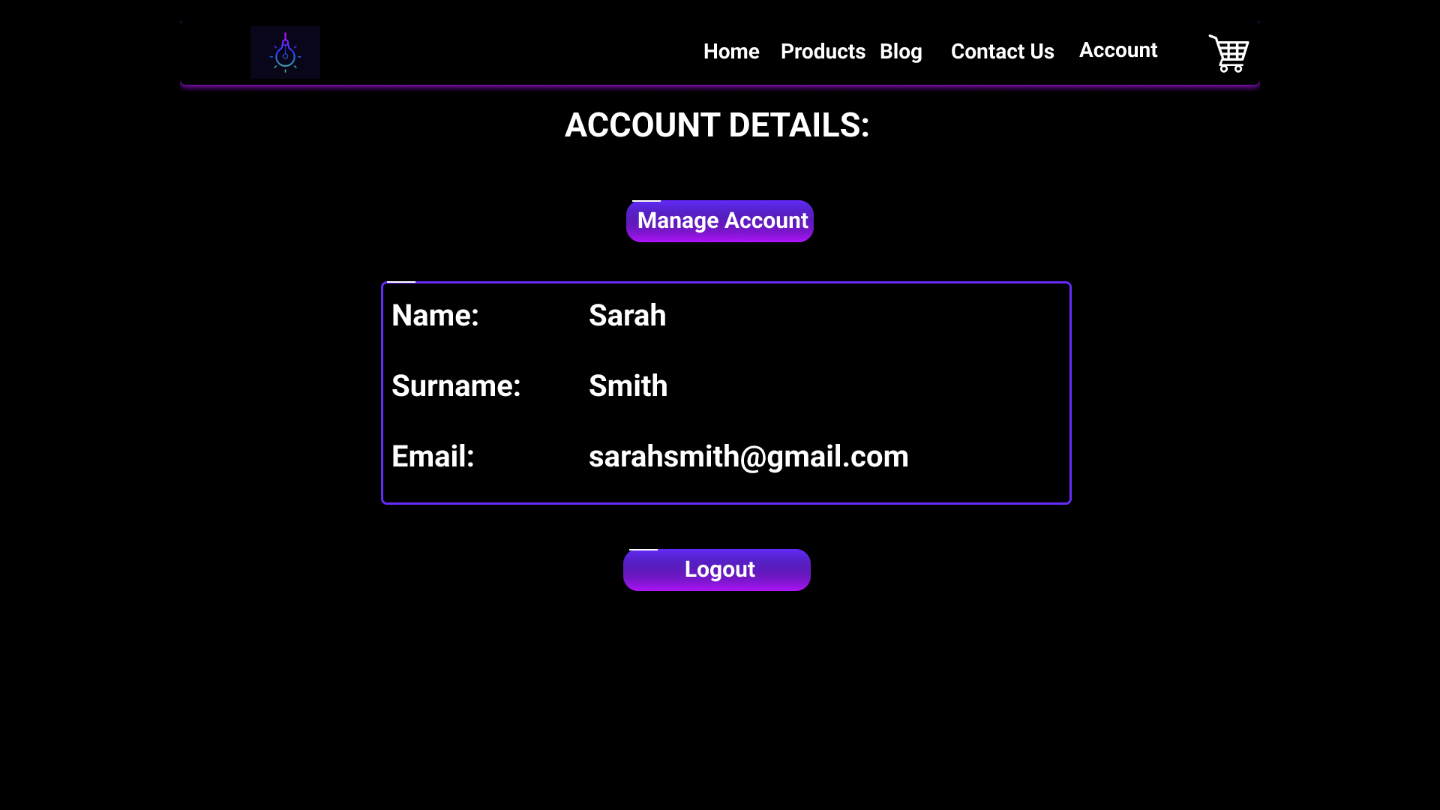

*Figure 40 - Account Page.*

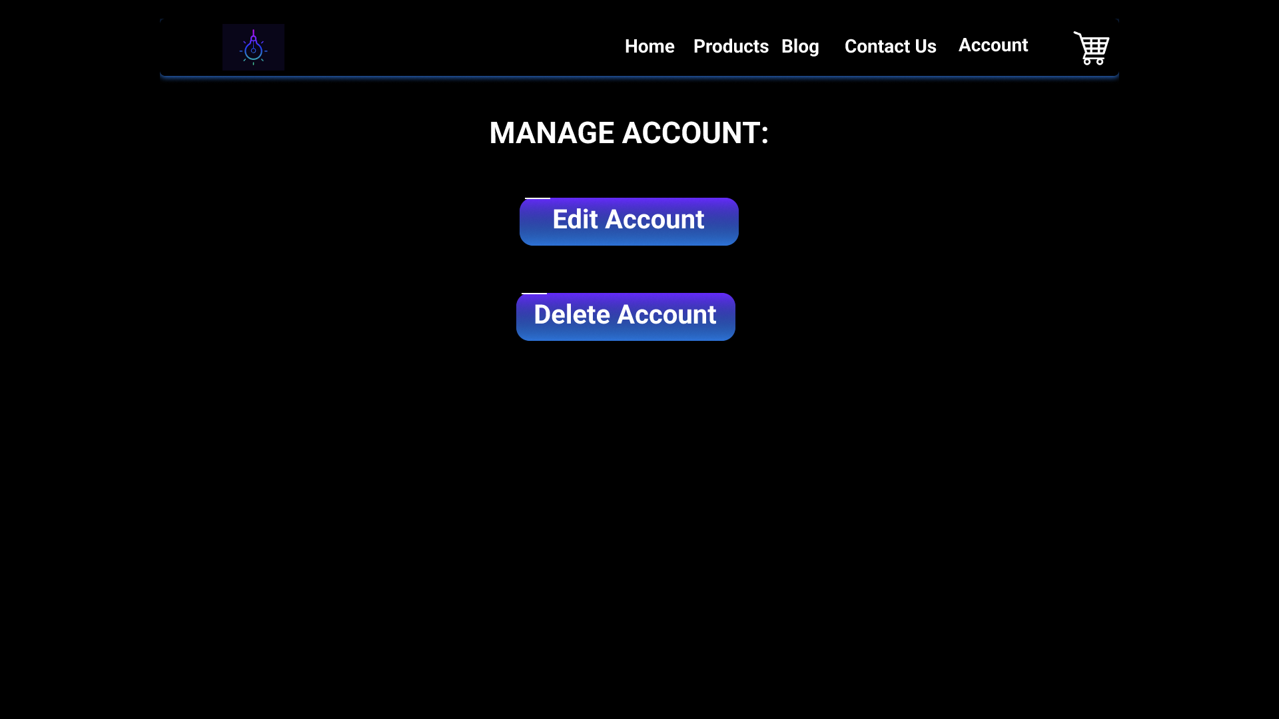

*Figure 41 - Manage Account Page.*

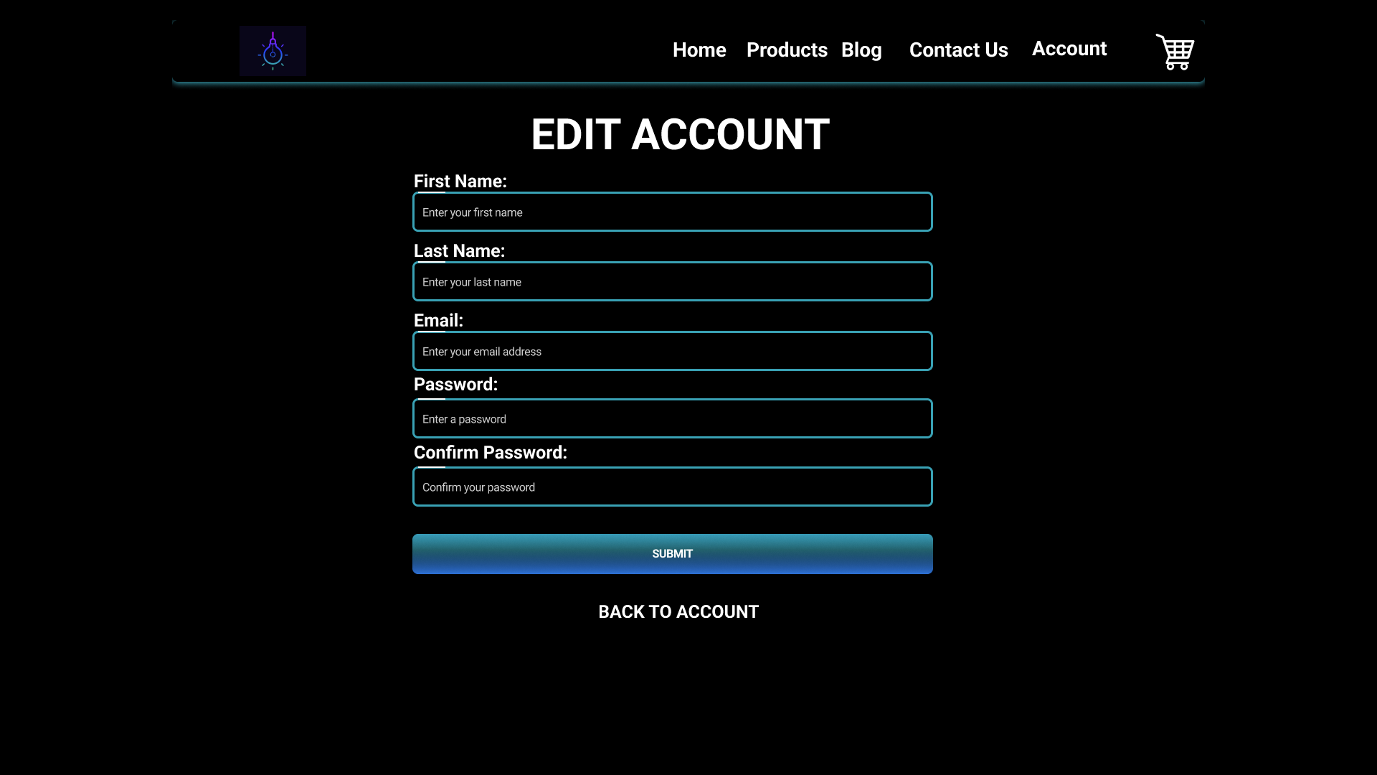

*Figure 42 - Edit Account Details Page.*

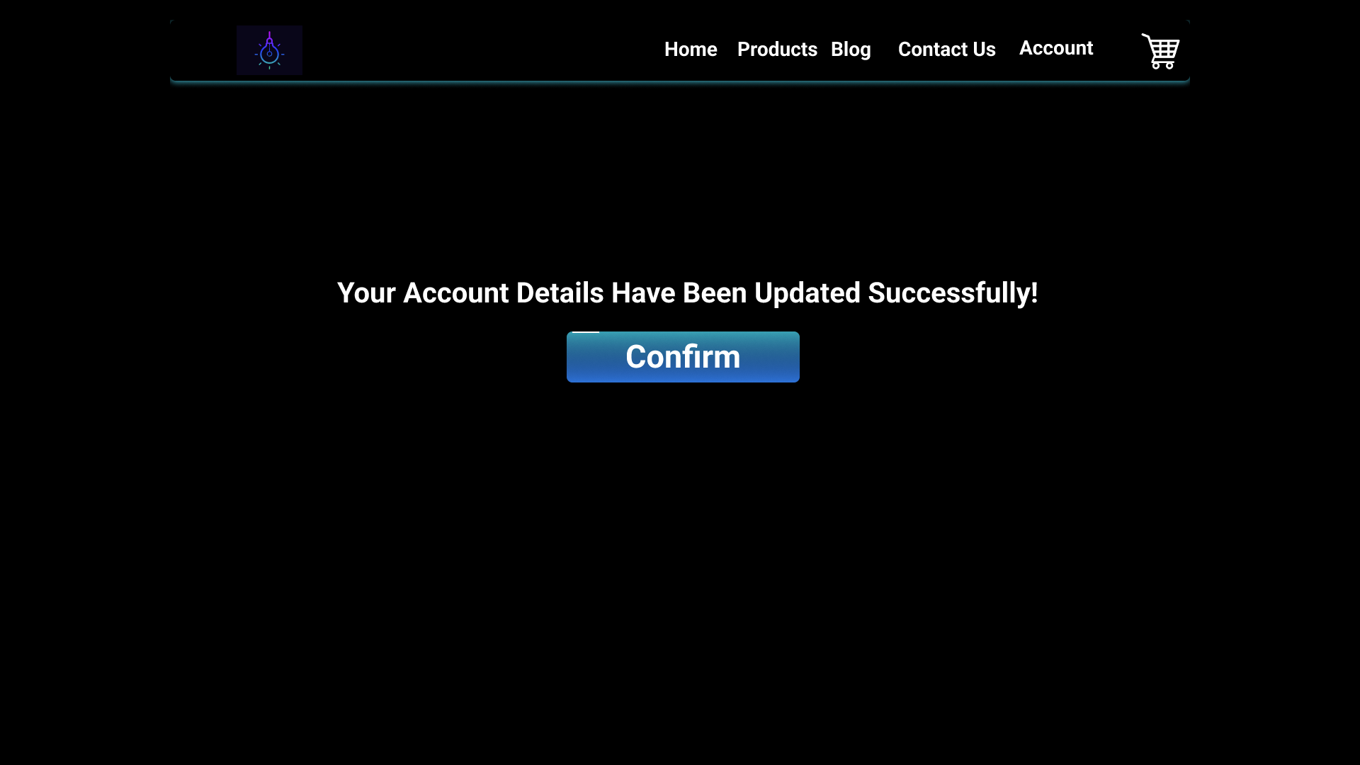

*Figure 43 - Notifying the user that their Account Details have been updated.*

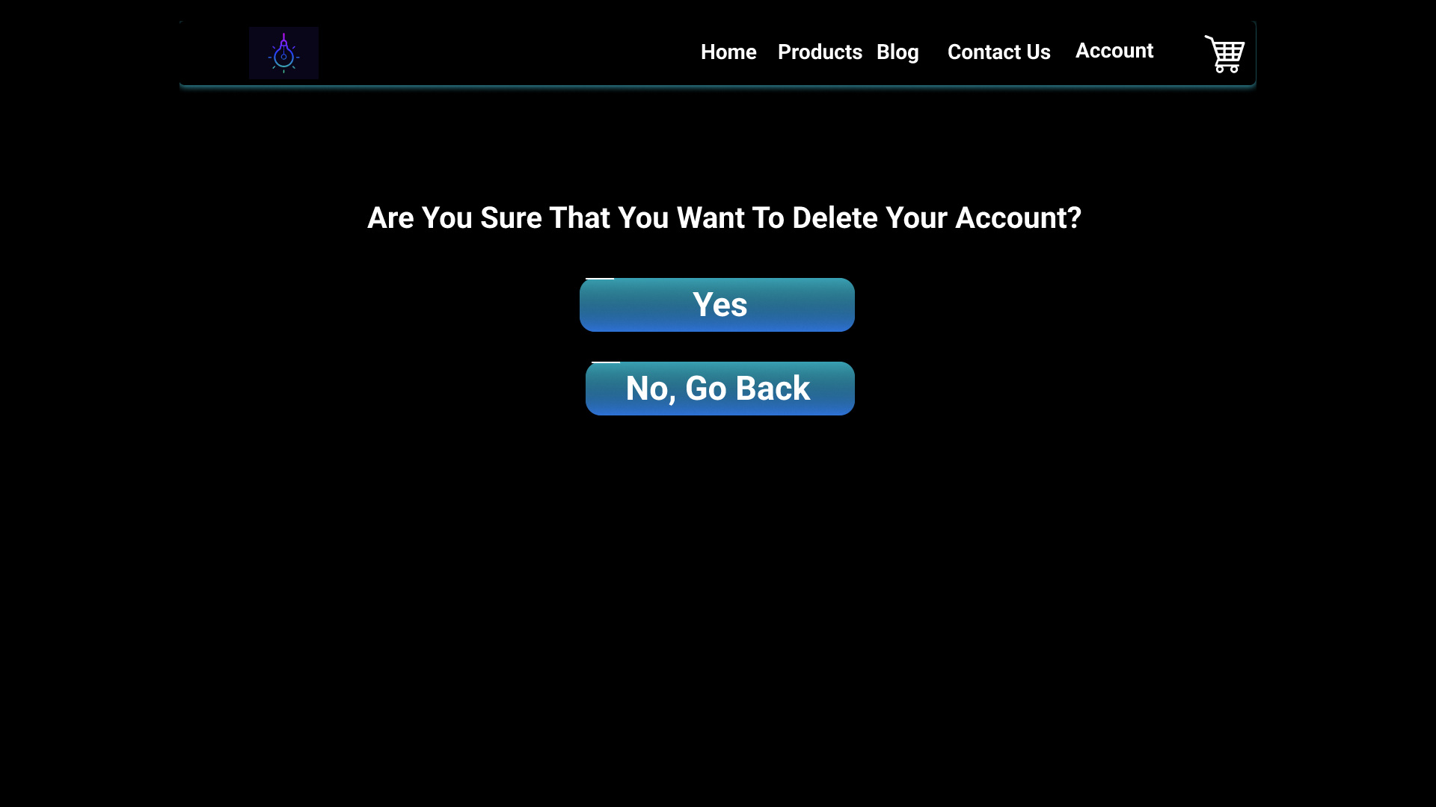

*Figure 44 - Asking the user if they want to Delete their Account.*

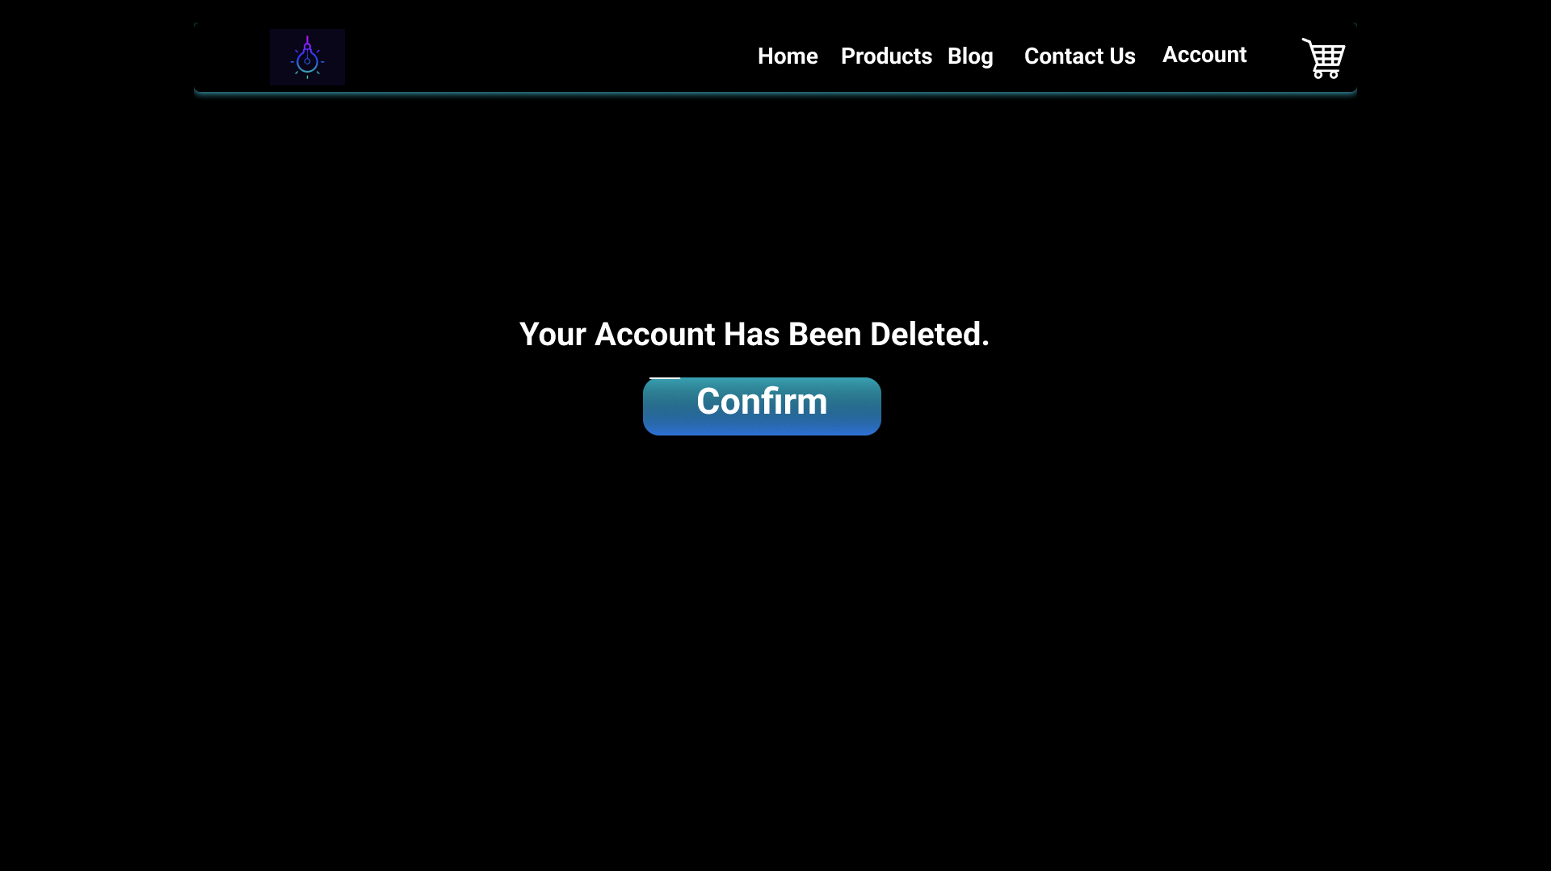

*Figure 45 - Notifying the user that their account has been deleted.*



*Figure 46 – Redirecting the user to the home page after deleting their account.*

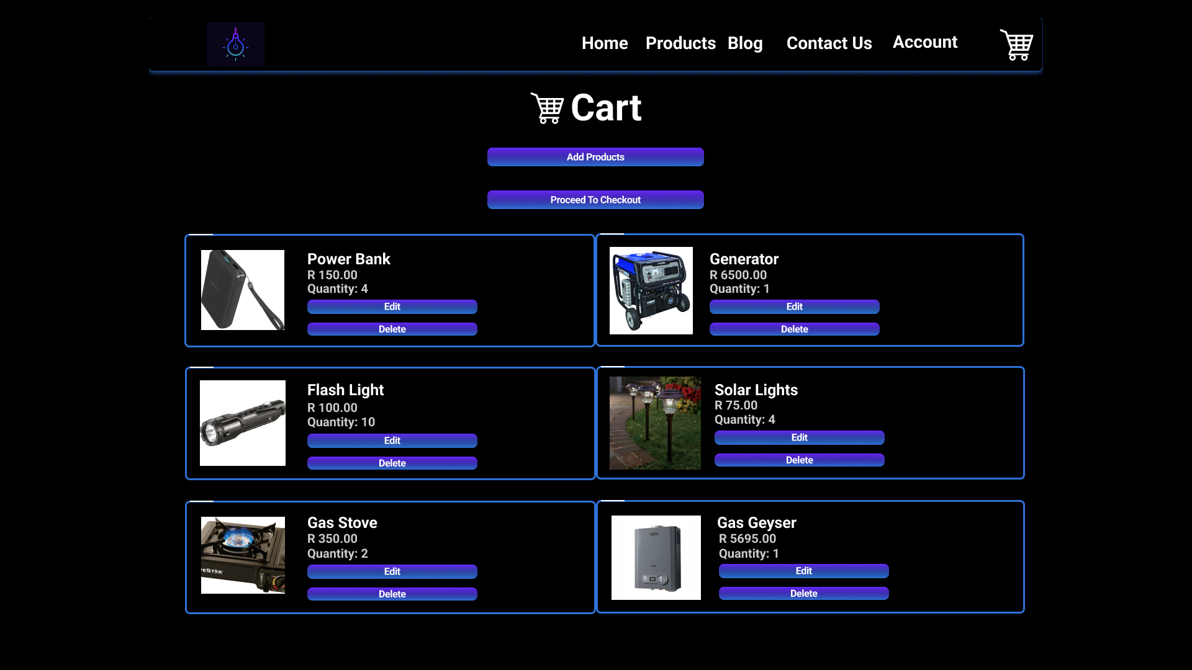

*Figure 47 - User cart page.*

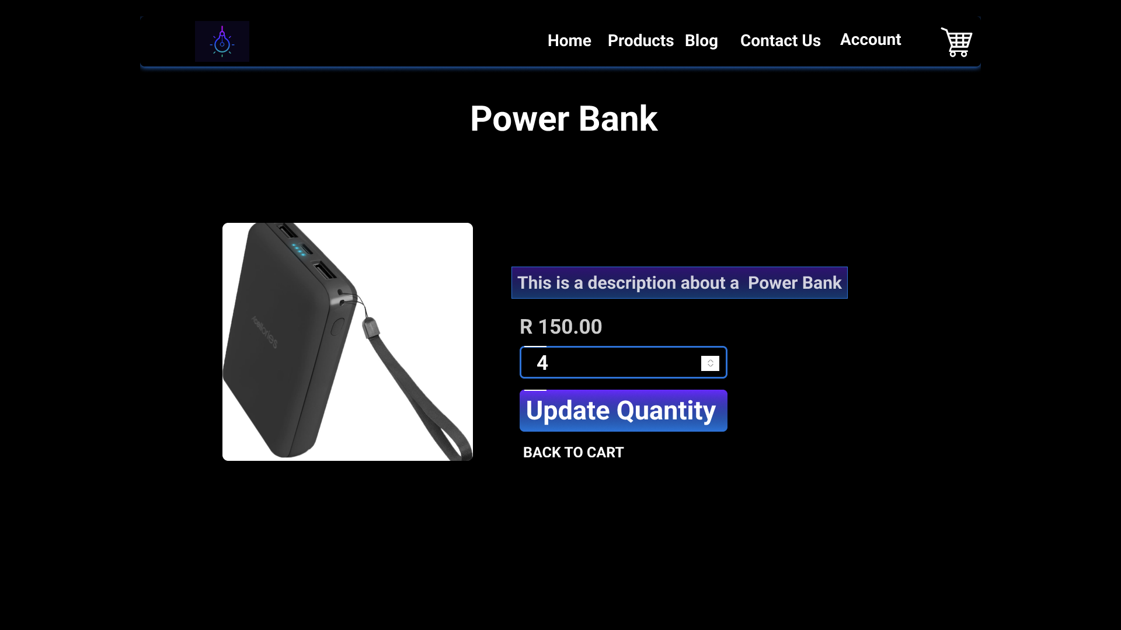

*Figure 48 - Updating the quantity of a product in the users’ cart.*

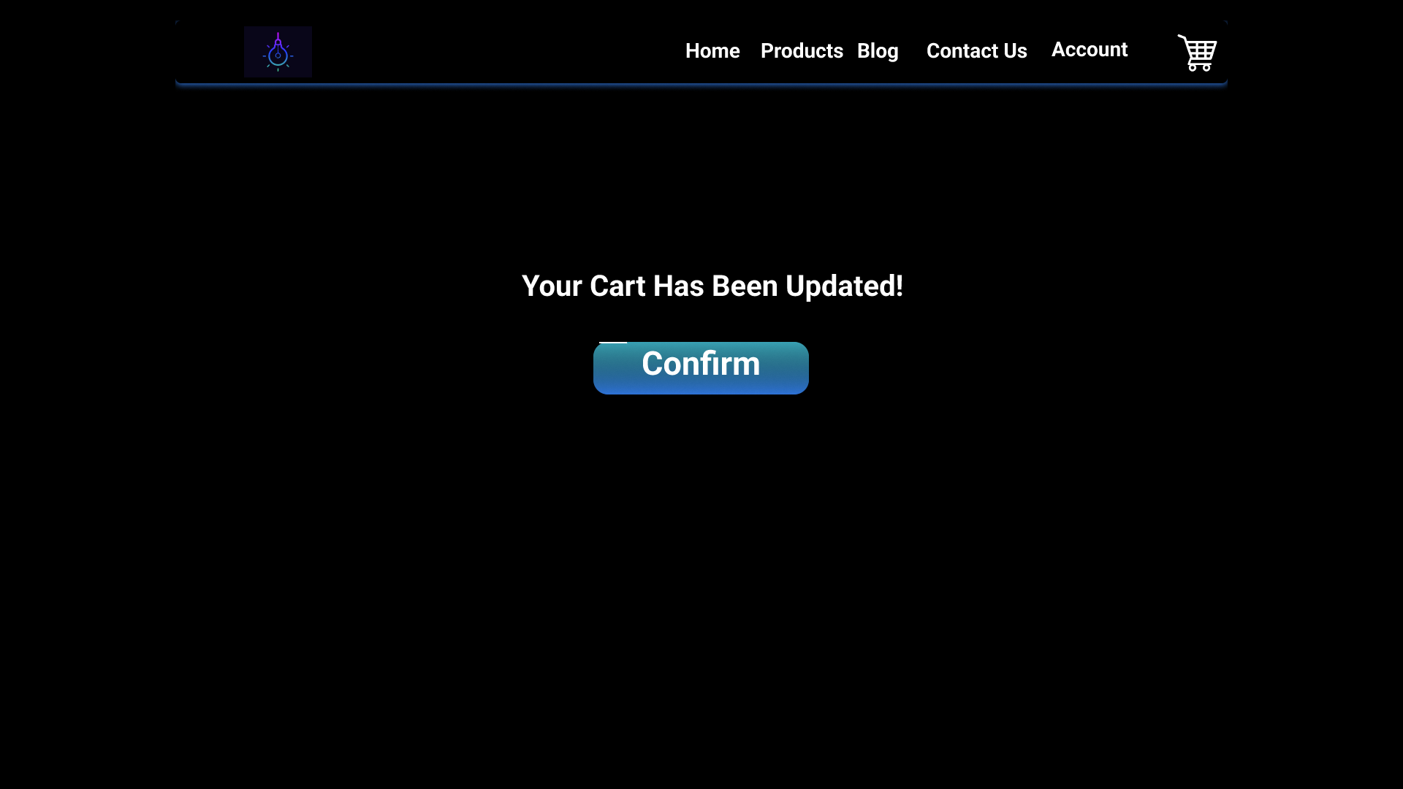

*Figure 49 Notifying the user that the product in their cart was updated.*

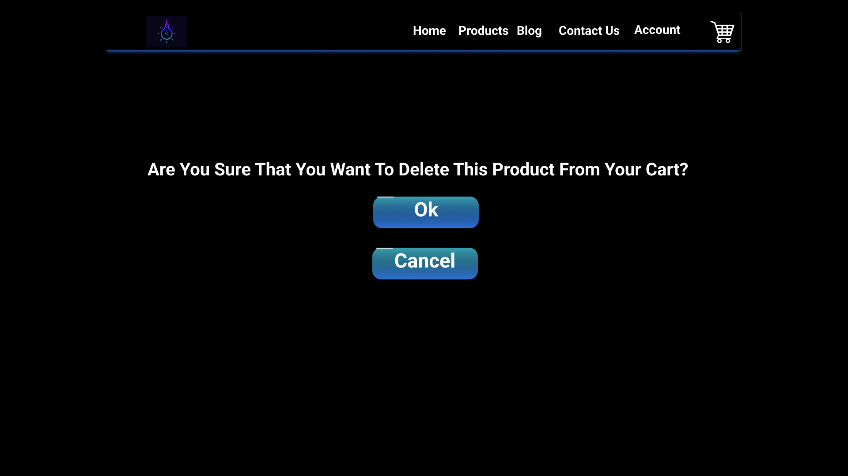

*Figure 50 - Asking the user if they want to delete a product in their cart.*

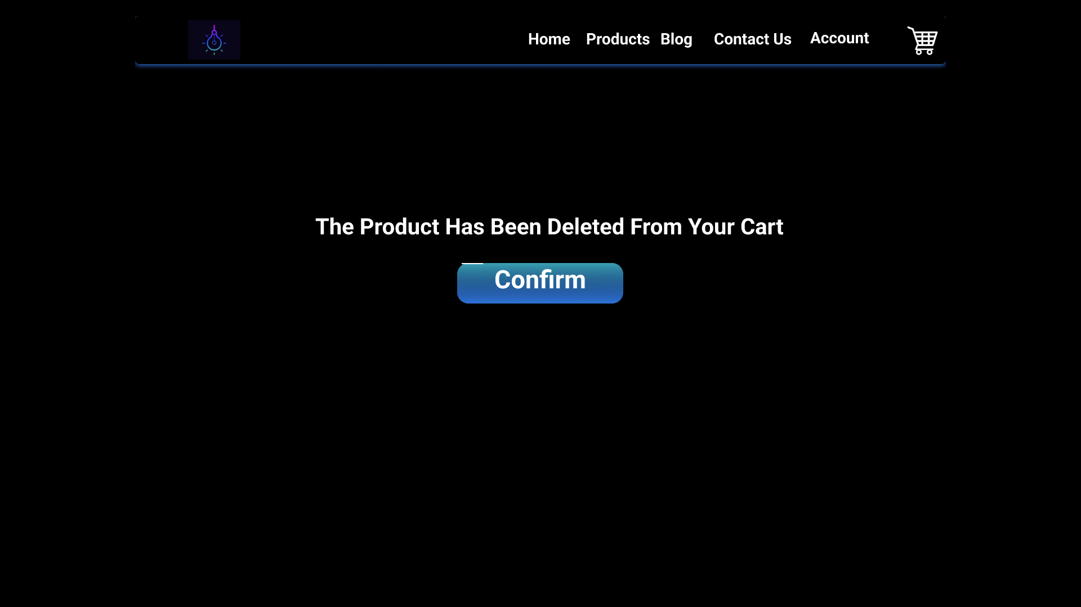

*Figure 51 - Notifying the user that the product has been deleted from their cart.*

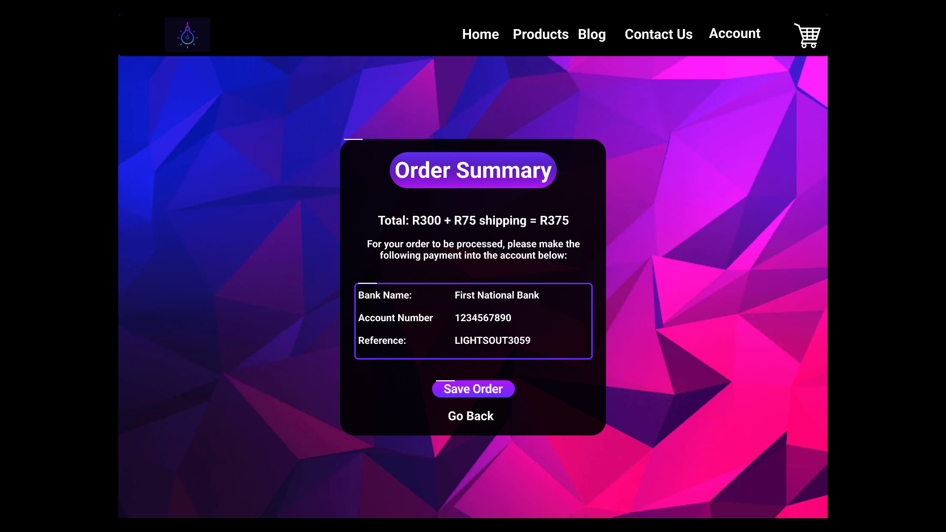

*Figure 52 - Checkout Page.*

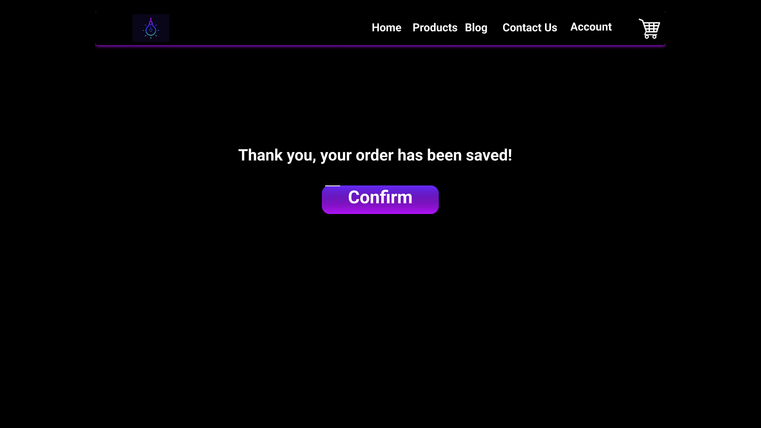

*Figure 53 - Notifying the user that their order was saved.*

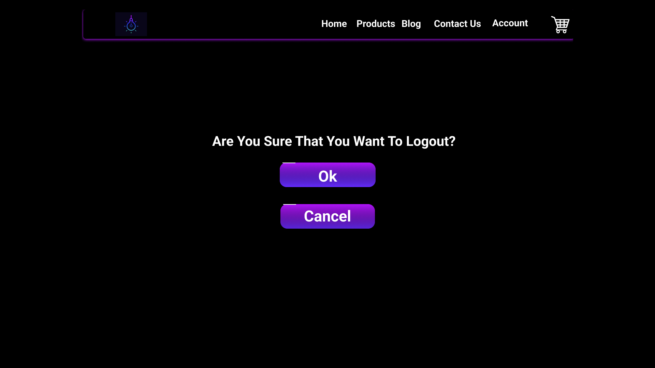

*Figure 54 - Asking the user if they want to log out of their account.*

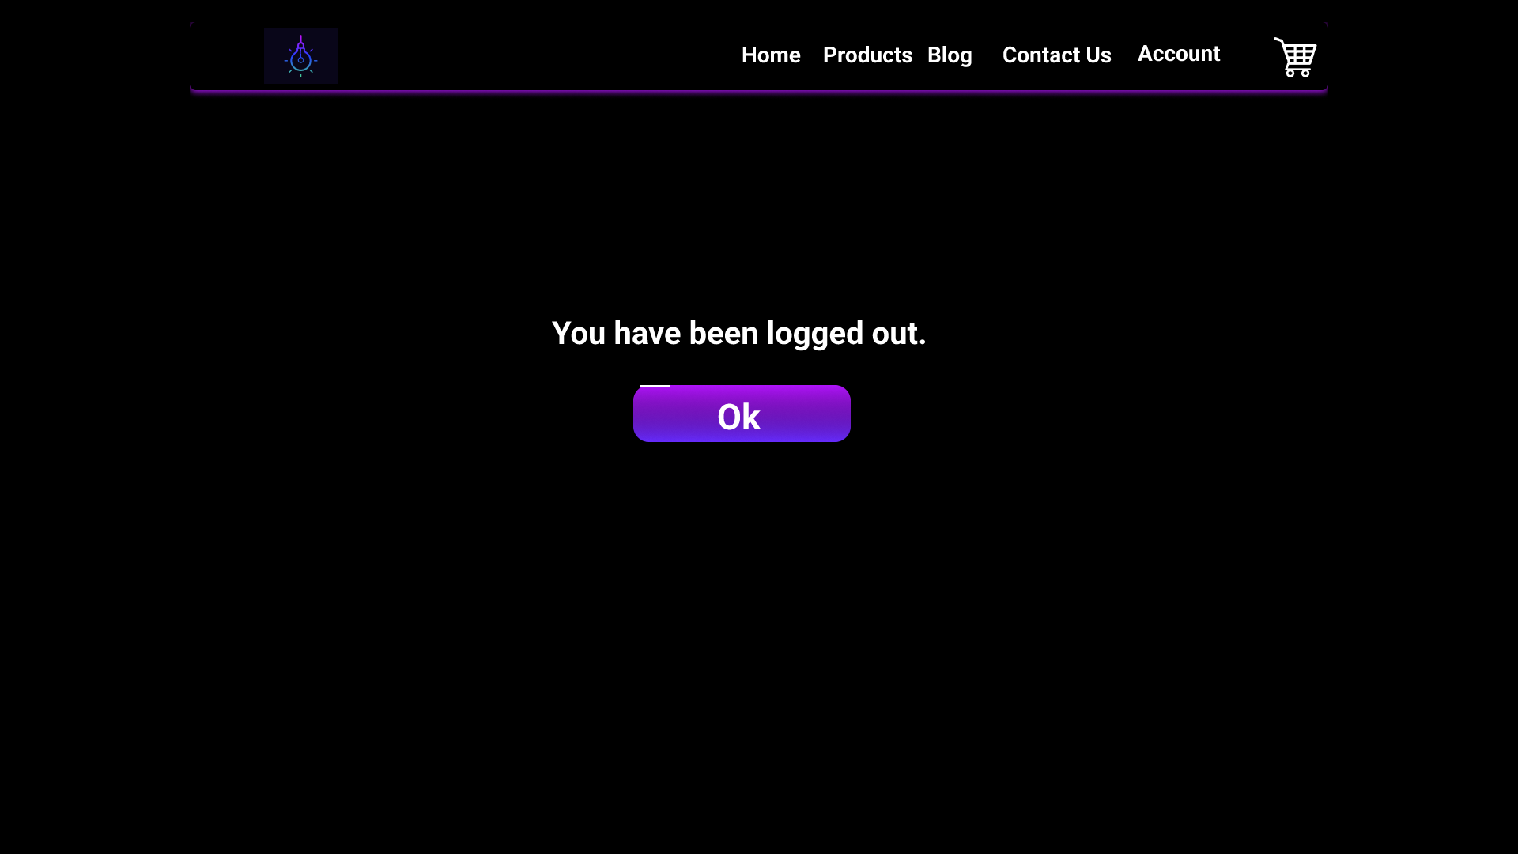

*Figure 55 - Notifying the user that they have been logged out.*



*Figure 56 - redirecting the user to the home page after logging out of their account.*

### Mobile view of the website:

<https://www.figma.com/proto/FV4Fr3QZqHhorygER0PKpR/Lights-Out-Prototype-2?type=design&node-id=22-2936&scaling=min-zoom&page-id=115%3A745&starting-point-node-id=22%3A2936>

# 2.3 Designing

## a. Class Responsibility Collaborator (CRC) cards

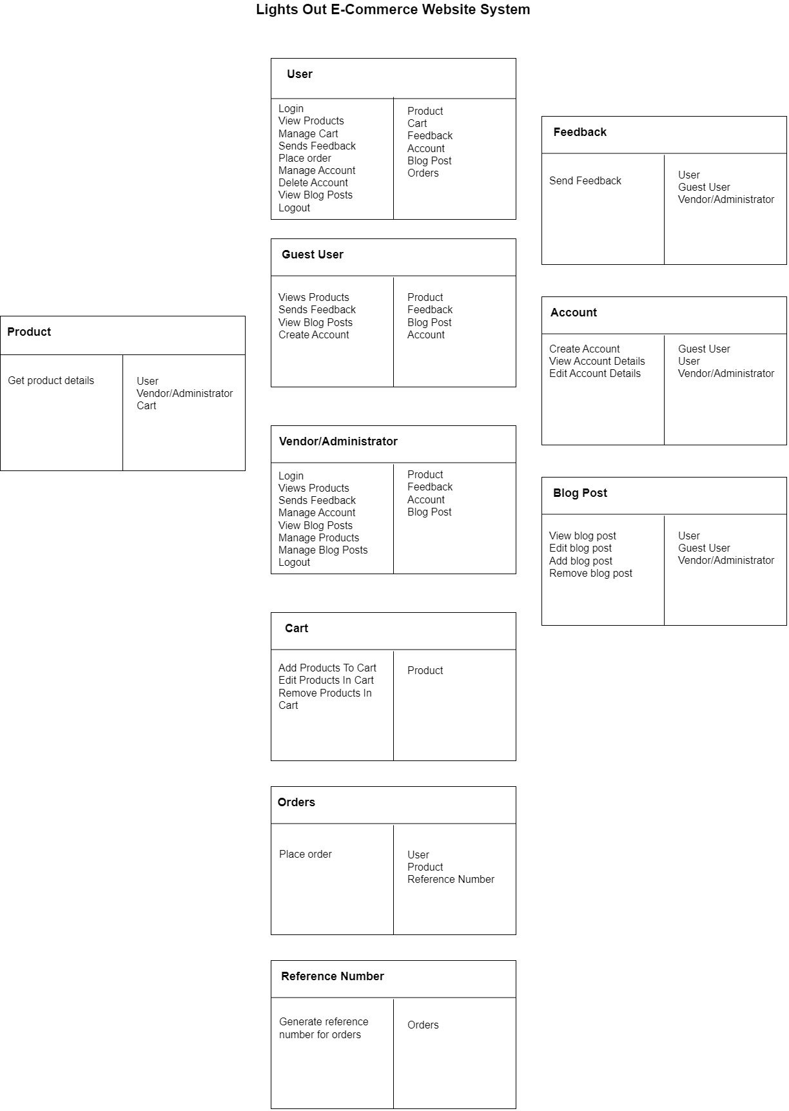

*Figure 57 - Class Responsibility Cards (CRC)* *for The Lights Out E-Commerce Website System.*

## b. Enhanced Entity Relationship Diagram (EERD)

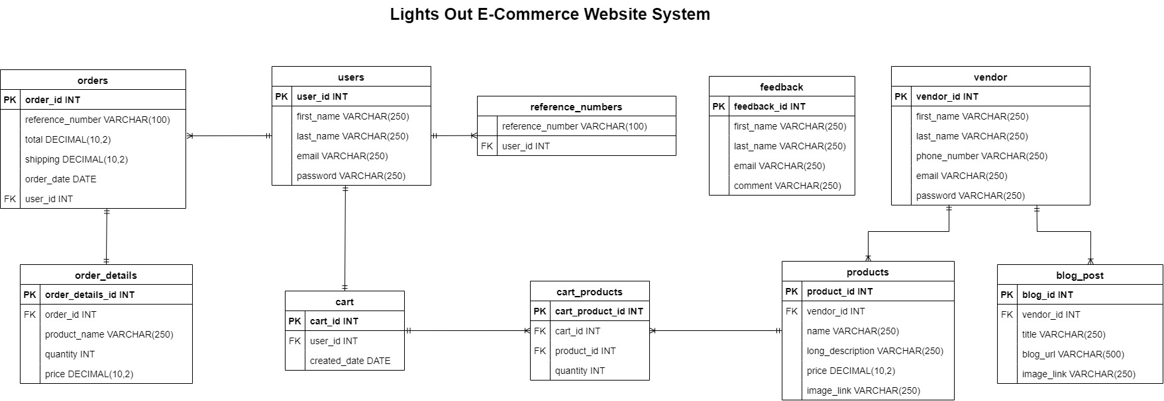

*Figure 58 - Enhanced Entity Relationship Diagram (EERD) for The Lights Out E-Commerce Website System.*

## c. Context Diagram

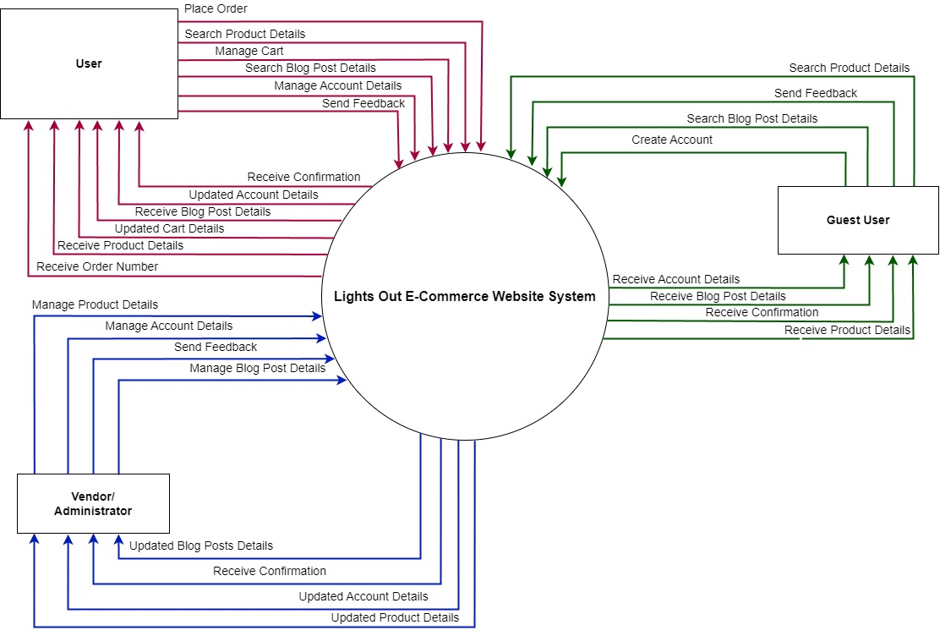

*Figure 59 - Context Diagram for The Lights Out E-Commerce Website System.*

## d. Data Flow Diagram (DFD)

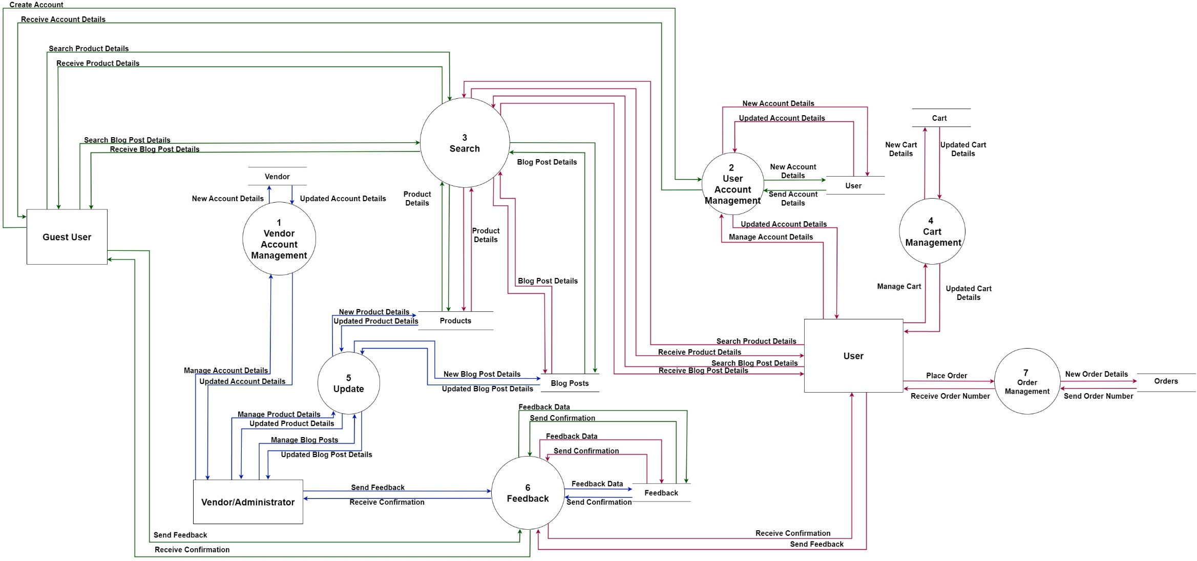

*Figure 60 – Data Flow Diagram for The Lights Out E-Commerce Website System.*

## e. Use Case Diagram

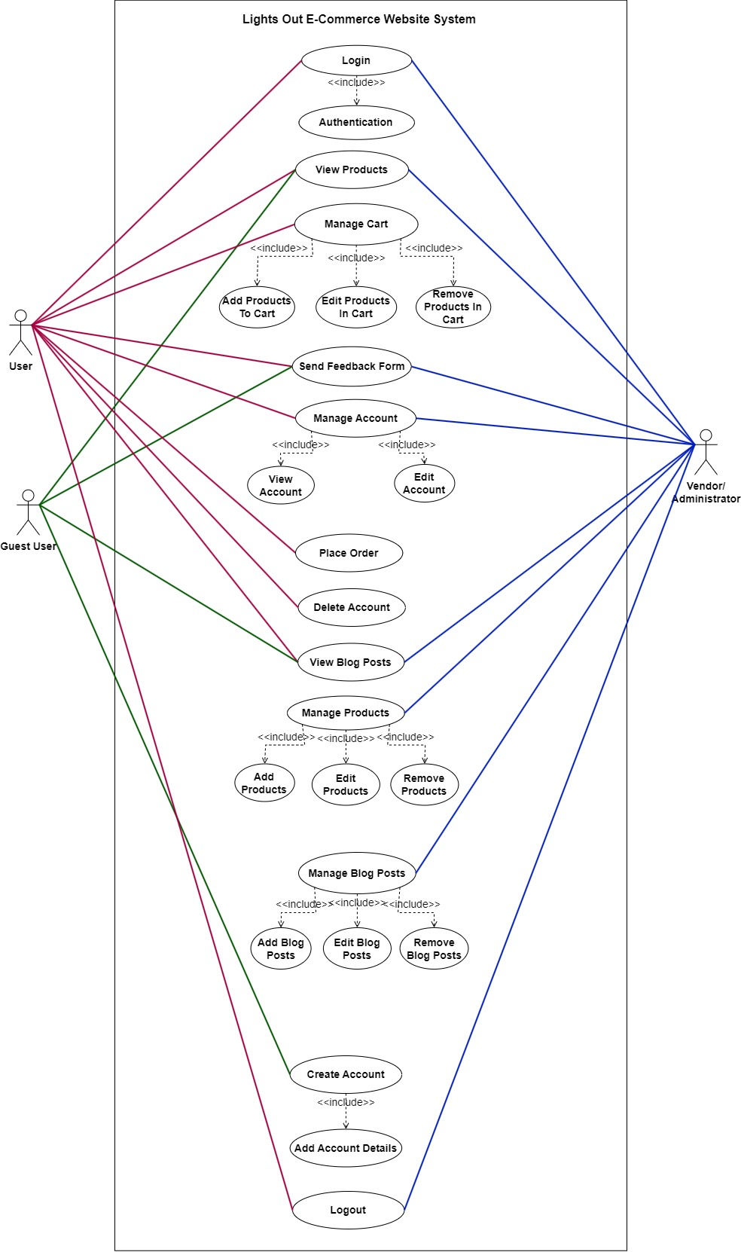

*Figure 61 – Use Case Diagram for The Lights Out E-Commerce Website System.*

## f. Database Design

The EERD diagram that was created in MySQL workbench is show below:

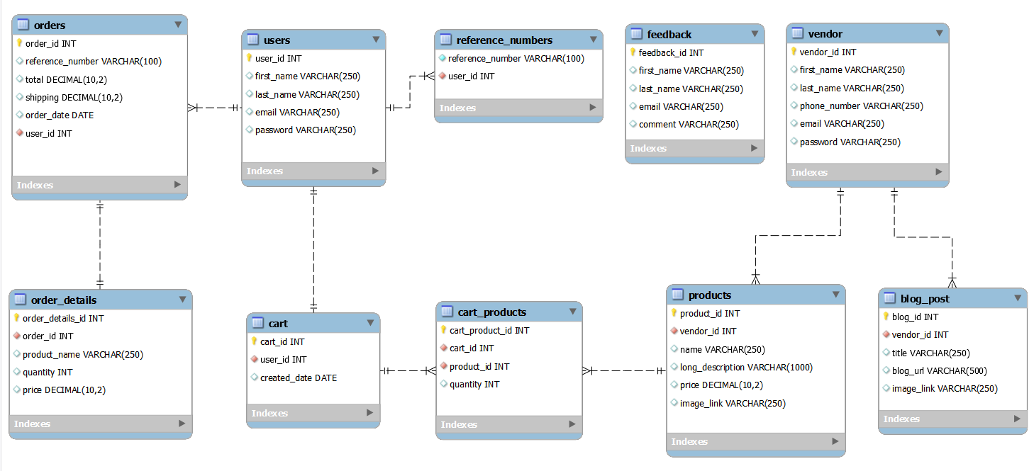

*Figure 62 - Enhanced Entity Relationship Diagram (EERD) for The Lights Out E-Commerce Website System.*

The forward engineering script to create the database is shown below:

-- MySQL Workbench Forward Engineering

SET @OLD_UNIQUE_CHECKS=@@UNIQUE_CHECKS, UNIQUE_CHECKS=0;

SET @OLD_FOREIGN_KEY_CHECKS=@@FOREIGN_KEY_CHECKS, FOREIGN_KEY_CHECKS=0;

SET @OLD_SQL_MODE=@@SQL_MODE, SQL_MODE='ONLY_FULL_GROUP_BY,STRICT_TRANS_TABLES,NO_ZERO_IN_DATE,NO_ZERO_DATE,ERROR_FOR_DIVISION_BY_ZERO,NO_ENGINE_SUBSTITUTION';

-- -----------------------------------------------------

-- Schema lights_out

-- -----------------------------------------------------

-- -----------------------------------------------------

-- Schema lights_out

-- -----------------------------------------------------

CREATE SCHEMA IF NOT EXISTS `lights_out` DEFAULT CHARACTER SET utf8 ;

USE `lights_out` ;

-- -----------------------------------------------------

-- Table `lights_out`.`users`

-- -----------------------------------------------------

CREATE TABLE IF NOT EXISTS `lights_out`.`users` (

  `user_id` INT NOT NULL AUTO_INCREMENT,

  `first_name` VARCHAR(250) NULL,

  `last_name` VARCHAR(250) NULL,

  `email` VARCHAR(250) NULL,

  `password` VARCHAR(250) NULL,

  PRIMARY KEY (`user_id`),

  UNIQUE INDEX `email_UNIQUE` (`email` ASC) VISIBLE)

ENGINE = InnoDB;

-- -----------------------------------------------------

-- Table `lights_out`.`cart`

-- -----------------------------------------------------

CREATE TABLE IF NOT EXISTS `lights_out`.`cart` (

  `cart_id` INT NOT NULL AUTO_INCREMENT,

  `user_id` INT NOT NULL,

  `created_date` DATE NULL,

  PRIMARY KEY (`cart_id`),

  INDEX `fk_cart_users_idx` (`user_id` ASC) VISIBLE,

  CONSTRAINT `fk_cart_users`

    FOREIGN KEY (`user_id`)

    REFERENCES `lights_out`.`users` (`user_id`)

    ON DELETE CASCADE

    ON UPDATE NO ACTION)

ENGINE = InnoDB;

-- -----------------------------------------------------

-- Table `lights_out`.`vendor`

-- -----------------------------------------------------

CREATE TABLE IF NOT EXISTS `lights_out`.`vendor` (

  `vendor_id` INT NOT NULL AUTO_INCREMENT,

  `first_name` VARCHAR(250) NULL,

  `last_name` VARCHAR(250) NULL,

  `phone_number` VARCHAR(250) NULL,

  `email` VARCHAR(250) NULL,

  `password` VARCHAR(250) NULL,

  PRIMARY KEY (`vendor_id`),

  UNIQUE INDEX `email_UNIQUE` (`email` ASC) VISIBLE)

ENGINE = InnoDB;

-- -----------------------------------------------------

-- Table `lights_out`.`products`

-- -----------------------------------------------------

CREATE TABLE IF NOT EXISTS `lights_out`.`products` (

  `product_id` INT NOT NULL AUTO_INCREMENT,

  `vendor_id` INT NOT NULL,

  `name` VARCHAR(250) NULL,

  `long_description` VARCHAR(1000) NULL,

  `price` DECIMAL(10,2) NULL,

  `image_link` VARCHAR(250) NULL,

  PRIMARY KEY (`product_id`),

  INDEX `fk_products_vendor1_idx` (`vendor_id` ASC) VISIBLE,

  CONSTRAINT `fk_products_vendor1`

    FOREIGN KEY (`vendor_id`)

    REFERENCES `lights_out`.`vendor` (`vendor_id`)

    ON DELETE CASCADE

    ON UPDATE NO ACTION)

ENGINE = InnoDB;

-- -----------------------------------------------------

-- Table `lights_out`.`cart_products`

-- -----------------------------------------------------

CREATE TABLE IF NOT EXISTS `lights_out`.`cart_products` (

  `cart_product_id` INT NOT NULL AUTO_INCREMENT,

  `cart_id` INT NOT NULL,

  `product_id` INT NOT NULL,

  `quantity` INT NULL,

  PRIMARY KEY (`cart_product_id`),

  INDEX `fk_cart_products_cart1_idx` (`cart_id` ASC) VISIBLE,

  INDEX `fk_cart_products_products1_idx` (`product_id` ASC) VISIBLE,

  CONSTRAINT `fk_cart_products_cart1`

    FOREIGN KEY (`cart_id`)

    REFERENCES `lights_out`.`cart` (`cart_id`)

    ON DELETE CASCADE

    ON UPDATE NO ACTION,

  CONSTRAINT `fk_cart_products_products1`

    FOREIGN KEY (`product_id`)

    REFERENCES `lights_out`.`products` (`product_id`)

    ON DELETE CASCADE

    ON UPDATE NO ACTION)

ENGINE = InnoDB;

-- -----------------------------------------------------

-- Table `lights_out`.`blog_post`

-- -----------------------------------------------------

CREATE TABLE IF NOT EXISTS `lights_out`.`blog_post` (

  `blog_id` INT NOT NULL AUTO_INCREMENT,

  `vendor_id` INT NOT NULL,

  `title` VARCHAR(250) NULL,

  `blog_url` VARCHAR(500) NULL,

  `image_link` VARCHAR(250) NULL,

  PRIMARY KEY (`blog_id`),

  INDEX `fk_blog_post_vendor1_idx` (`vendor_id` ASC) VISIBLE,

  CONSTRAINT `fk_blog_post_vendor1`

    FOREIGN KEY (`vendor_id`)

    REFERENCES `lights_out`.`vendor` (`vendor_id`)

    ON DELETE CASCADE

    ON UPDATE NO ACTION)

ENGINE = InnoDB;

-- -----------------------------------------------------

-- Table `lights_out`.`feedback`

-- -----------------------------------------------------

CREATE TABLE IF NOT EXISTS `lights_out`.`feedback` (

  `feedback_id` INT NOT NULL AUTO_INCREMENT,

  `first_name` VARCHAR(250) NULL,

  `last_name` VARCHAR(250) NULL,

  `email` VARCHAR(250) NULL,

  `comment` VARCHAR(250) NULL,

  PRIMARY KEY (`feedback_id`),

  UNIQUE INDEX `email_UNIQUE` (`email` ASC) VISIBLE)

ENGINE = InnoDB;

-- -----------------------------------------------------

-- Table `lights_out`.`orders`

-- -----------------------------------------------------

CREATE TABLE IF NOT EXISTS `lights_out`.`orders` (

  `order_id` INT NOT NULL AUTO_INCREMENT,

  `reference_number` VARCHAR(100) NULL,

  `total` DECIMAL(10,2) NULL,

  `shipping` DECIMAL(10,2) NULL,

  `order_date` DATE NULL,

  `user_id` INT NOT NULL,

  PRIMARY KEY (`order_id`),

  INDEX `fk_orders_users1_idx` (`user_id` ASC) VISIBLE,

  UNIQUE INDEX `reference_number_UNIQUE` (`reference_number` ASC) VISIBLE,

  CONSTRAINT `fk_orders_users1`

    FOREIGN KEY (`user_id`)

    REFERENCES `lights_out`.`users` (`user_id`)

    ON DELETE CASCADE

    ON UPDATE NO ACTION)

ENGINE = InnoDB;

-- -----------------------------------------------------

-- Table `lights_out`.`order_details`

-- -----------------------------------------------------

CREATE TABLE IF NOT EXISTS `lights_out`.`order_details` (

  `order_details_id` INT NOT NULL AUTO_INCREMENT,

  `order_id` INT NOT NULL,

  `product_name` VARCHAR(250) NULL,

  `quantity` INT NULL,

  `price` DECIMAL(10,2) NULL,

  PRIMARY KEY (`order_details_id`),

  INDEX `fk_order_details_orders1_idx` (`order_id` ASC) VISIBLE,

  CONSTRAINT `fk_order_details_orders1`

    FOREIGN KEY (`order_id`)

    REFERENCES `lights_out`.`orders` (`order_id`)

    ON DELETE CASCADE

    ON UPDATE NO ACTION)

ENGINE = InnoDB;

-- -----------------------------------------------------

-- Table `lights_out`.`reference_numbers`

-- -----------------------------------------------------

CREATE TABLE IF NOT EXISTS `lights_out`.`reference_numbers` (

  `reference_number` VARCHAR(100) NOT NULL,

  `user_id` INT NOT NULL,

  UNIQUE INDEX `reference_number_UNIQUE` (`reference_number` ASC) VISIBLE,

  INDEX `fk_reference_numbers_users1_idx` (`user_id` ASC) VISIBLE,

  CONSTRAINT `fk_reference_numbers_users1`

    FOREIGN KEY (`user_id`)

    REFERENCES `lights_out`.`users` (`user_id`)

    ON DELETE CASCADE

    ON UPDATE NO ACTION)

ENGINE = InnoDB;

SET SQL_MODE=@OLD_SQL_MODE;

SET FOREIGN_KEY_CHECKS=@OLD_FOREIGN_KEY_CHECKS;

SET UNIQUE_CHECKS=@OLD_UNIQUE_CHECKS;

# 2.4 Coding

## Screenshots

### Link To the Hosted Website:

<https://lights-out-south-africa.000webhostapp.com/index.php>

### Guest User View of The Website:

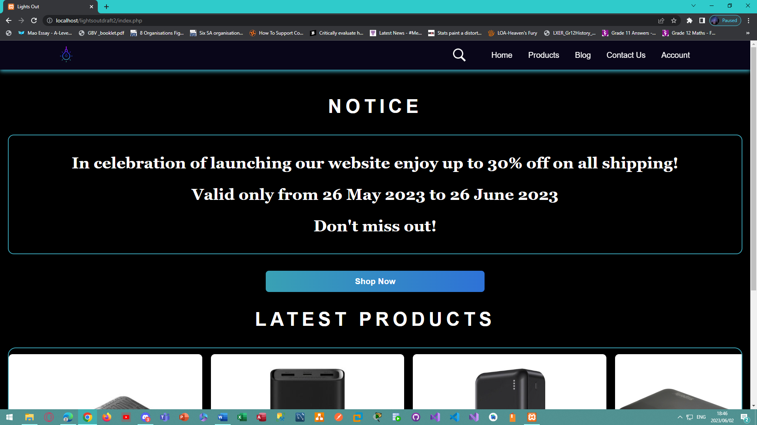

*Figure 63 - Desktop view of the home page for the Lights Out E-Commerce Website.*

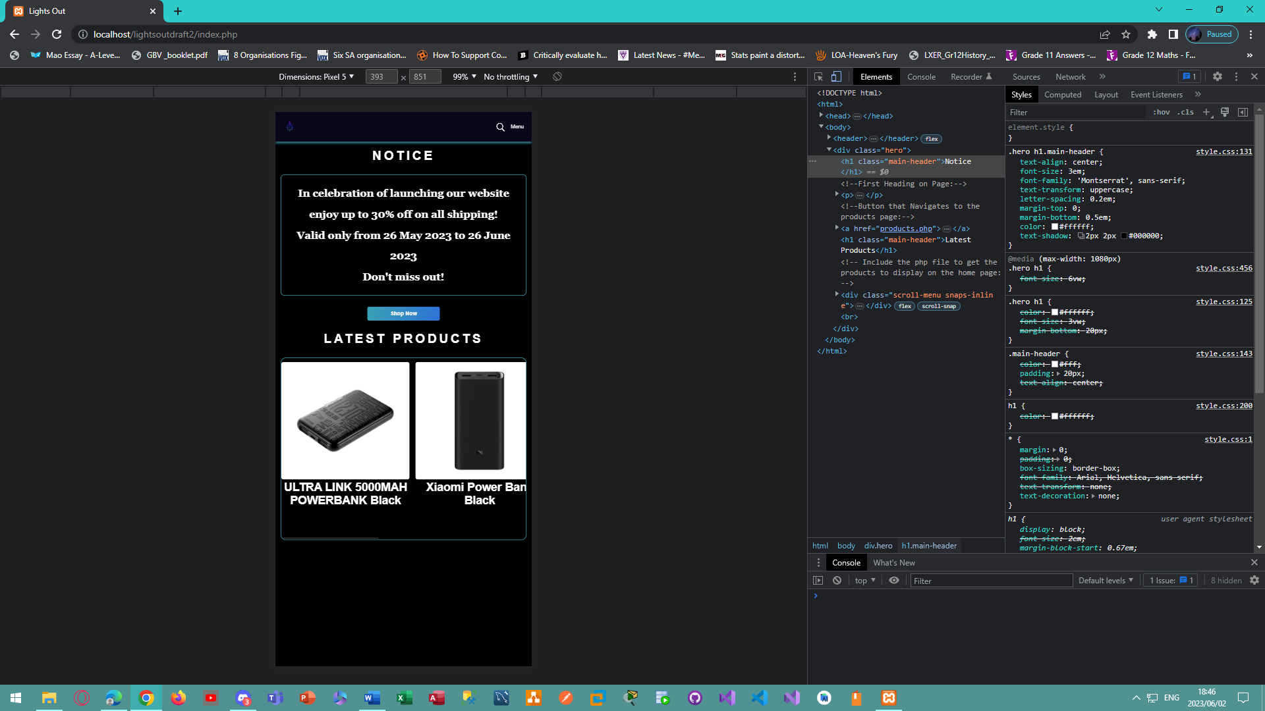

*Figure 64 - Mobile view of the home page for the Lights Out E-Commerce Website.*

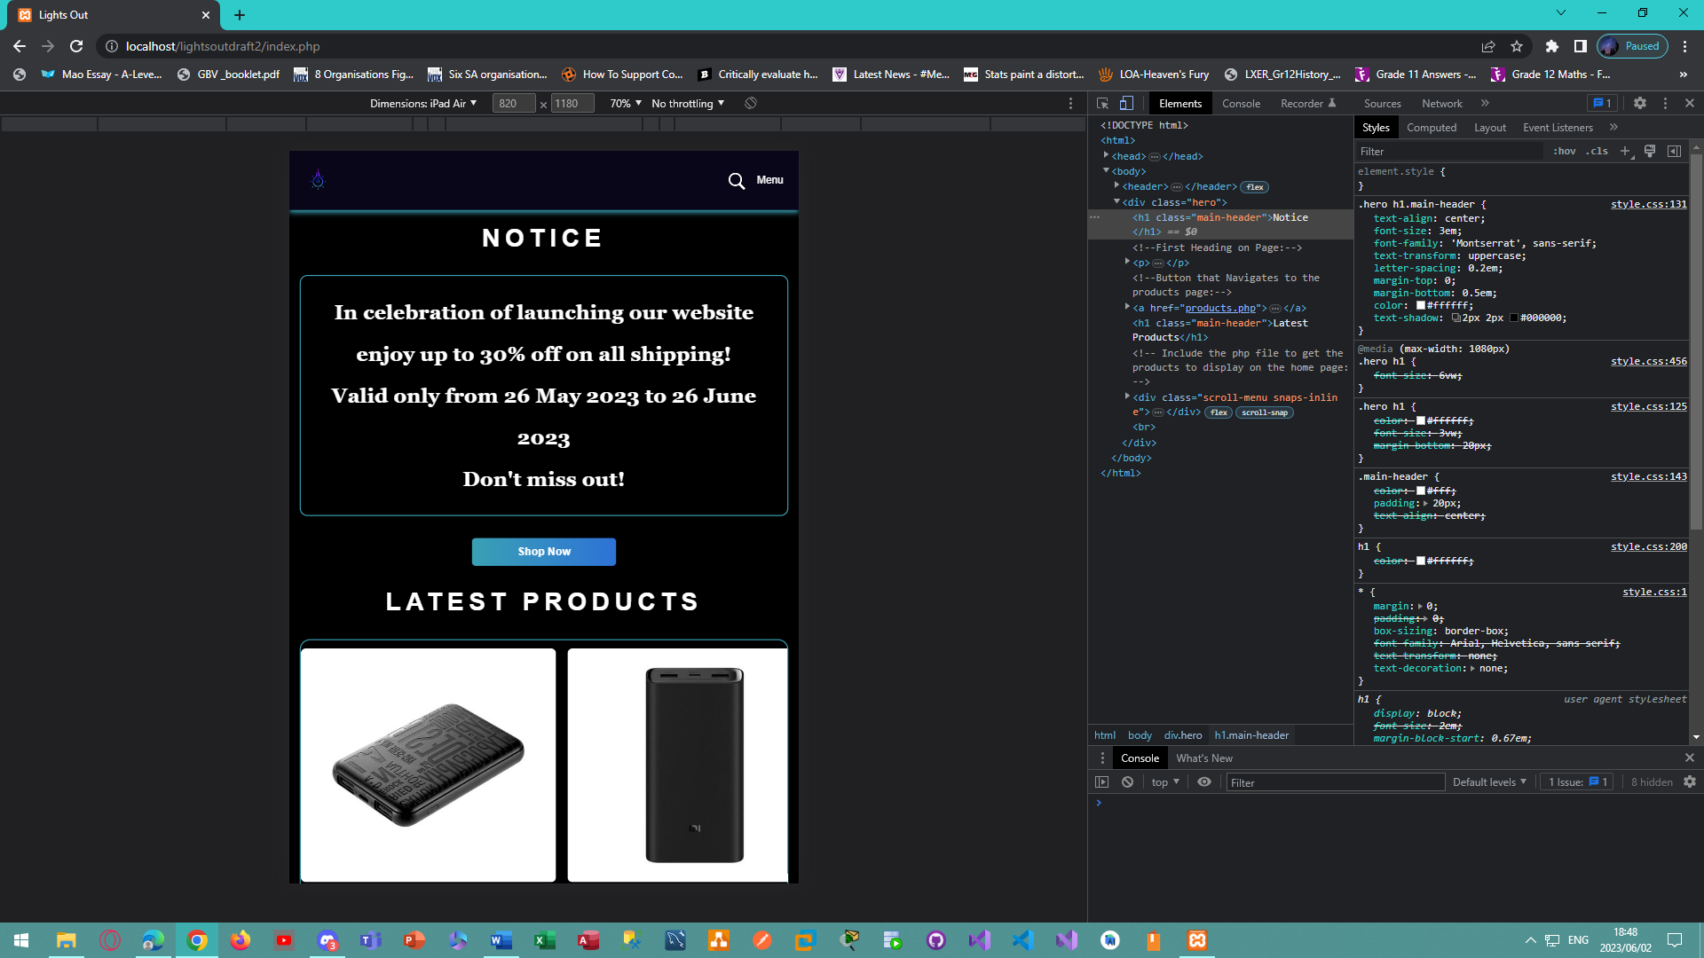

*Figure 65 - Tablet view of the home page for the Lights Out E-Commerce Website.*

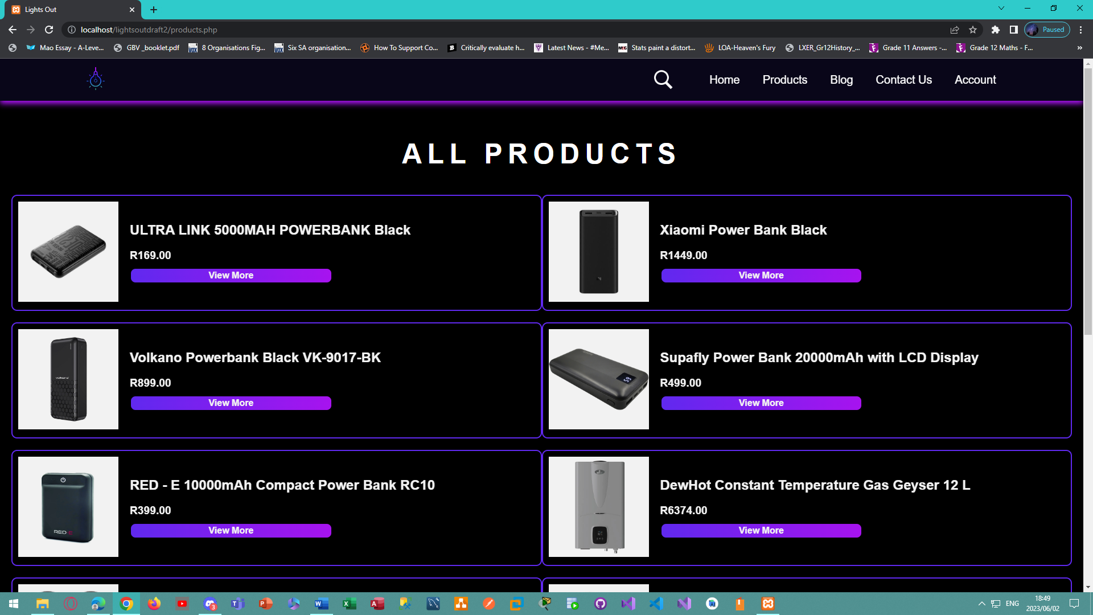

*Figure 66 - Desktop view of the products page for the Lights Out E-Commerce Website.*

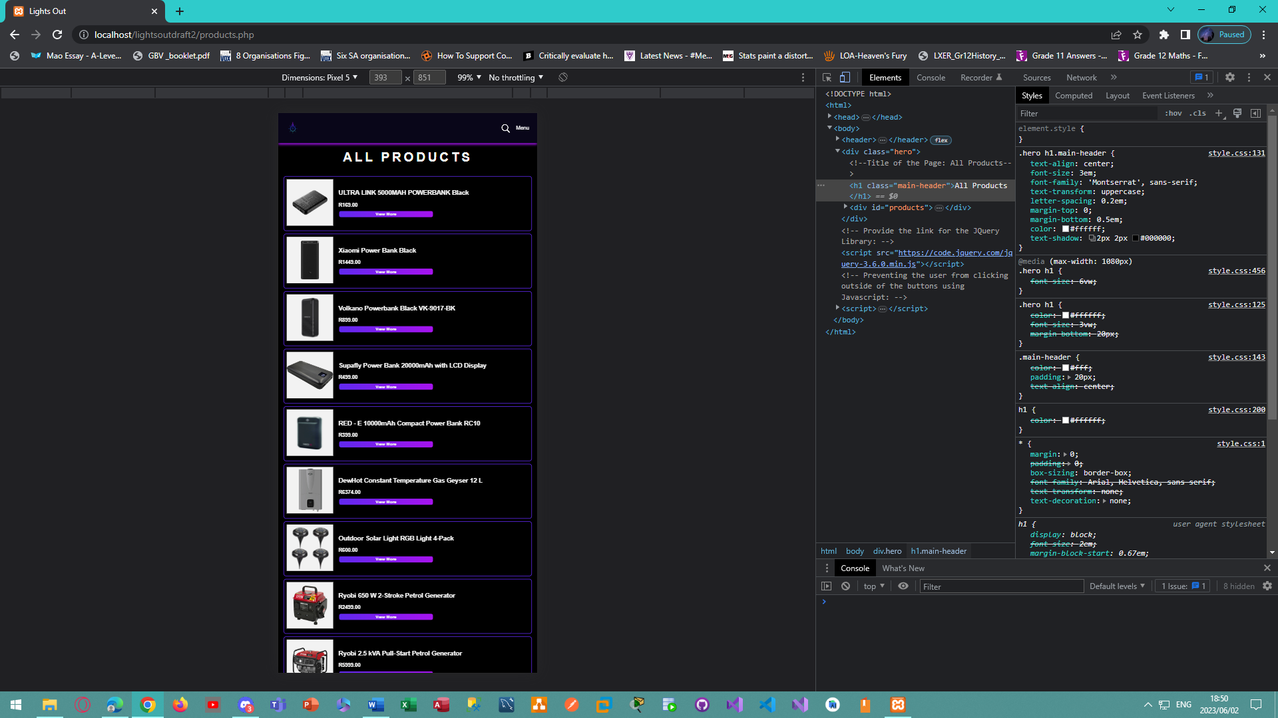

*Figure 67 - Mobile view of the products page for the Lights Out E-Commerce Website.*

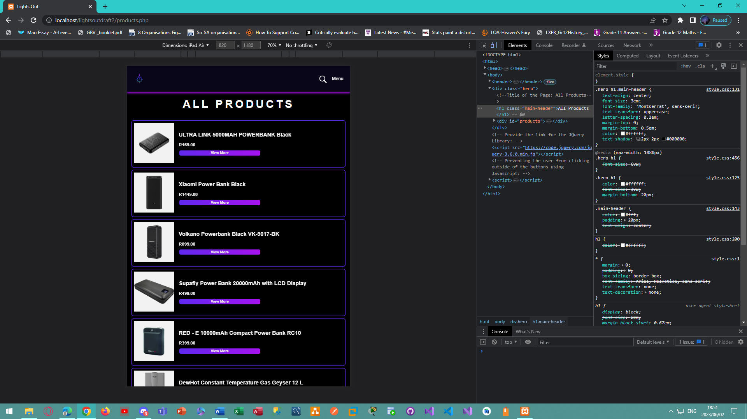

*Figure 68 - Tablet view of the products page for the Lights Out E-Commerce Website.*

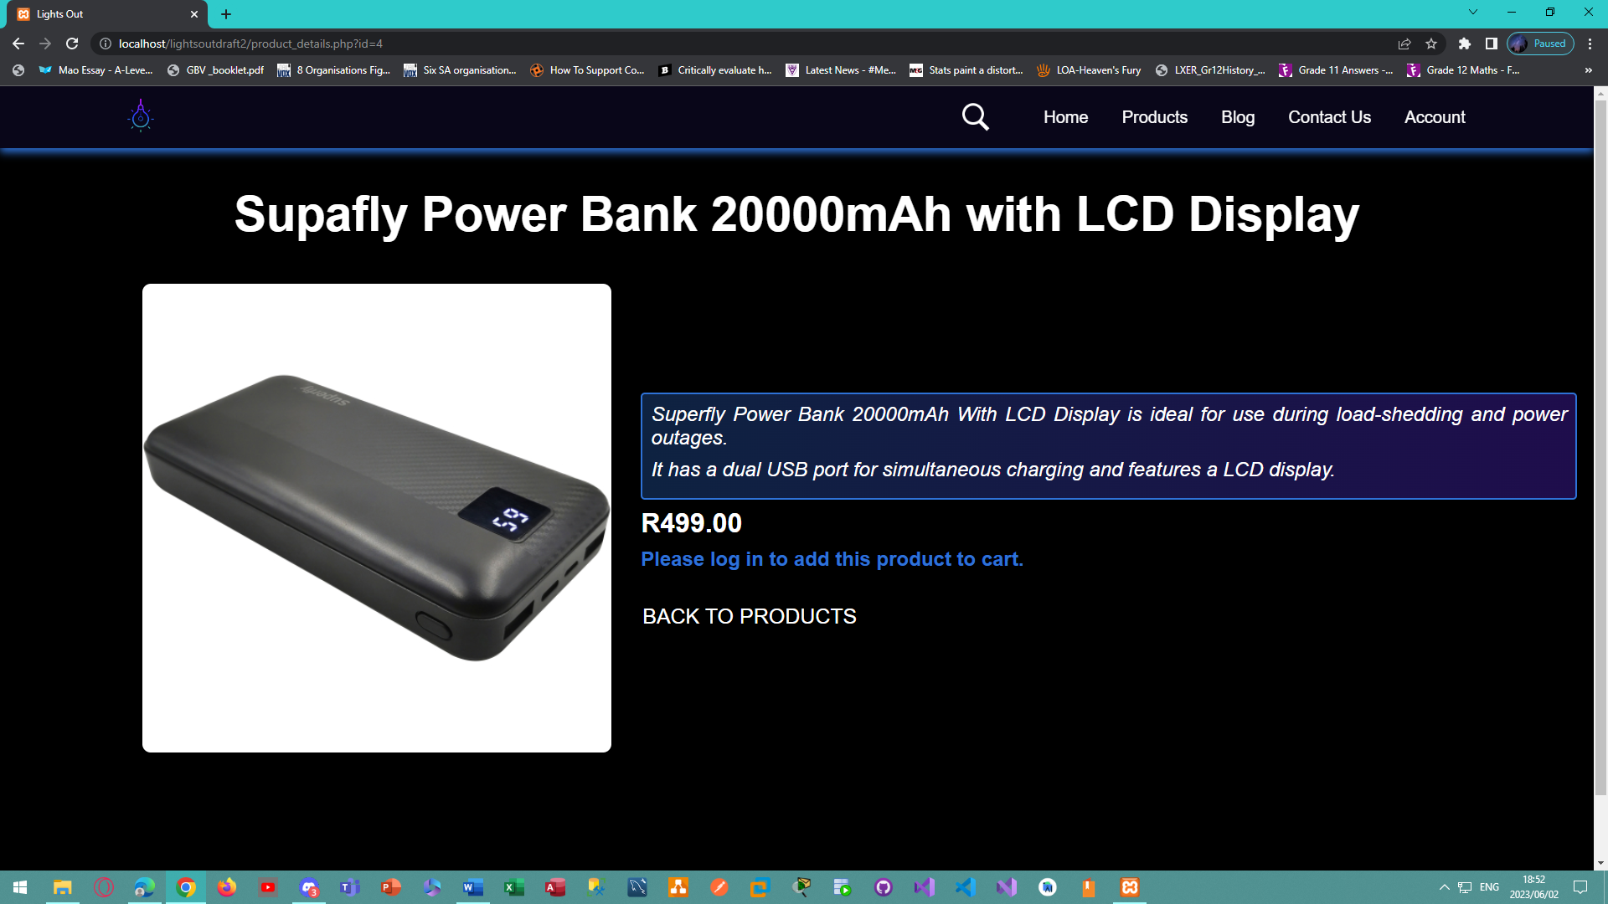

*Figure 69 - Desktop view of the product details page when a user is not logged in for the Lights Out E-Commerce Website.*

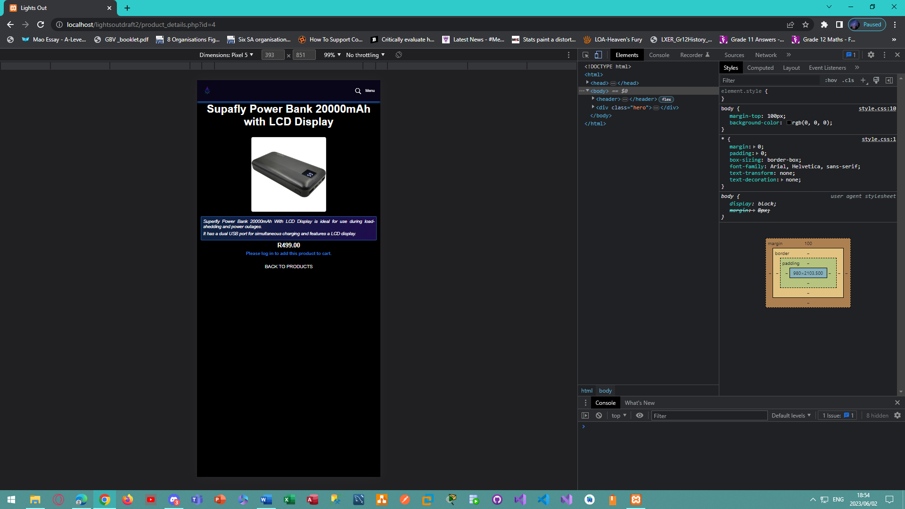

*Figure 70 - Mobile view of the product details page when a user is not logged in for the Lights Out E-Commerce Website.*

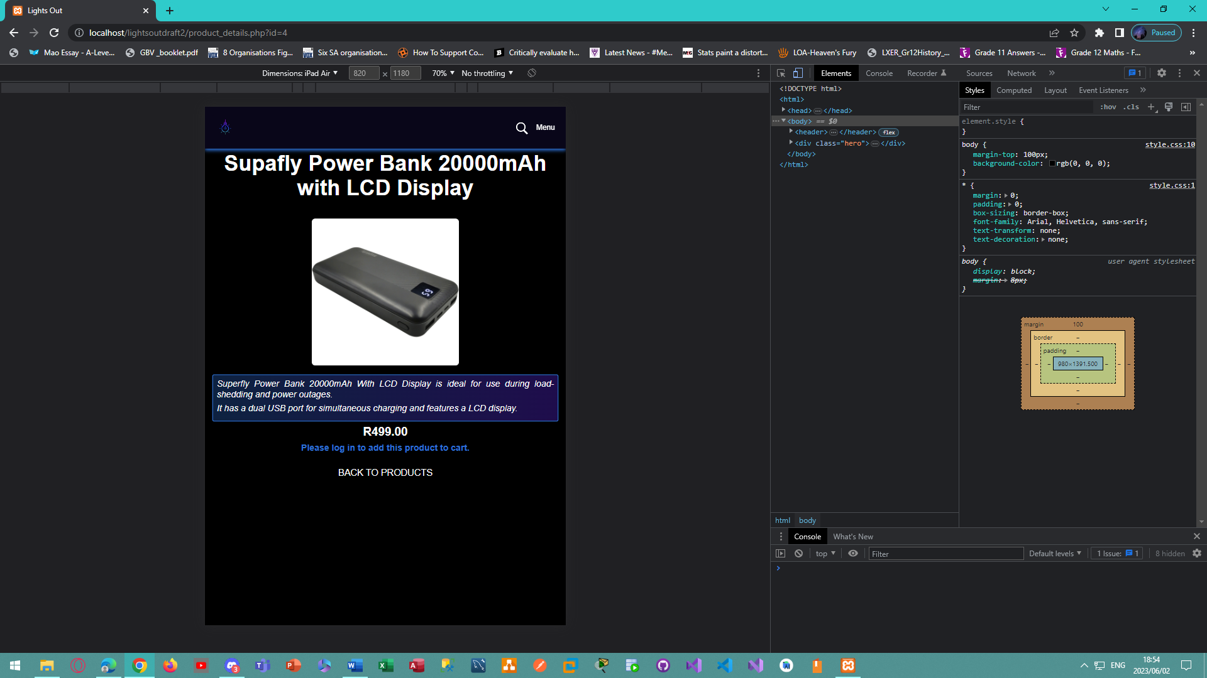

*Figure 71 - Tablet view of the product details page when a user is not logged in for the Lights Out E-Commerce Website.*

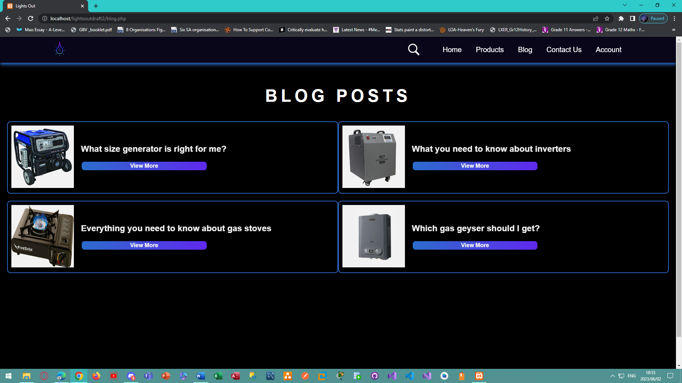

*Figure 72 - Desktop view of the blog posts page for the Lights Out E-Commerce Website.*

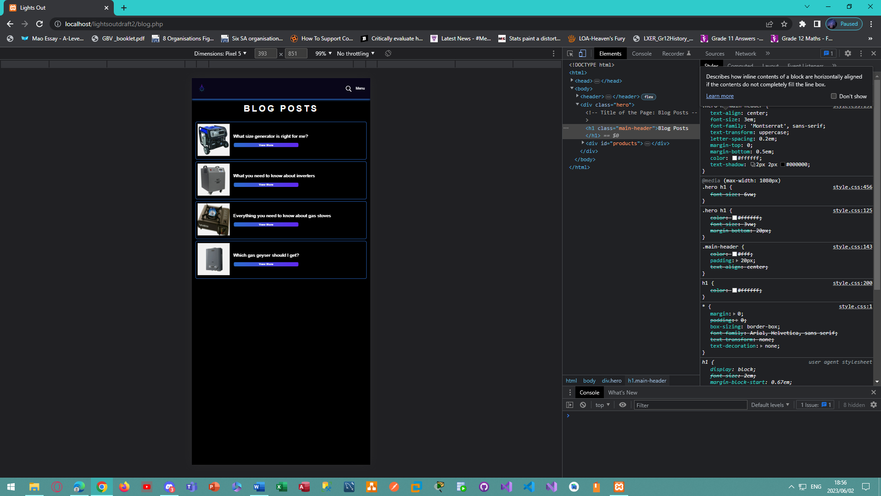

*Figure 73 - Mobile view of the blog posts page for the Lights Out E-Commerce Website.*

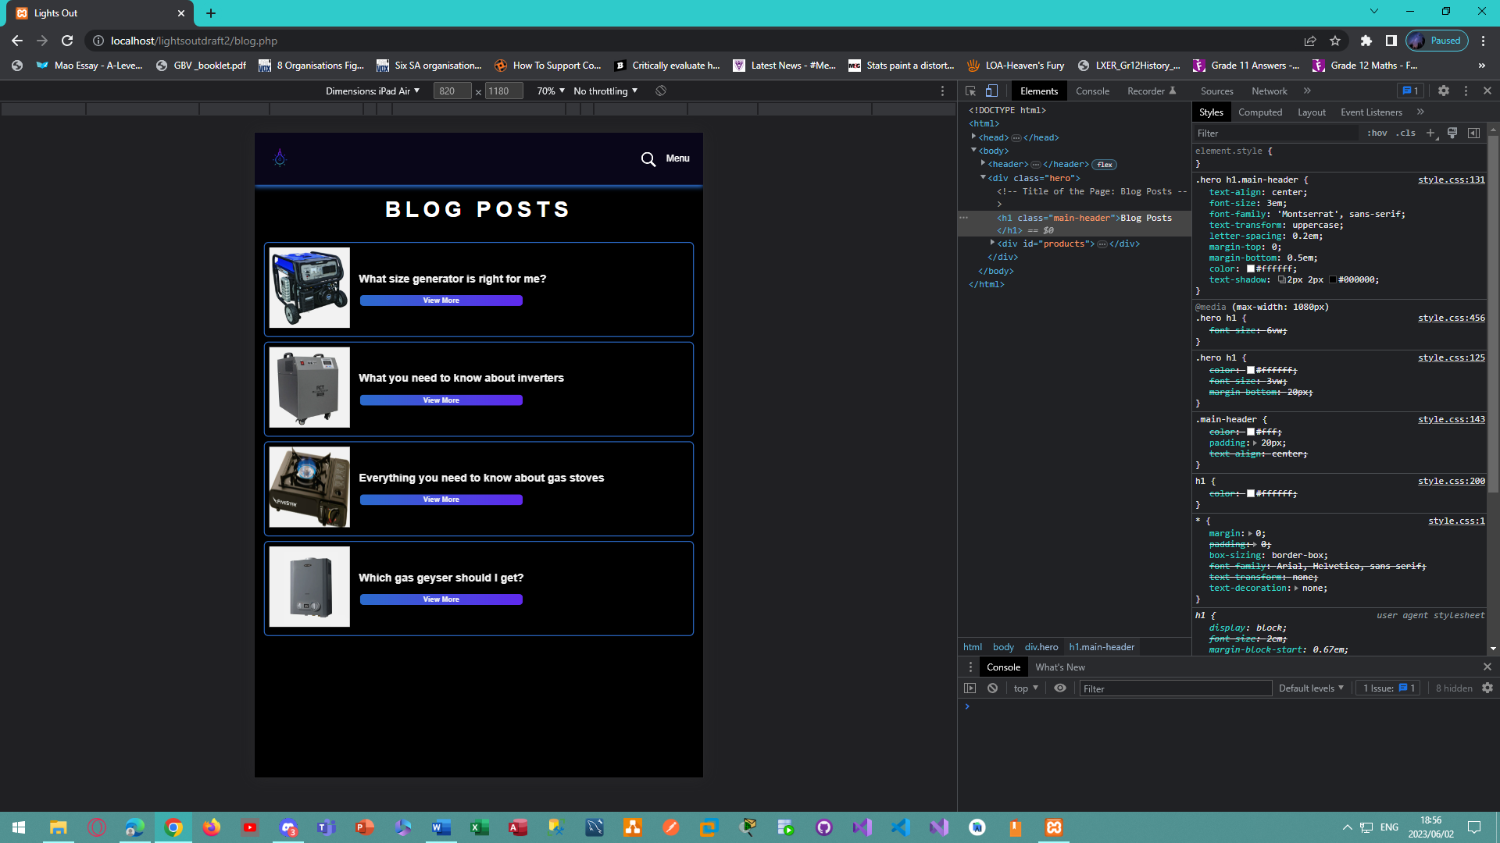

*Figure 74 - Tablet view of the blog posts page for the Lights Out E-Commerce Website.*

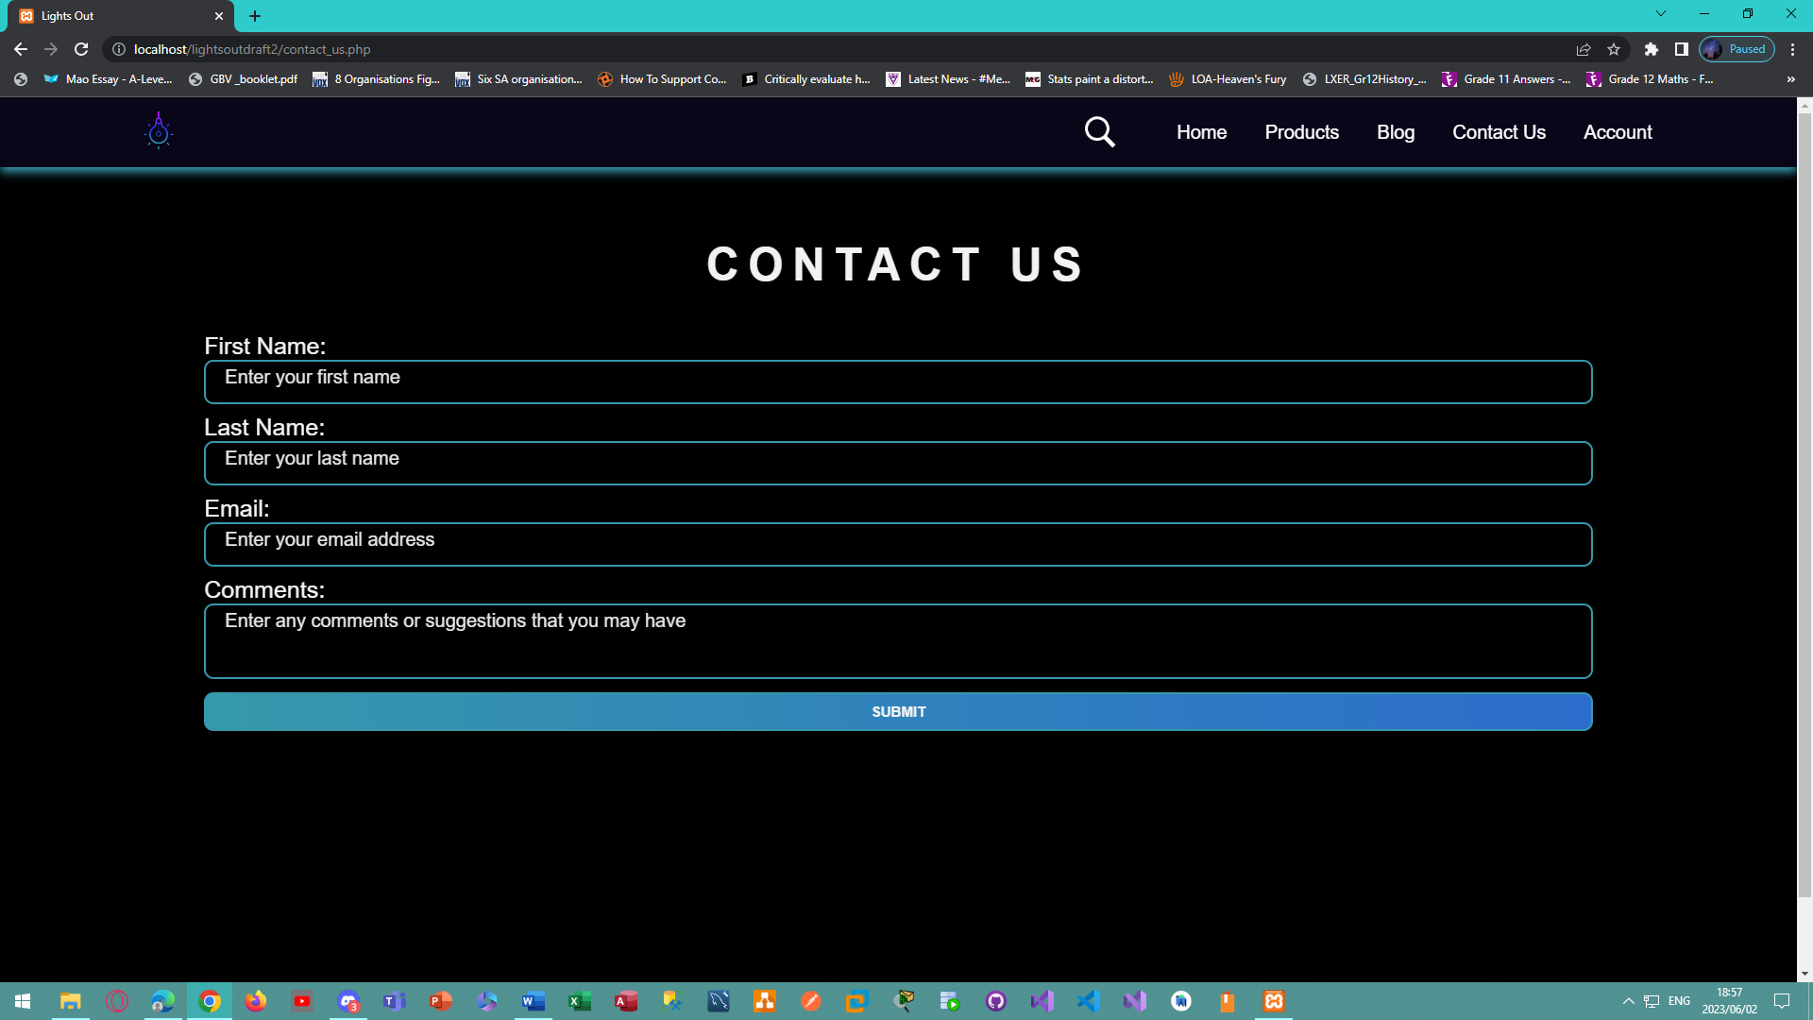

*Figure 75 - Desktop view of the contact us page for the Lights Out E-Commerce Website.*

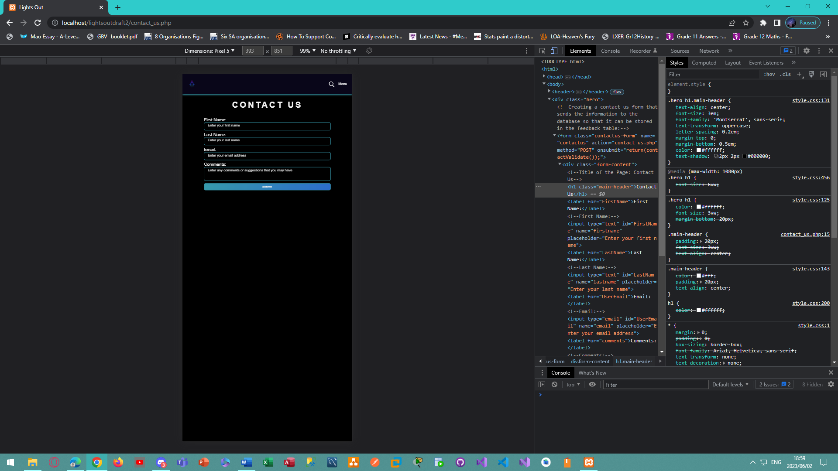

*Figure 76 - Mobile view of the contact us page for the Lights Out E-Commerce Website.*

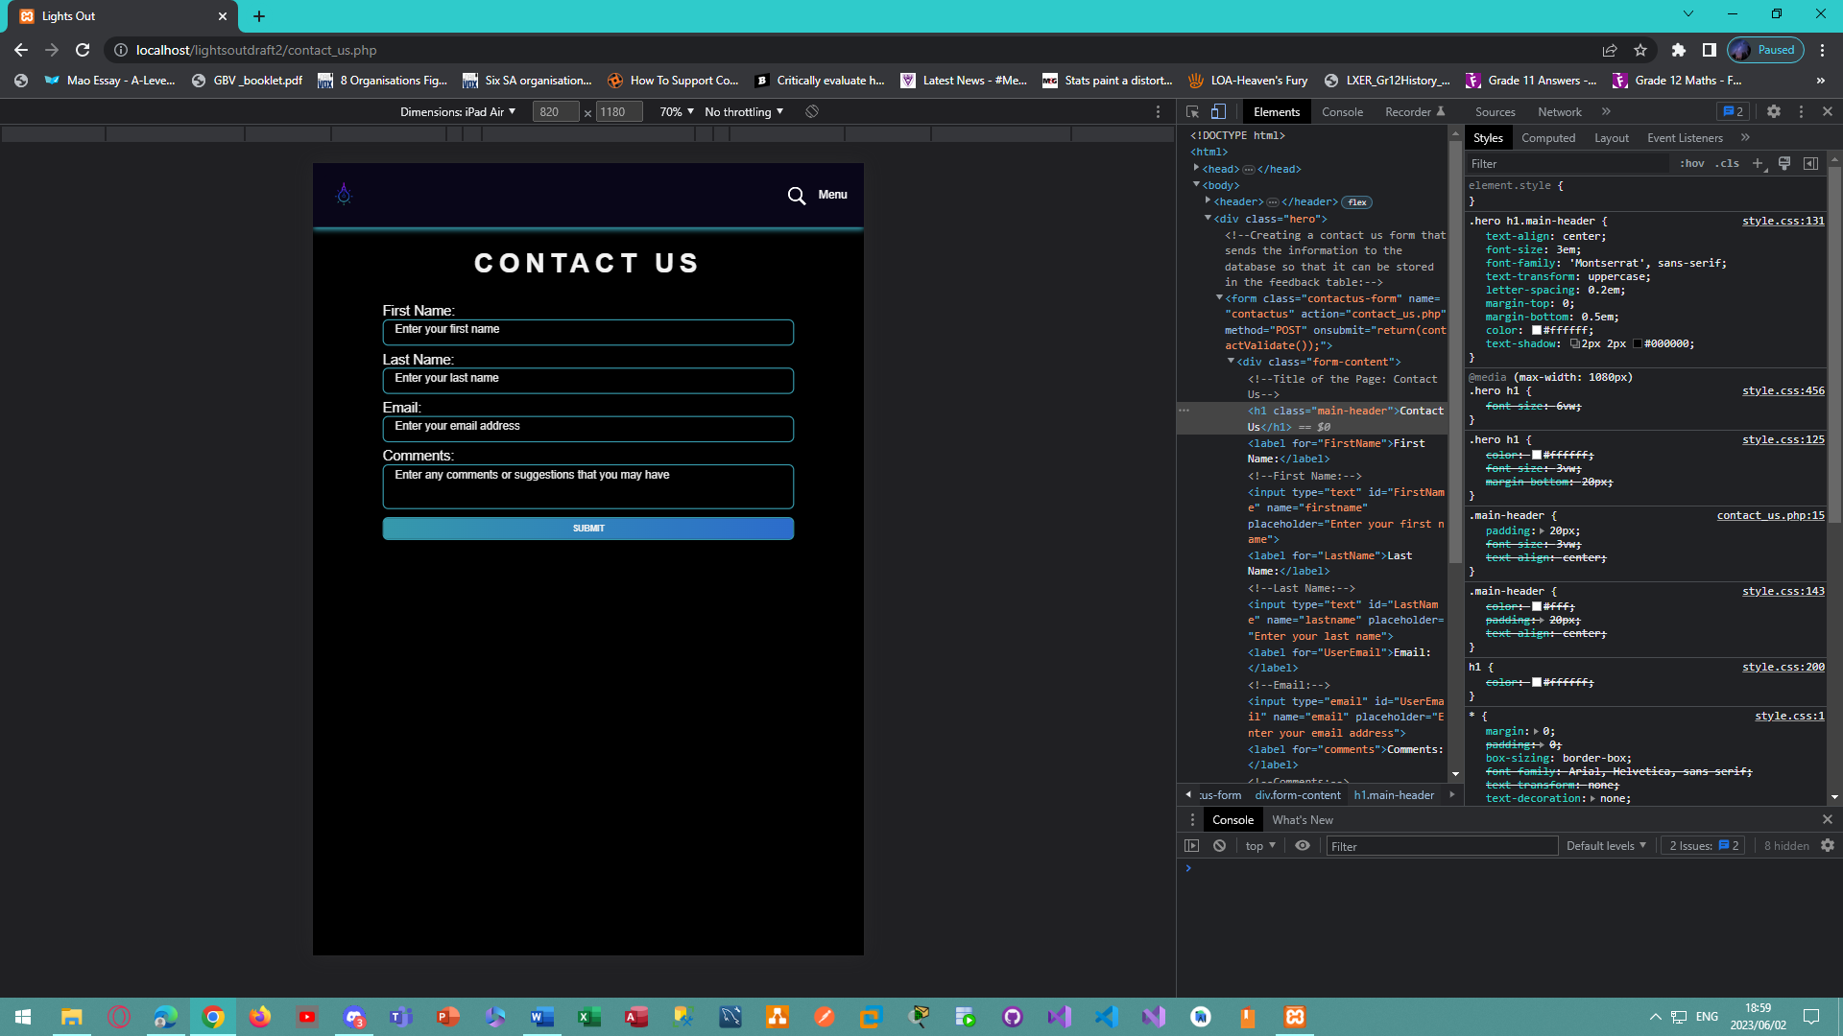

*Figure 77 – Tablet view of the contact us page for the Lights Out E-Commerce Website.*

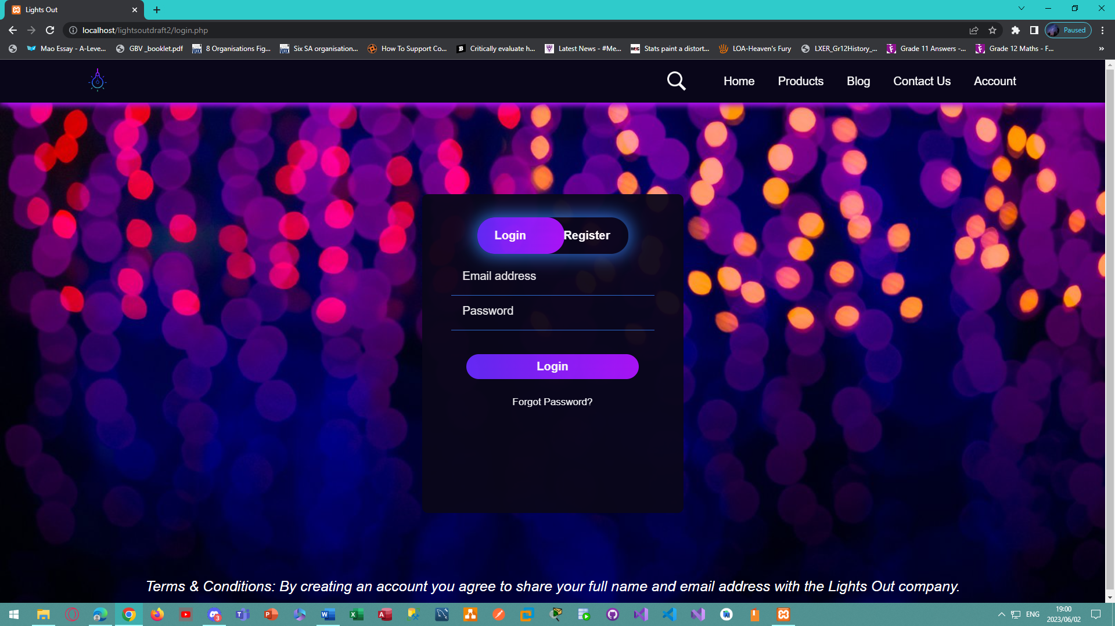

*Figure 78 - Desktop view of the login page for the Lights Out E-Commerce Website.*

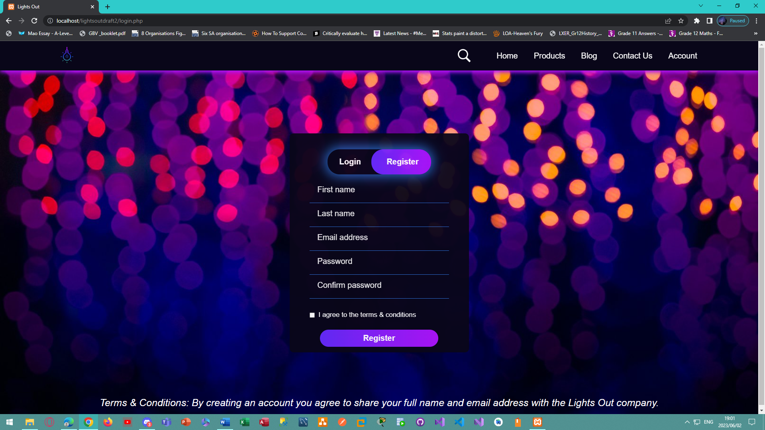

*Figure 79 - Desktop view of the register page for the Lights Out E-Commerce Website.*

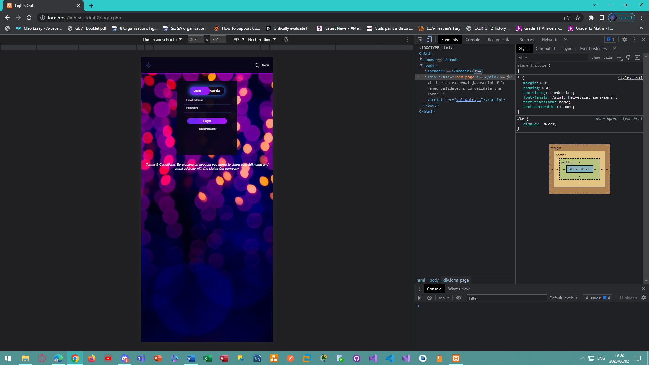

*Figure 80 - Mobile view of the login page for the Lights Out E-Commerce Website.*

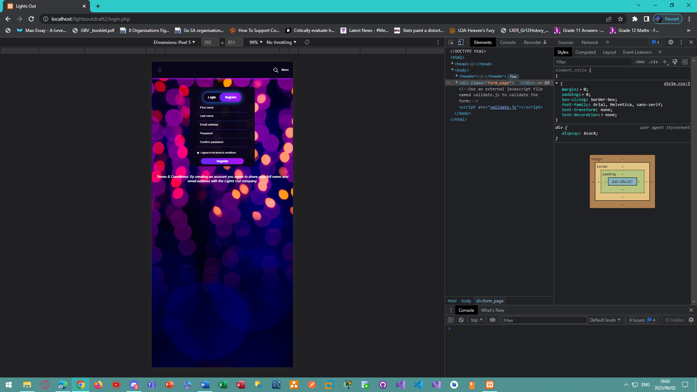

*Figure 81 - Mobile view of the register page for the Lights Out E-Commerce Website.*

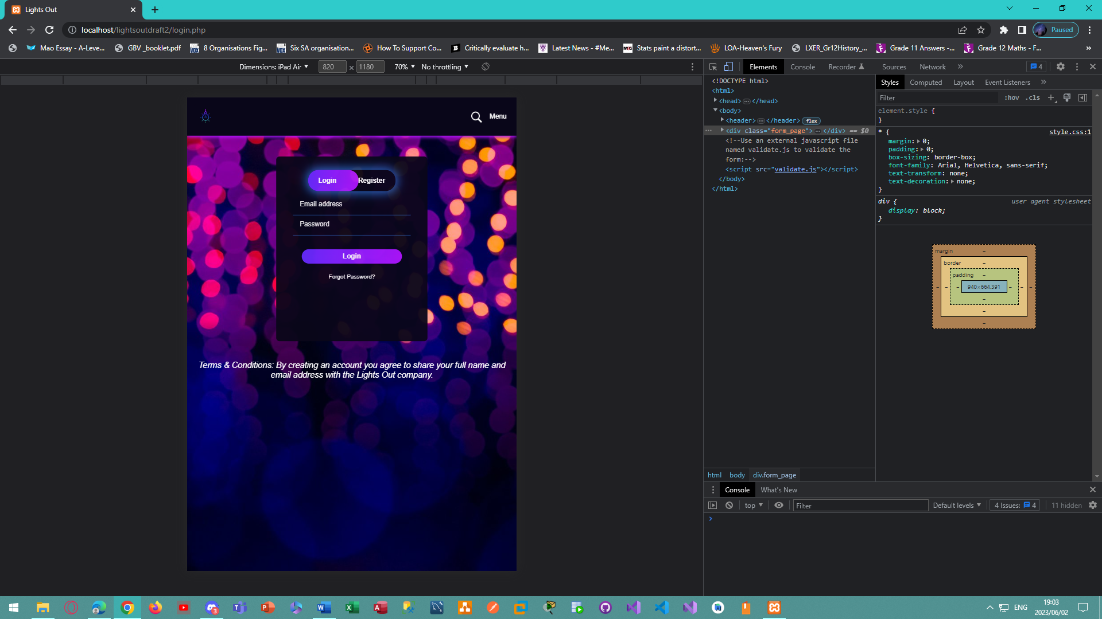

*Figure 82 - Tablet view of the login page for the Lights Out E-Commerce Website.*

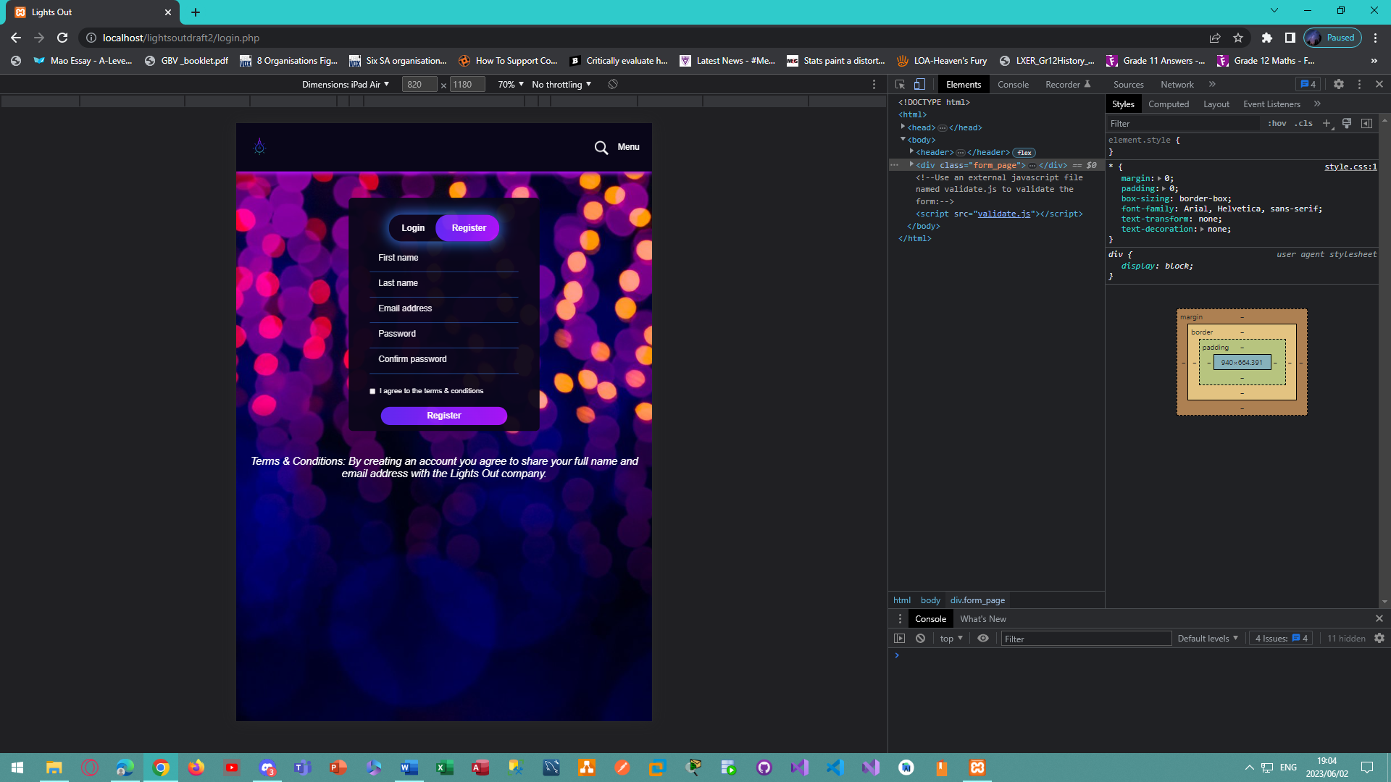

*Figure 83 - Tablet view of the register page for the Lights Out E-Commerce Website.*

### User View of The Website:

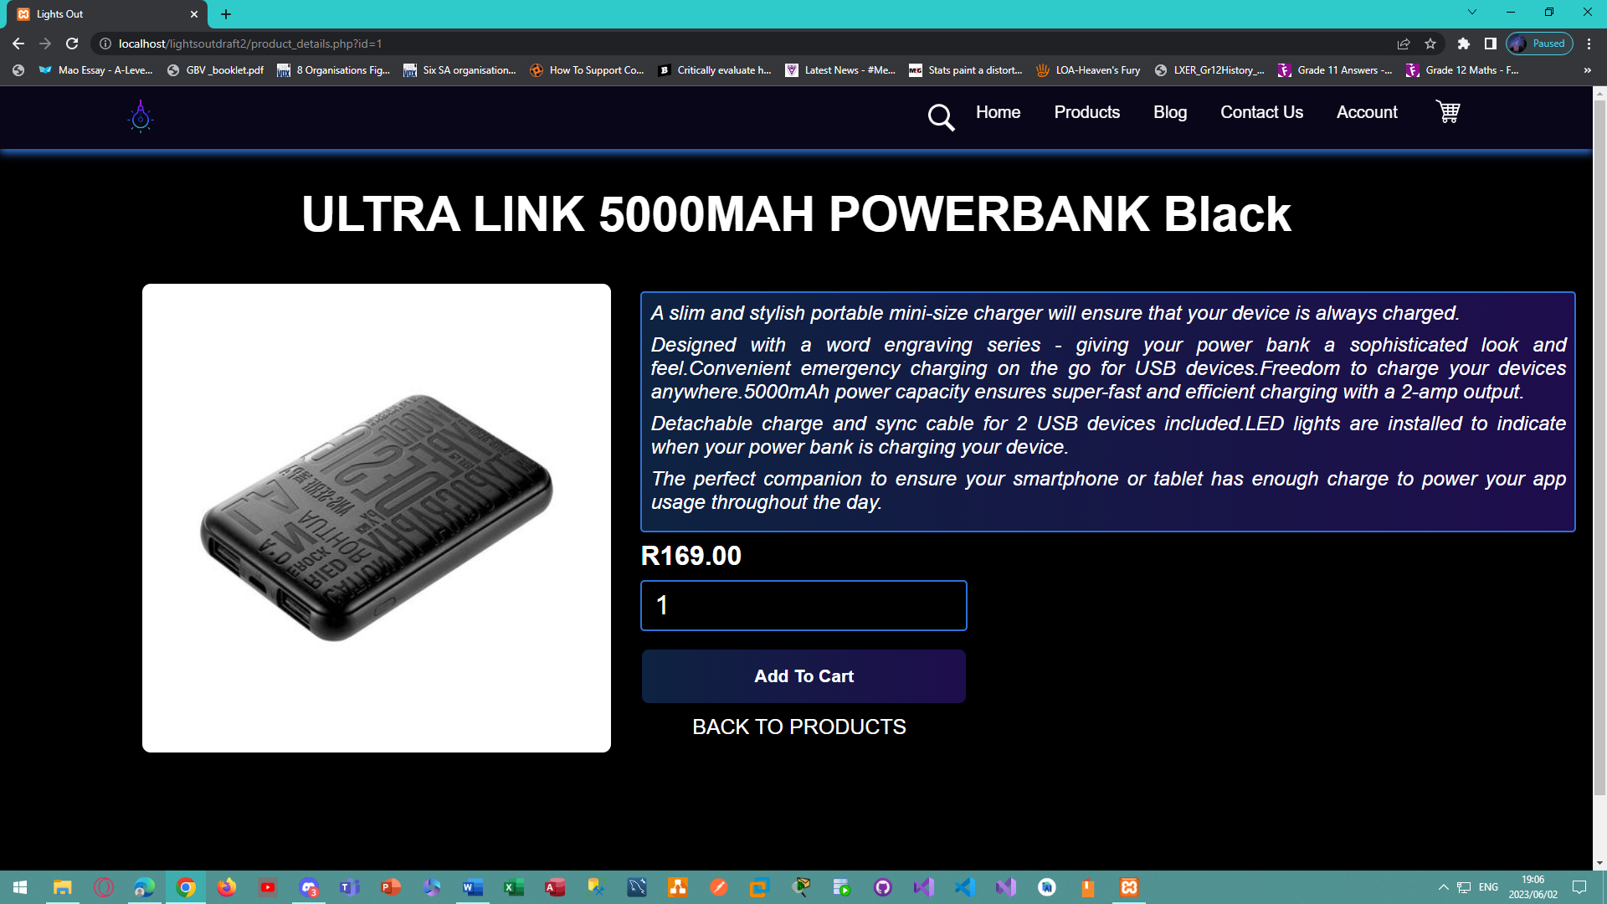

*Figure 84 - Desktop view of the product details page for the Lights Out E-Commerce Website.*

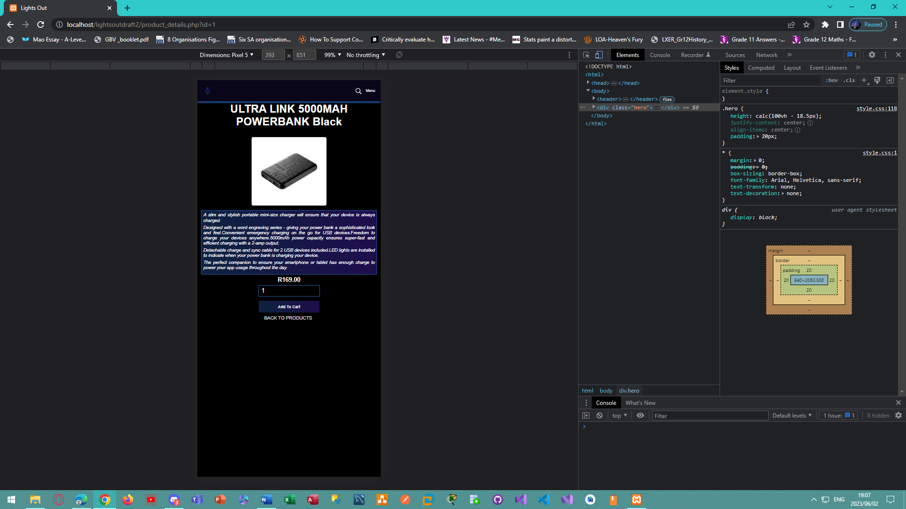

*Figure 85 - Mobile view of the product details page for the Lights Out E-Commerce Website.*

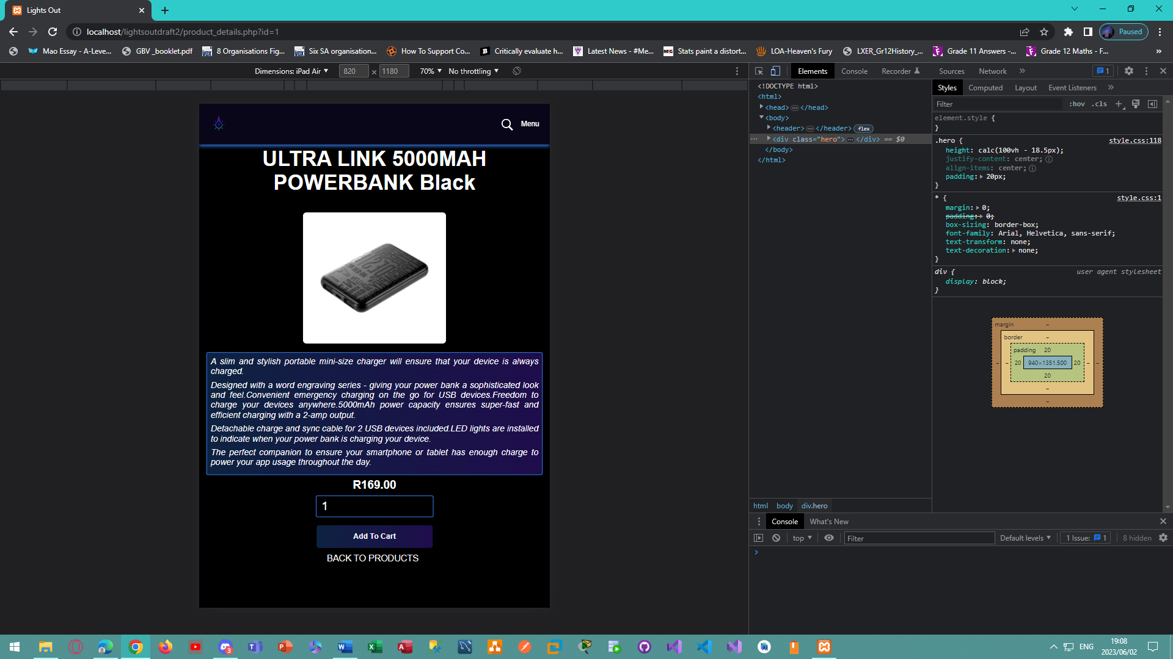

*Figure 86 - Tablet view of the product details page for the Lights Out E-Commerce Website.*

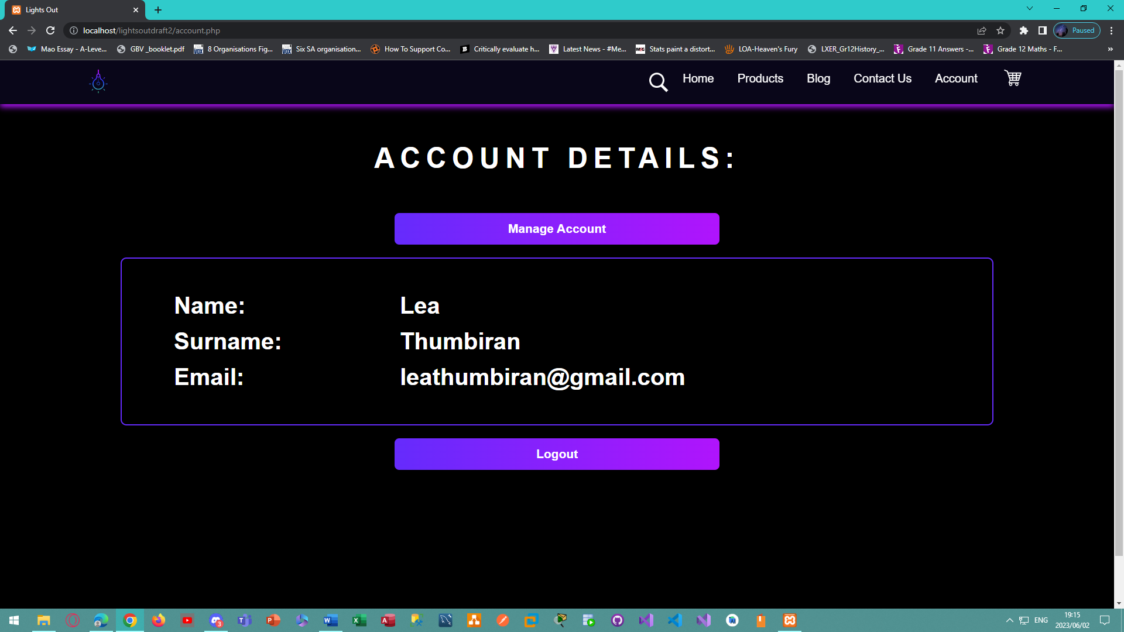

*Figure 87 - Desktop view of the account page for the Lights Out E-Commerce Website.*

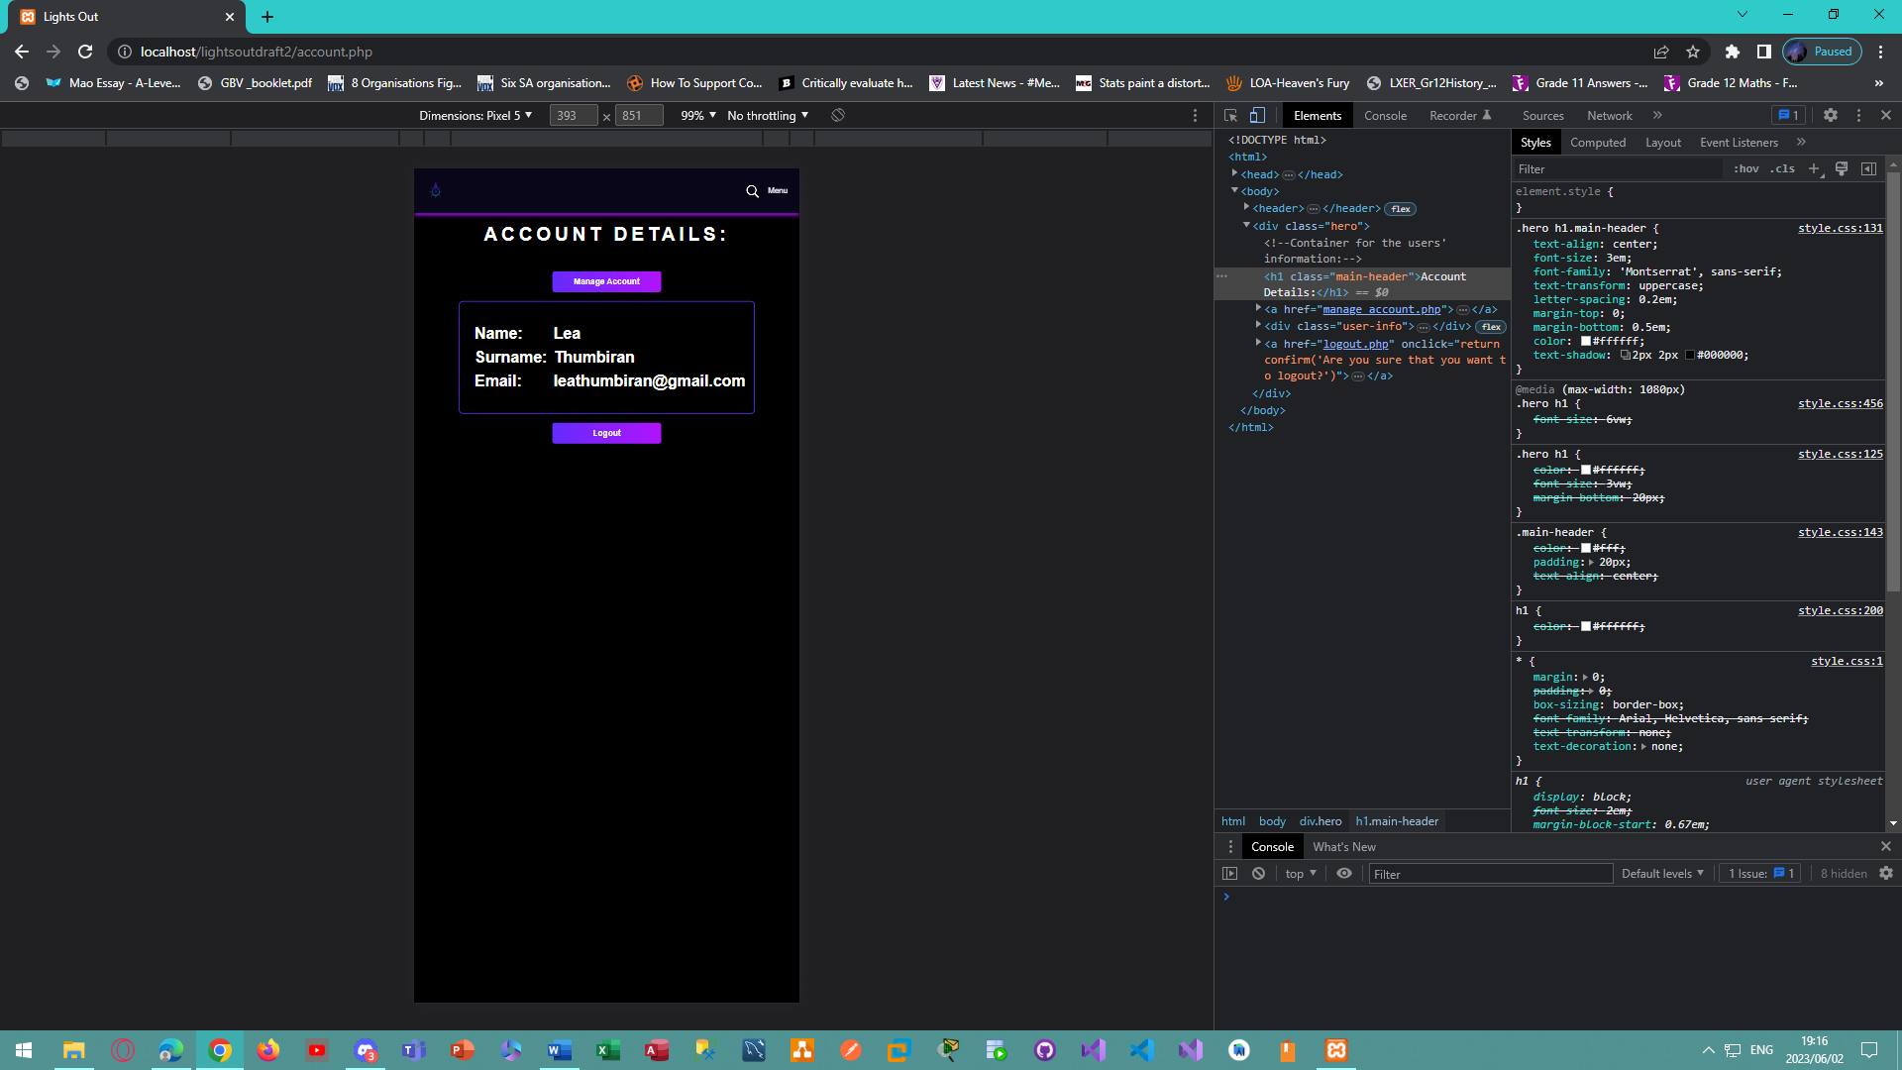

*Figure 88 - Mobile view of the account page for the Lights Out E-Commerce Website.*

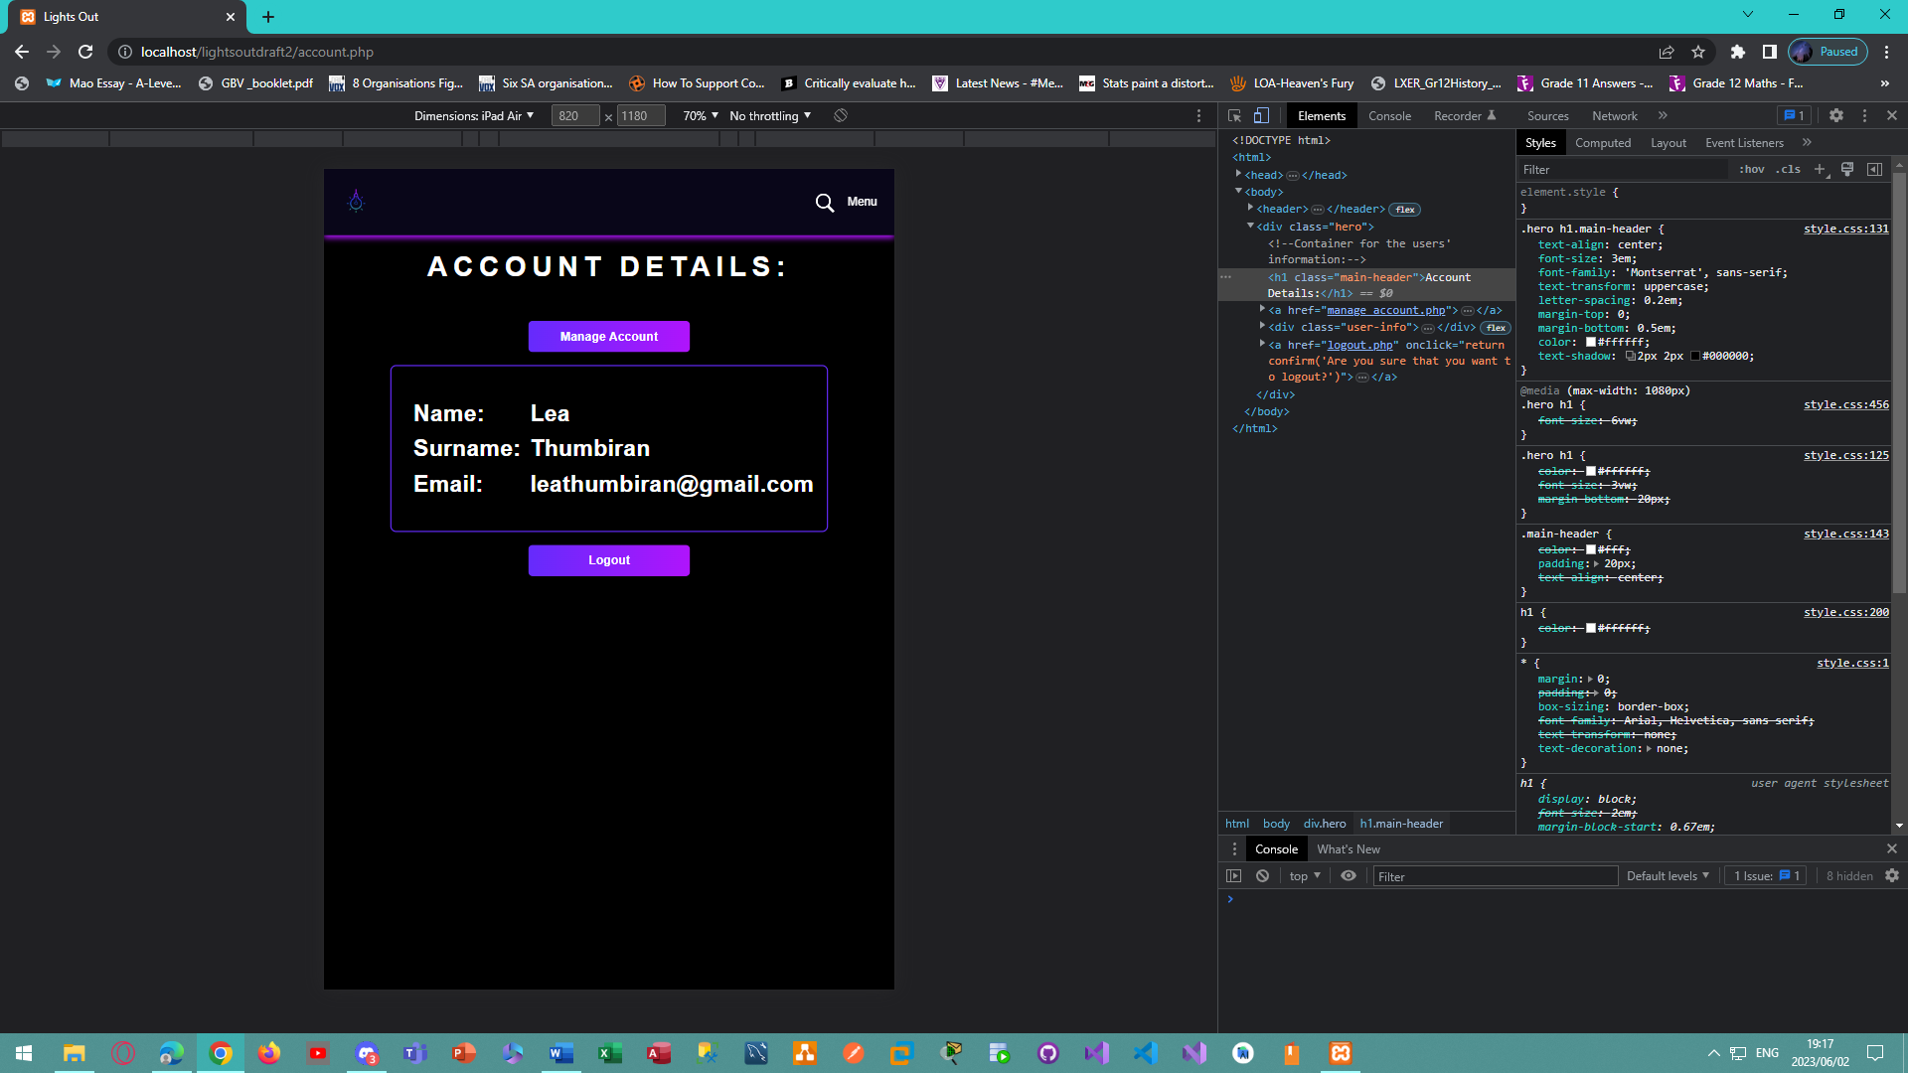

*Figure 89 - Tablet view of the account page for the Lights Out E-Commerce Website.*

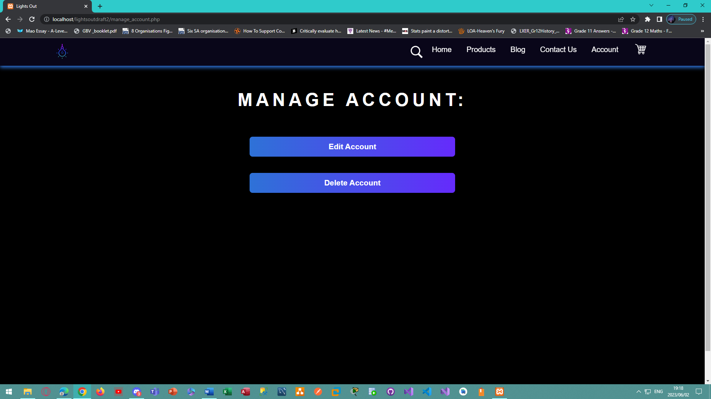

*Figure 90 - Desktop view of the manage account page for the Lights Out E-Commerce Website.*

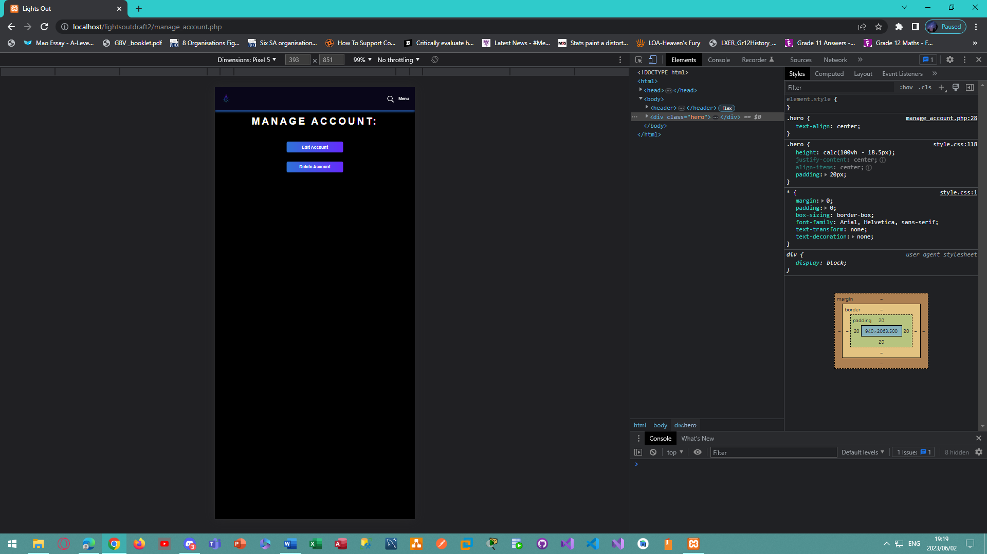

*Figure 91 - Mobile view of the manage account page for the Lights Out E-Commerce Website.*

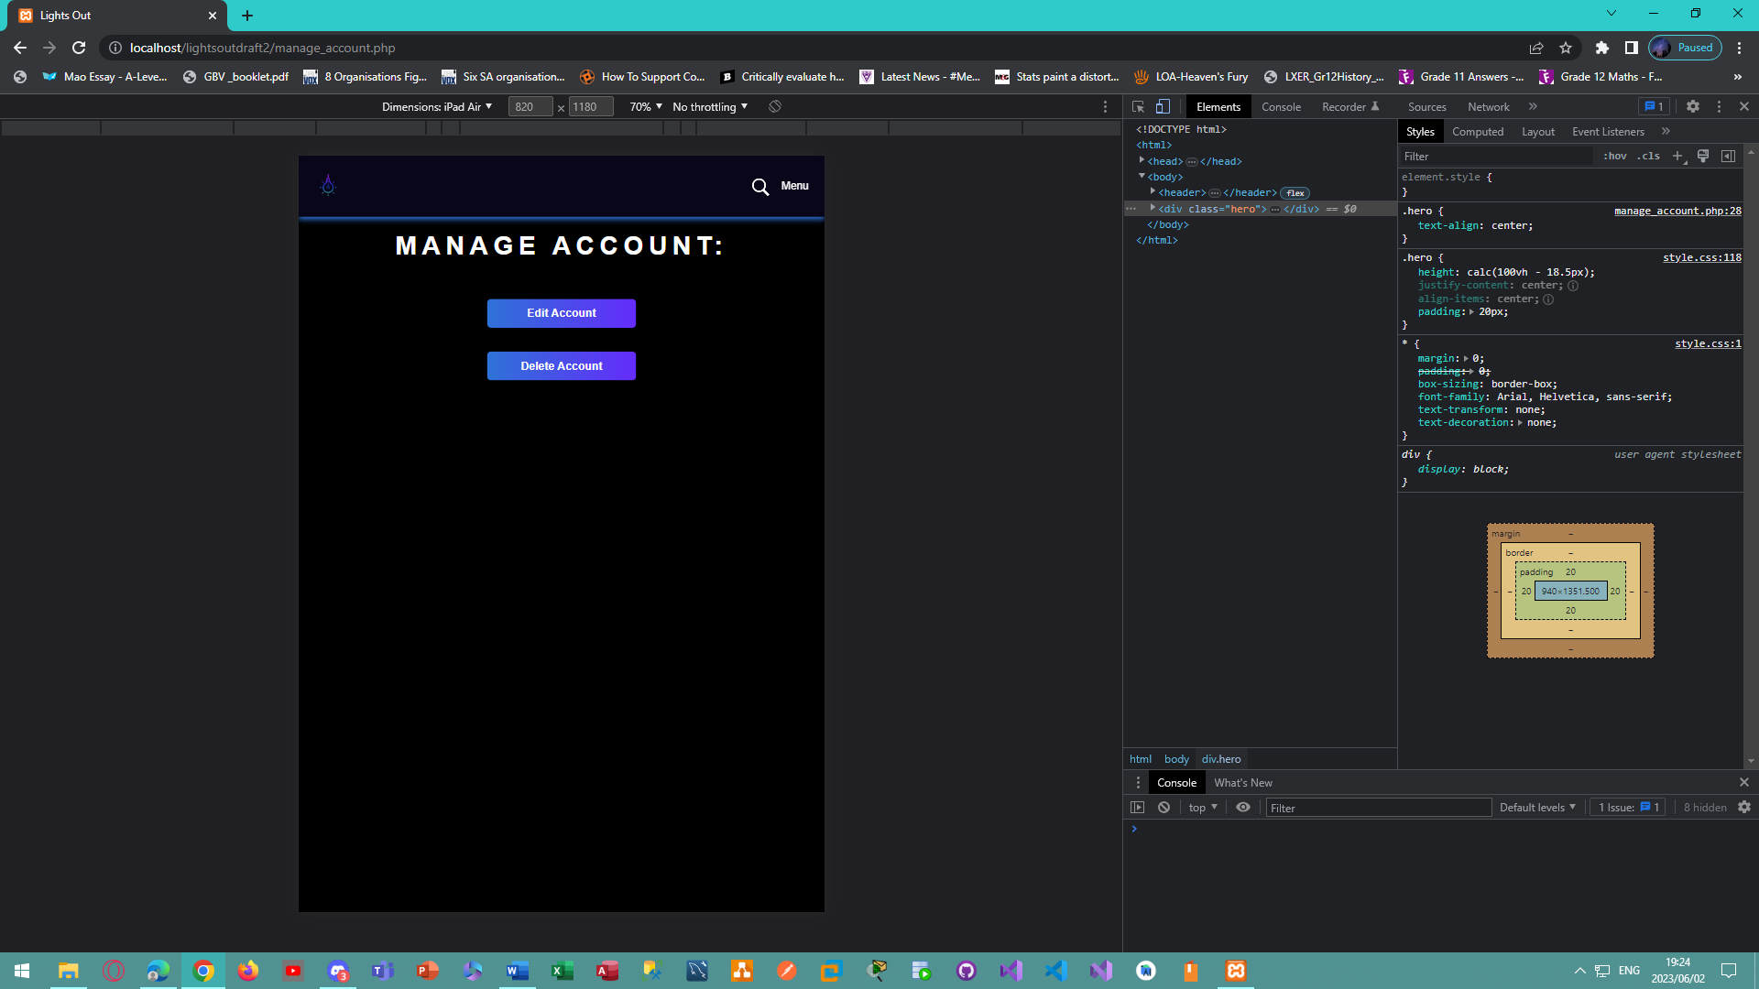

*Figure 92 – Tablet view of the manage account page for the Lights Out E-Commerce Website.*

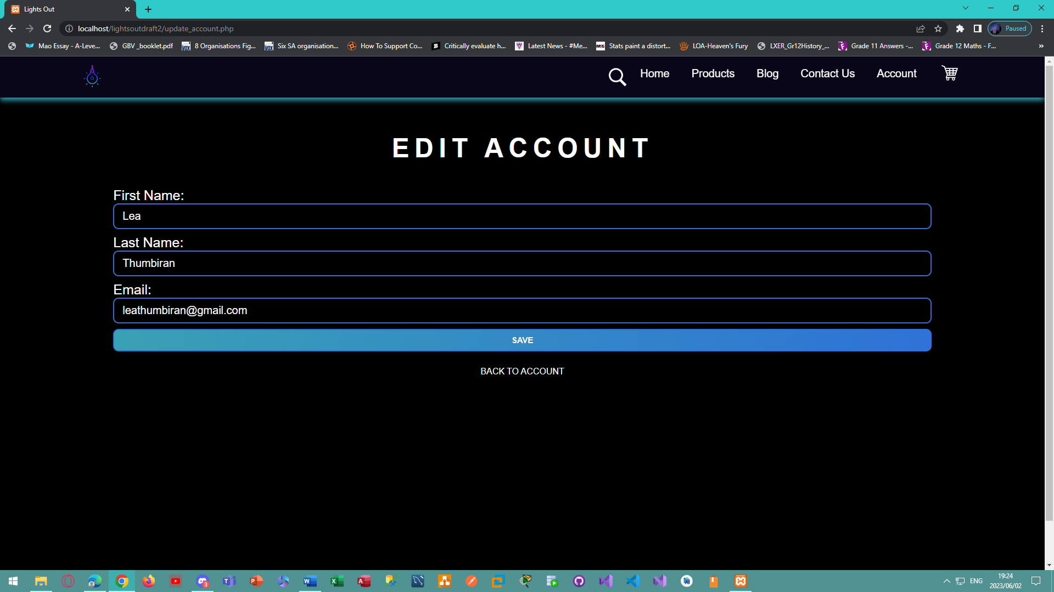

*Figure 93 – Desktop view of the edit account page for the Lights Out E-Commerce Website.*

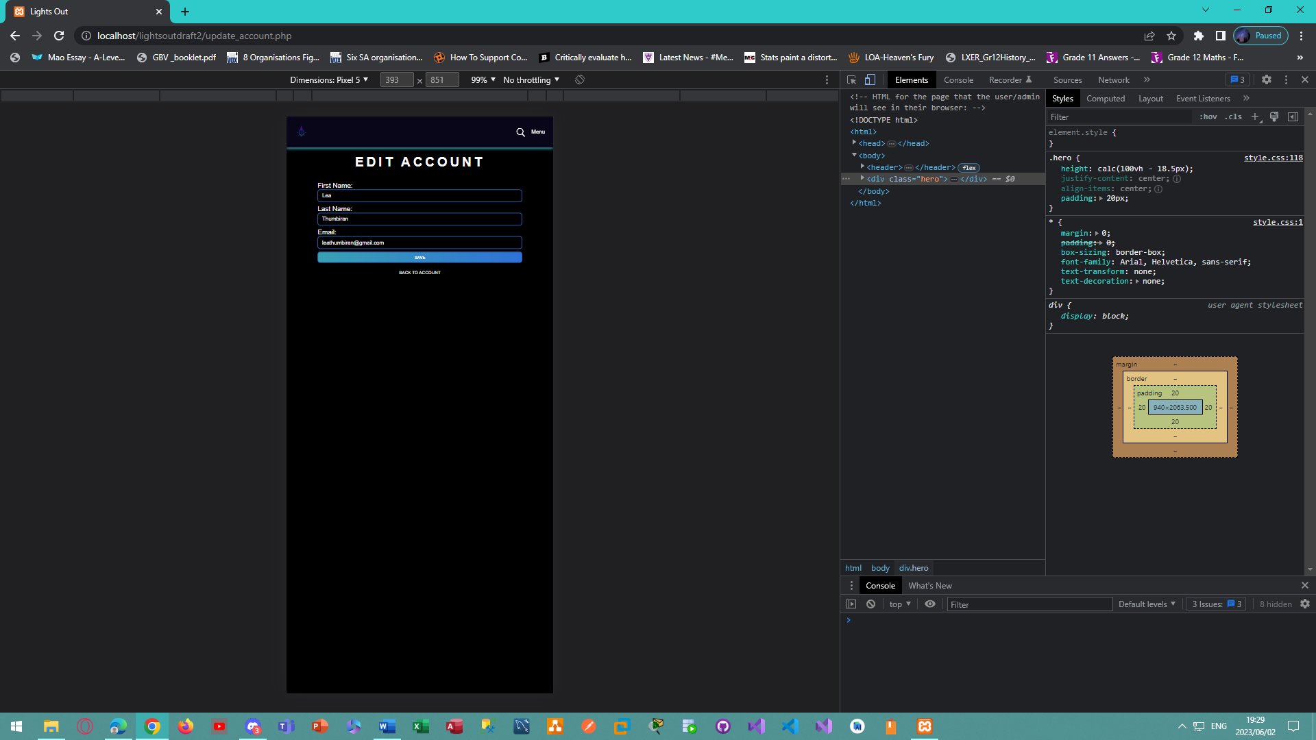

*Figure 94 - Mobile view of the edit account page for the Lights Out E-Commerce Website.*

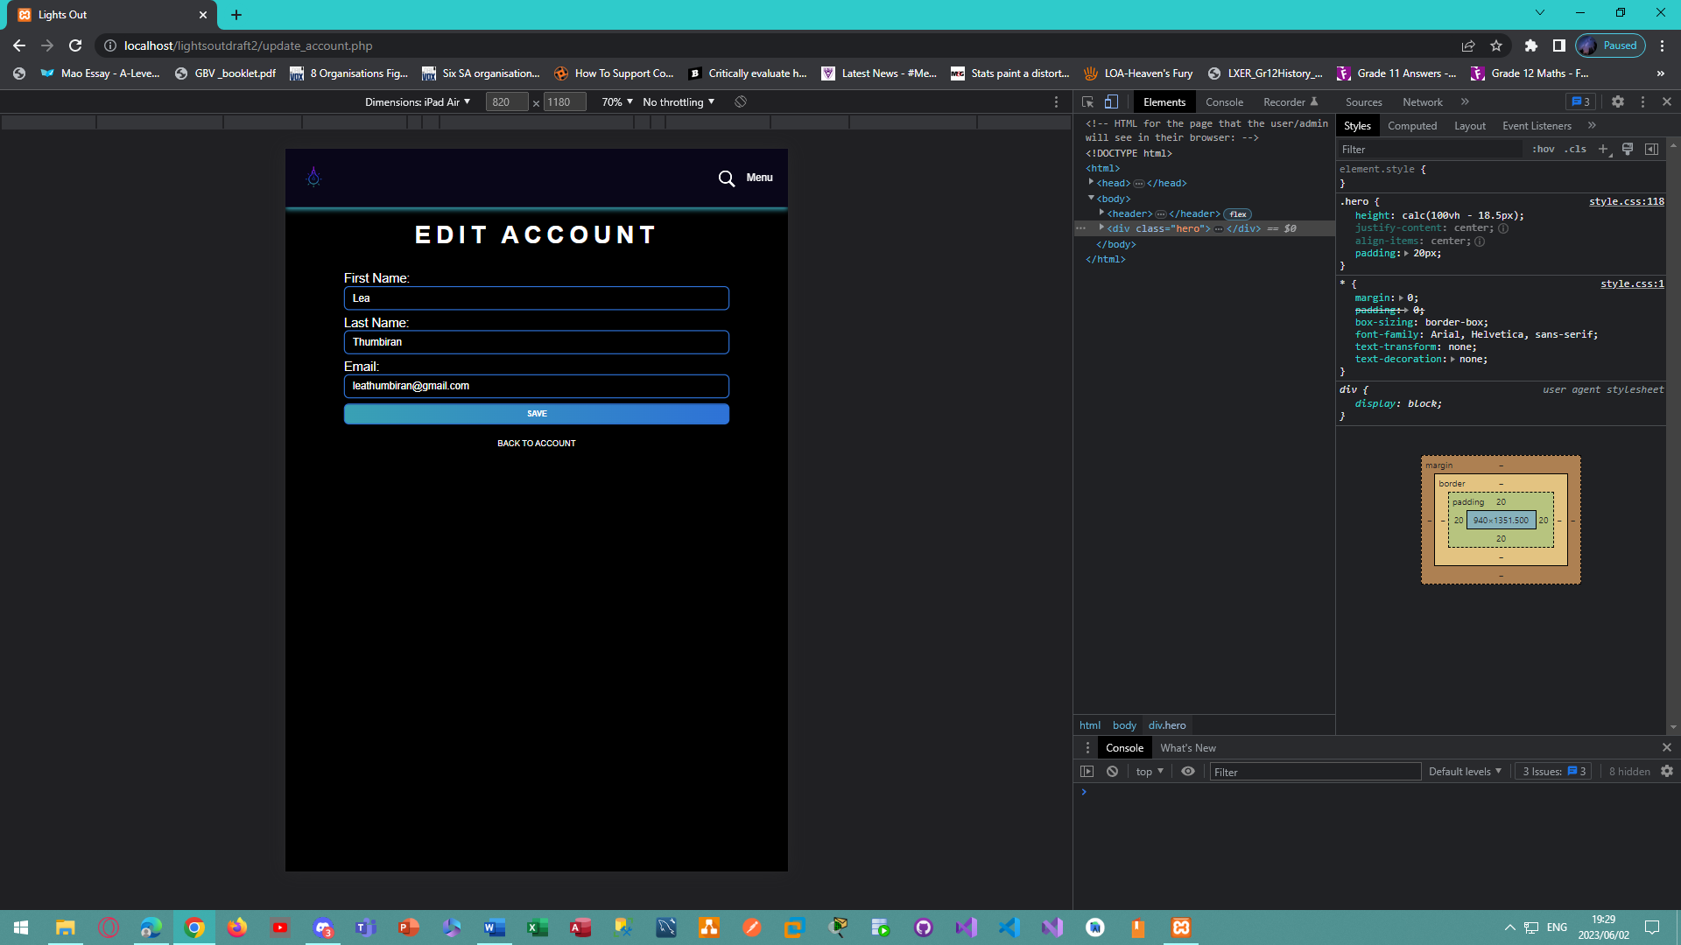

*Figure 95 - Tablet view of the edit account page for the Lights Out E-Commerce Website.*

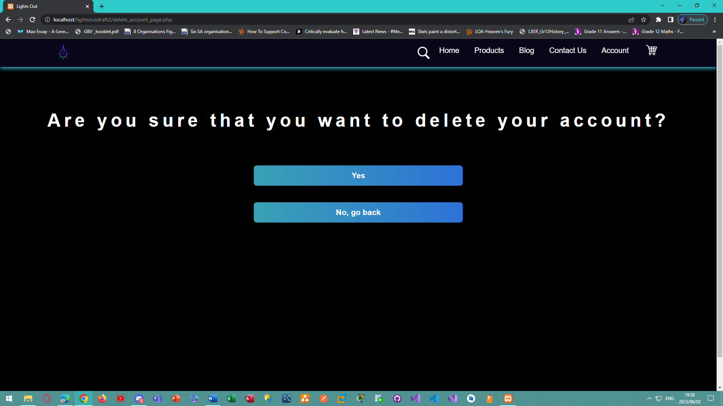

*Figure 96 - Desktop view of the delete account page for the Lights Out E-Commerce Website.*

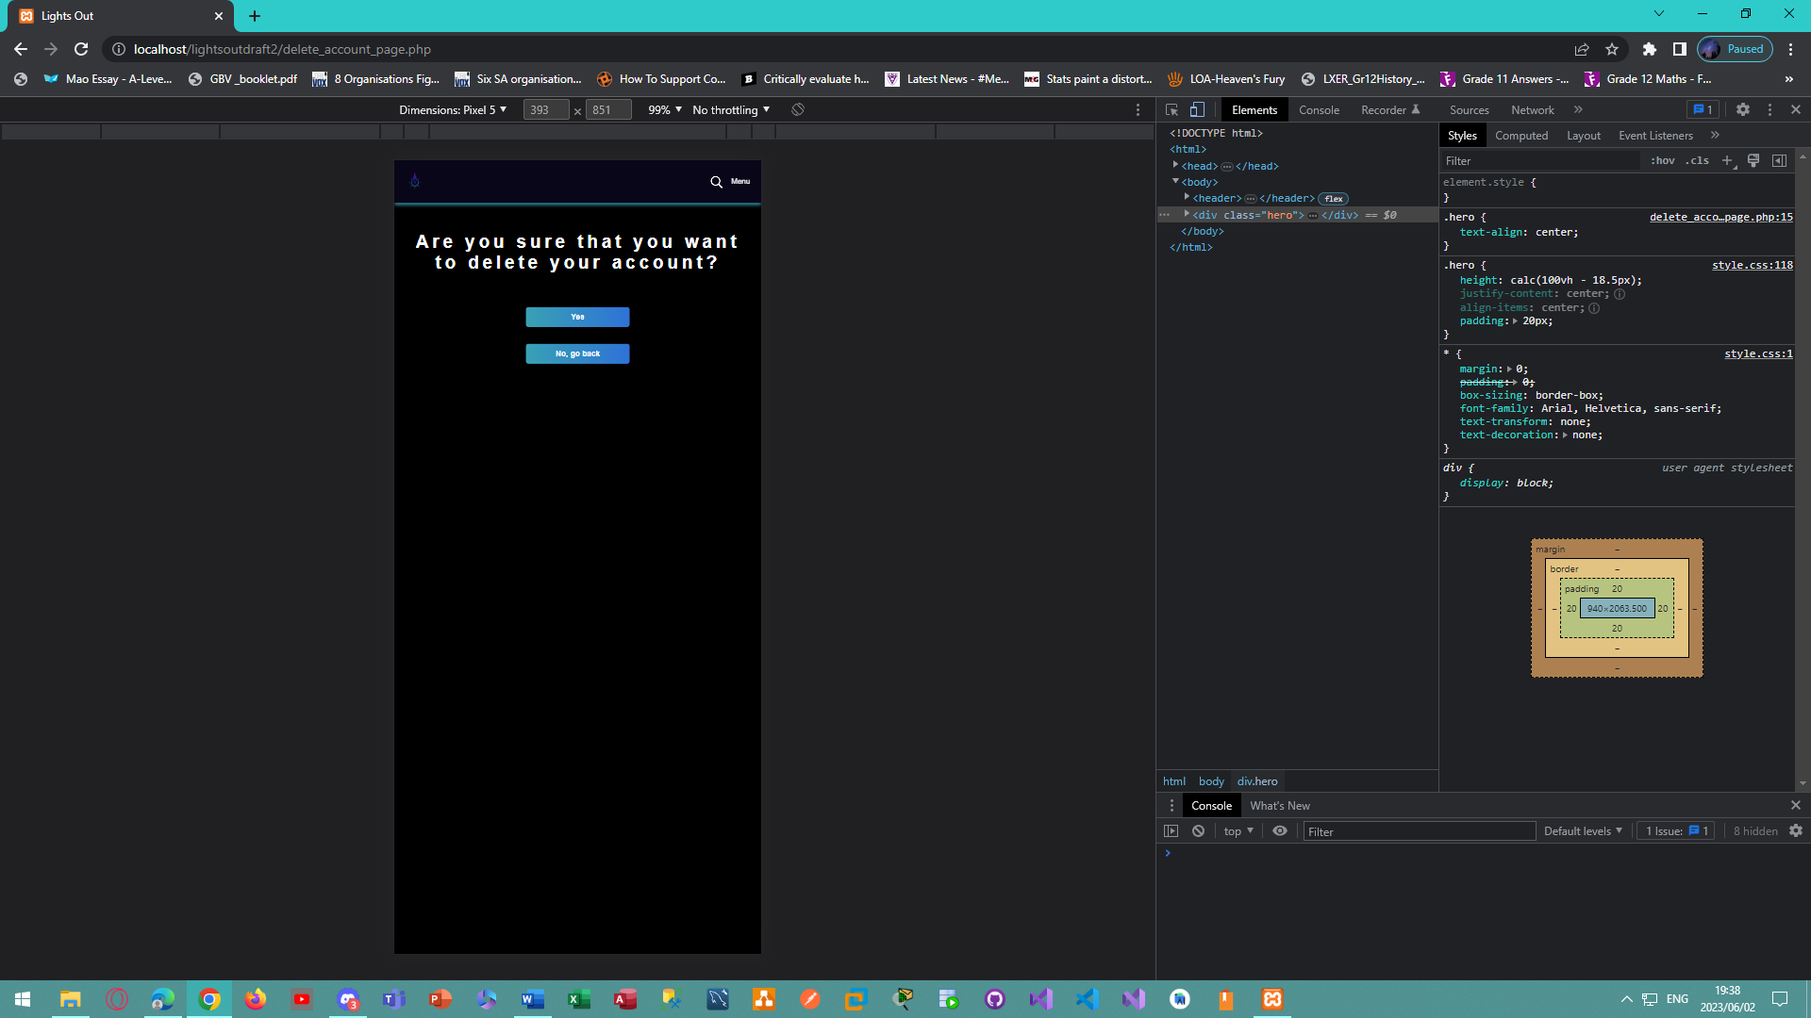

*Figure 97 - Mobile view of the delete account page for the Lights Out E-Commerce Website.*

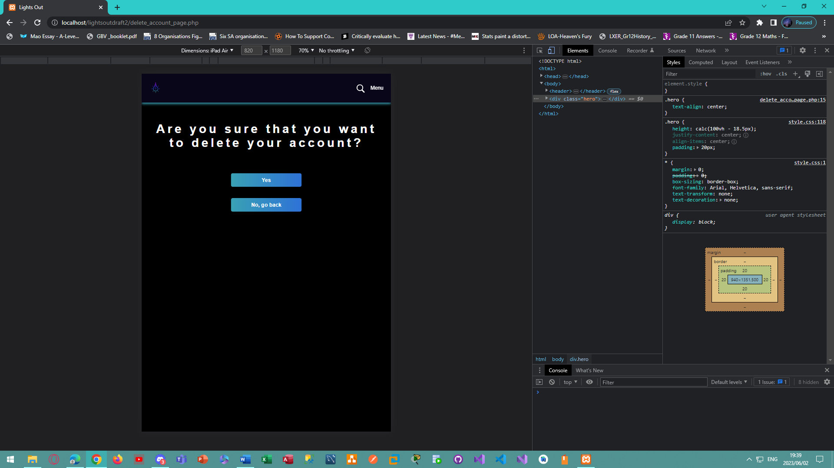

*Figure 98 - Tablet view of the delete account page for the Lights Out E-Commerce Website.*

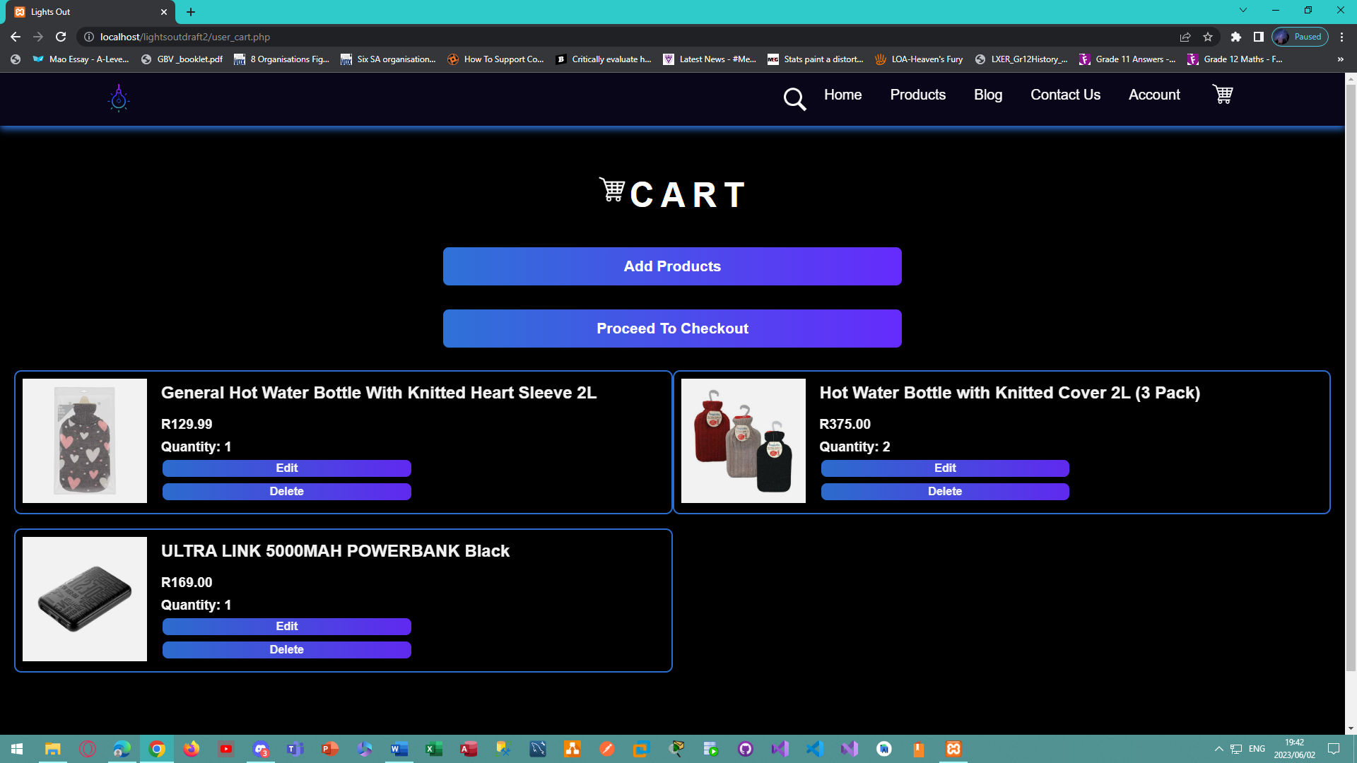

*Figure 99 - Desktop view of the cart page for the Lights Out E-Commerce Website.*

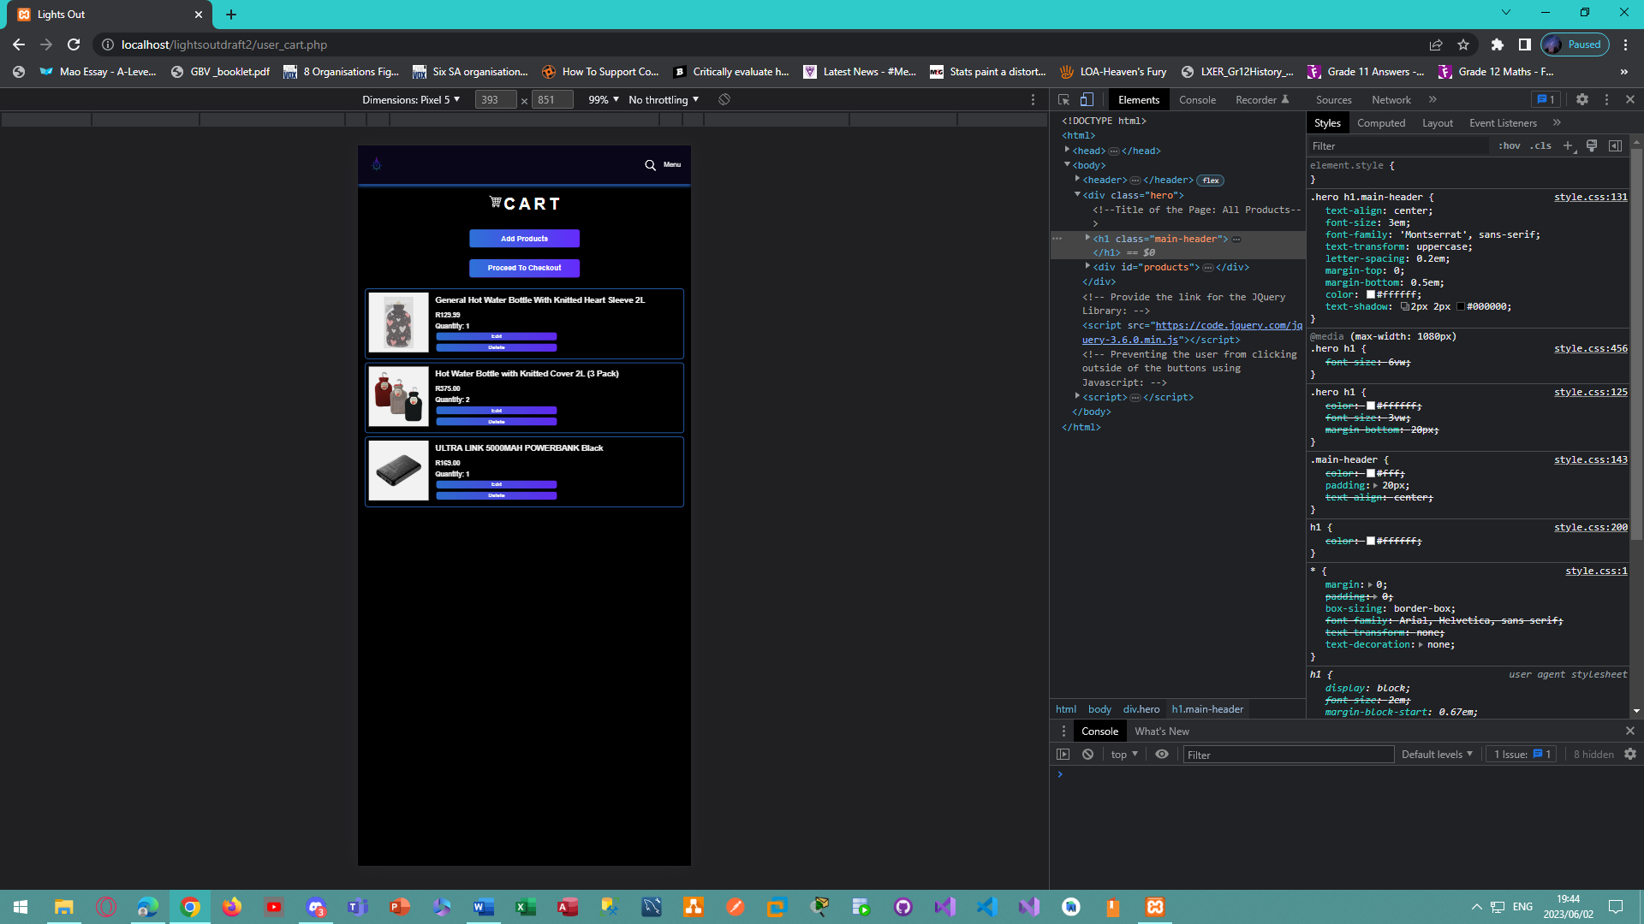

*Figure 100 – Mobile view of the cart page for the Lights Out E-Commerce Website.*

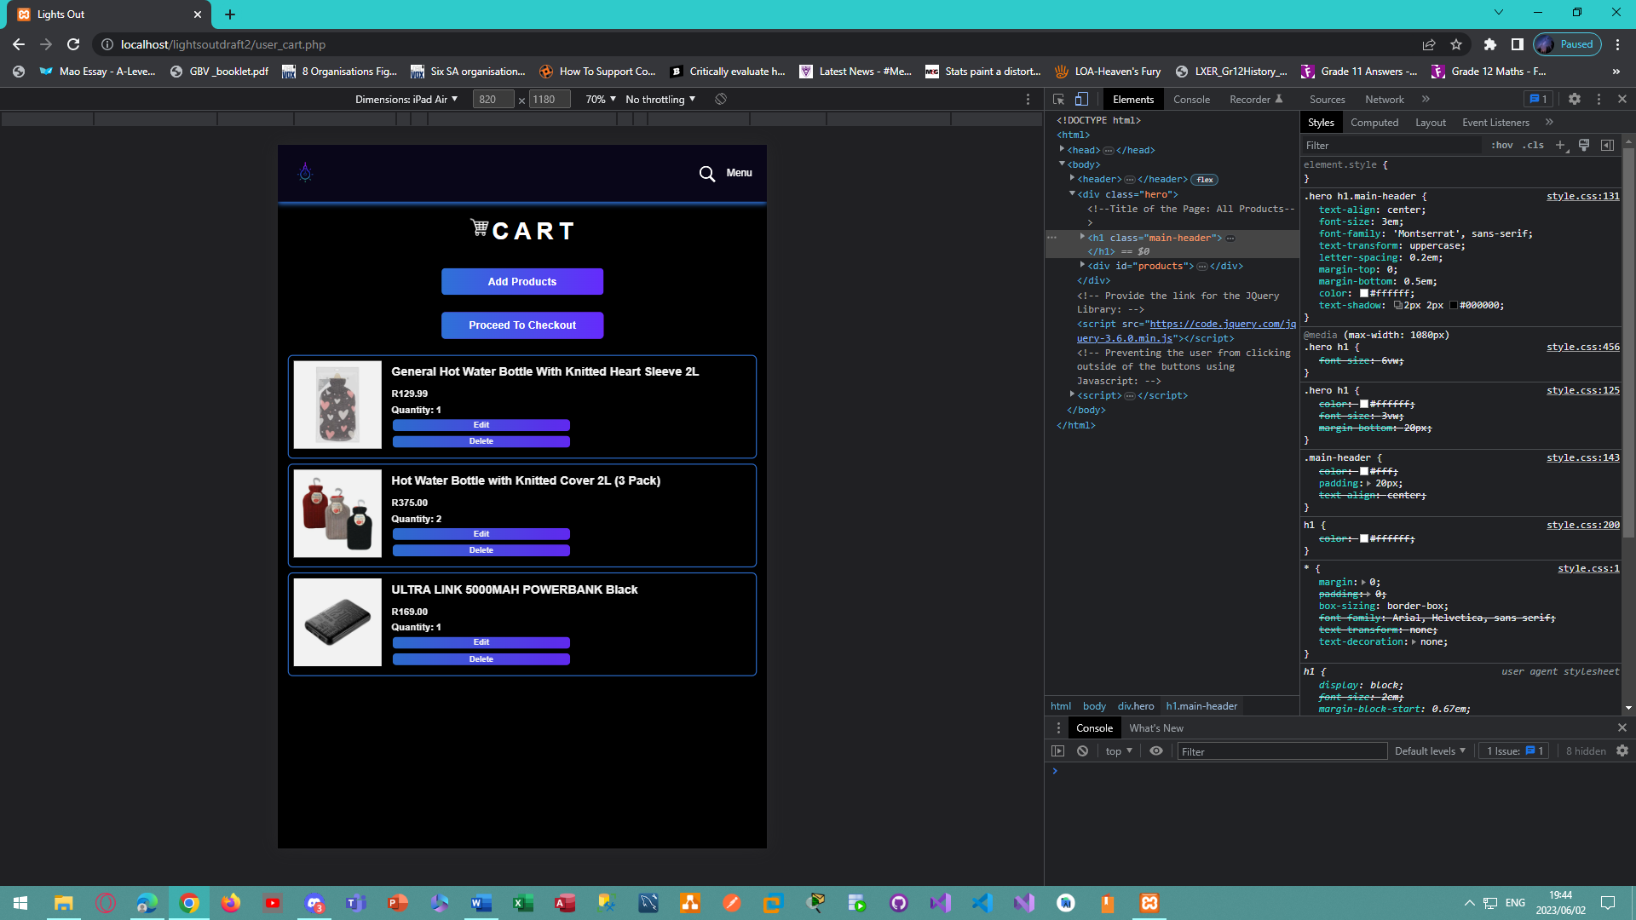

*Figure 101 - Tablet view of the cart page for the Lights Out E-Commerce Website.*

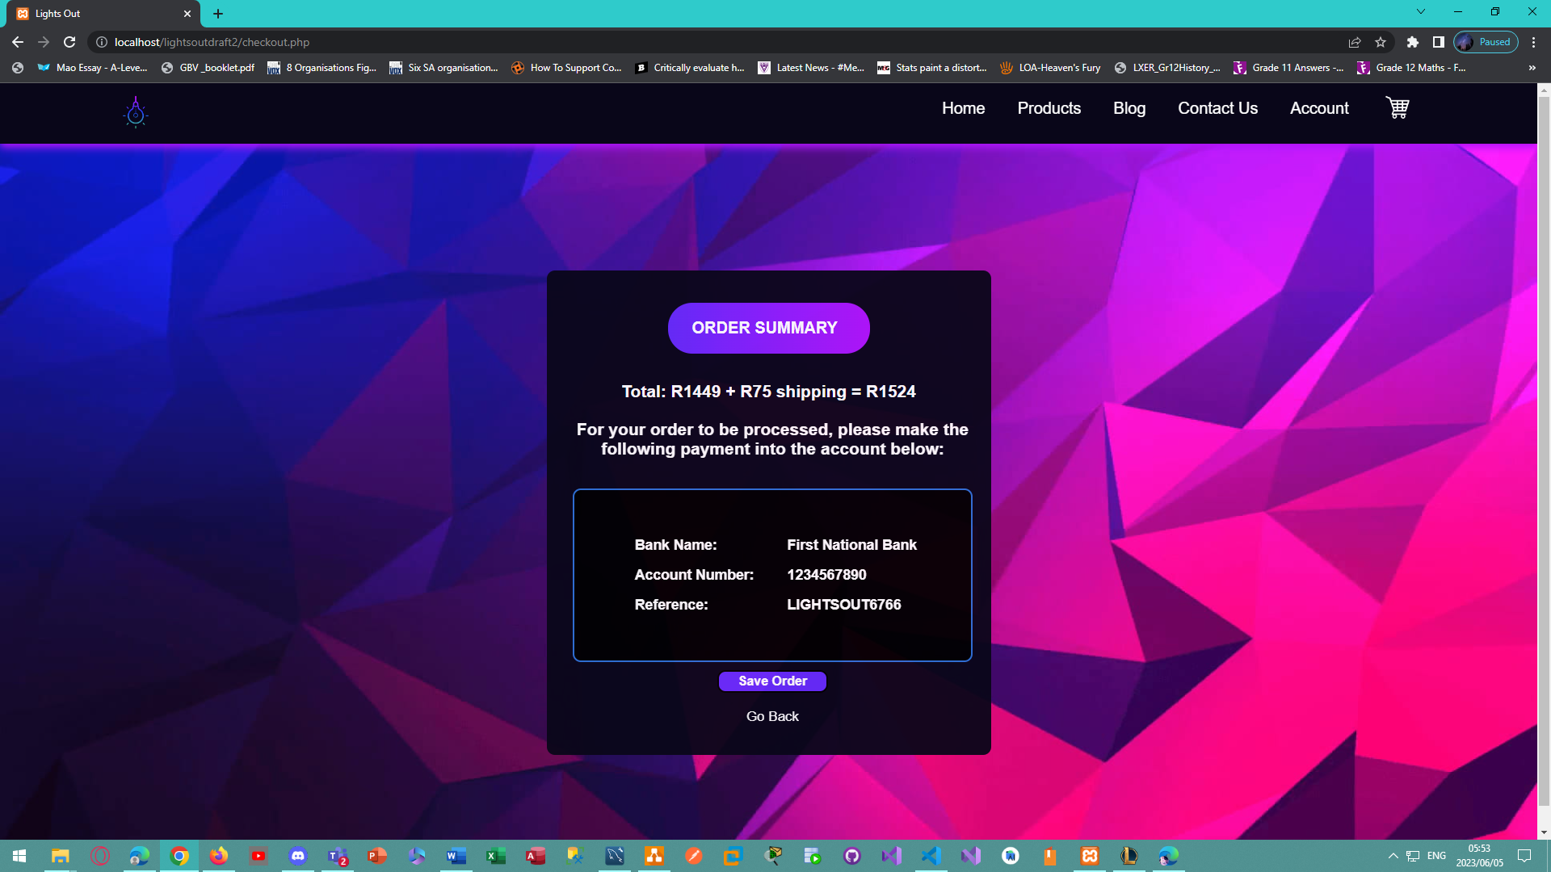

*Figure 102 - Desktop view of the payment page that displays the total plus shipping and the bank account details for users to pay in for the Lights Out E-Commerce Website.*

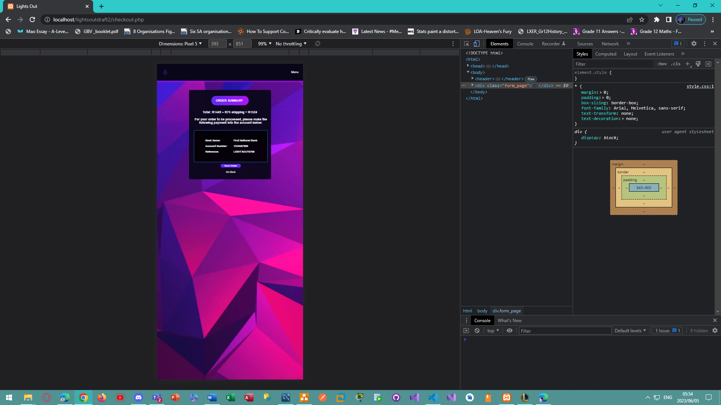

*Figure 103 - Mobile view of the payment page that displays the total plus shipping and the bank account details for users to pay in for the Lights Out E-Commerce Website.*

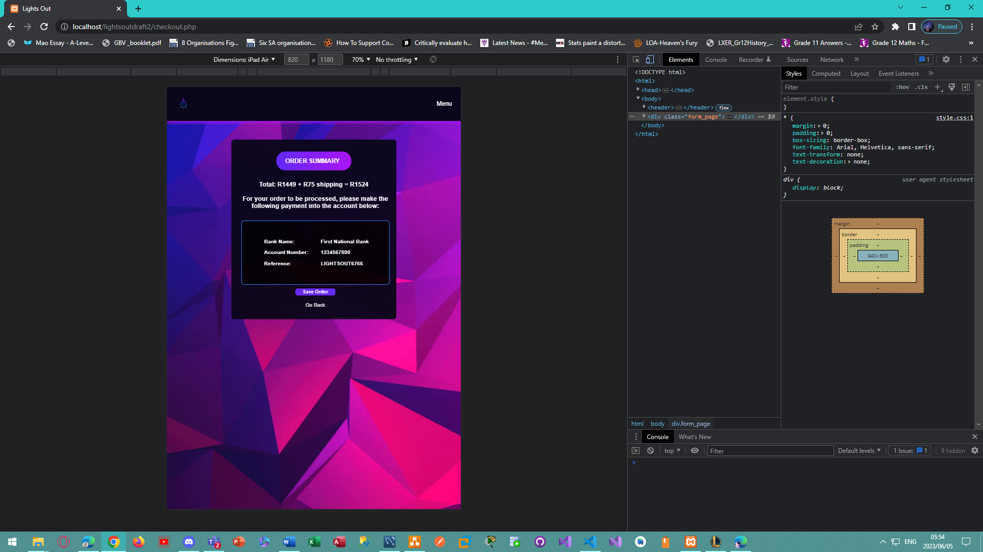

*Figure 104 - Tablet view of the payment page that displays the total plus shipping and the bank account details for users to pay in for the Lights Out E-Commerce Website.*

### Administrator/Vendor View of The Website:

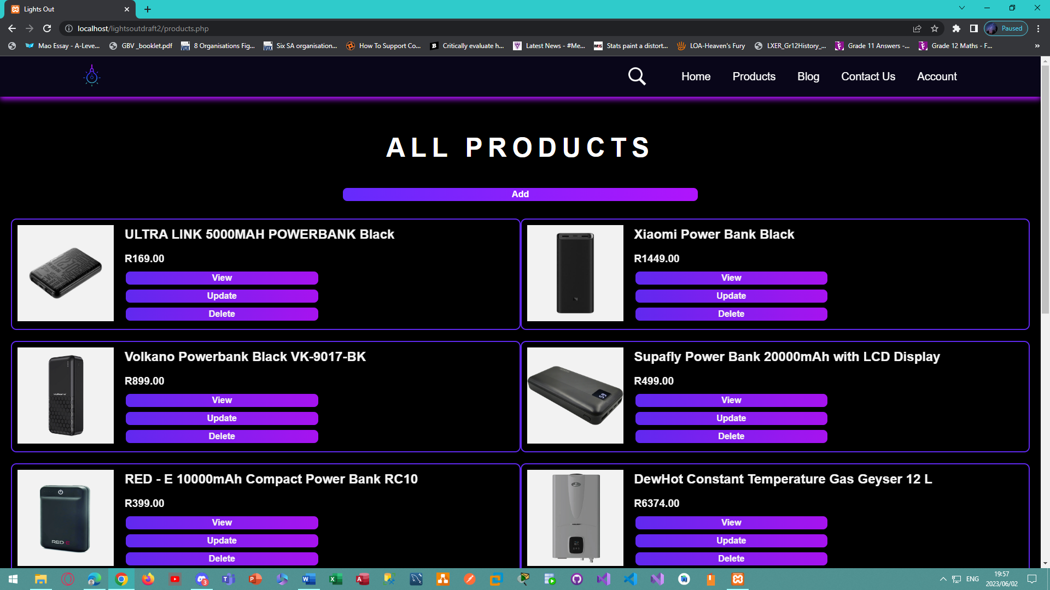

*Figure 105 - Desktop view of the product page for administrators to view, add, update, and delete products.*

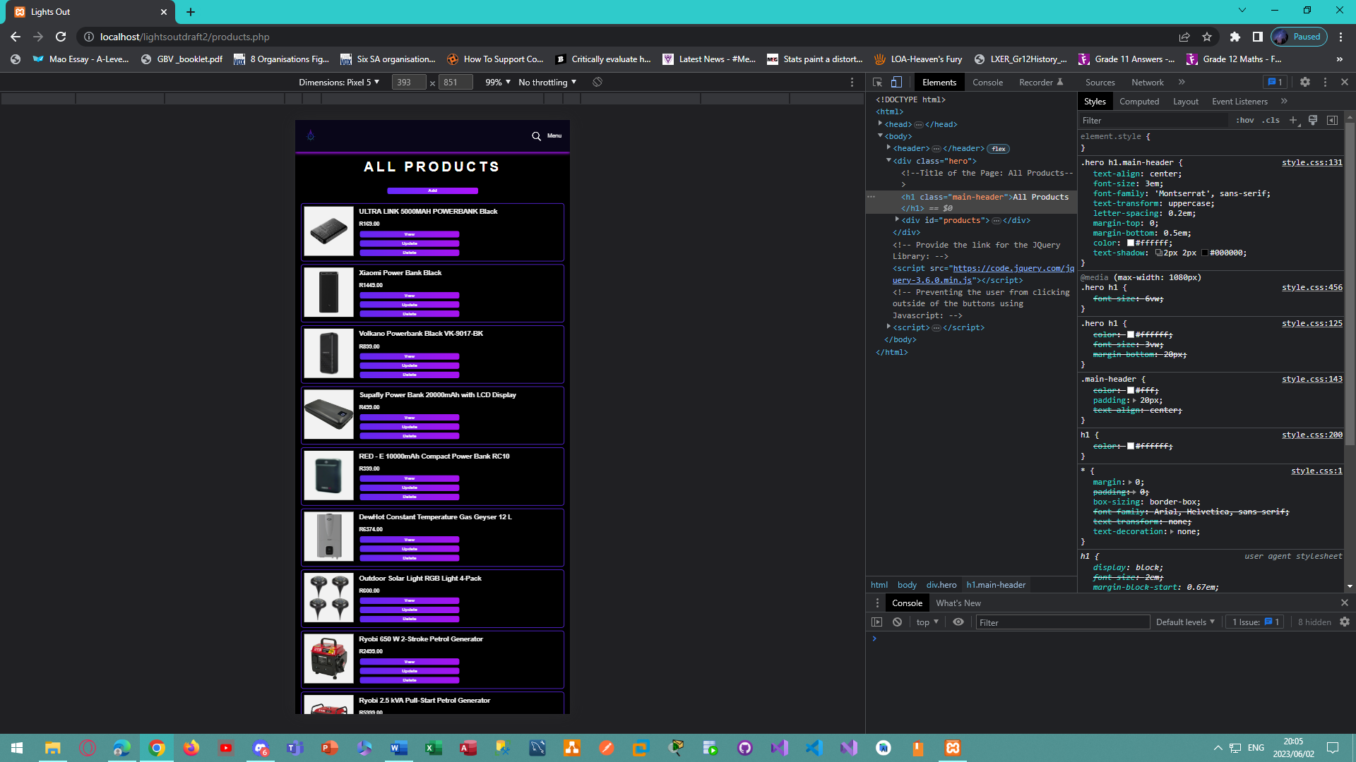

*Figure 106 - Mobile view of the product page for administrators to view, add, update, and delete products.*

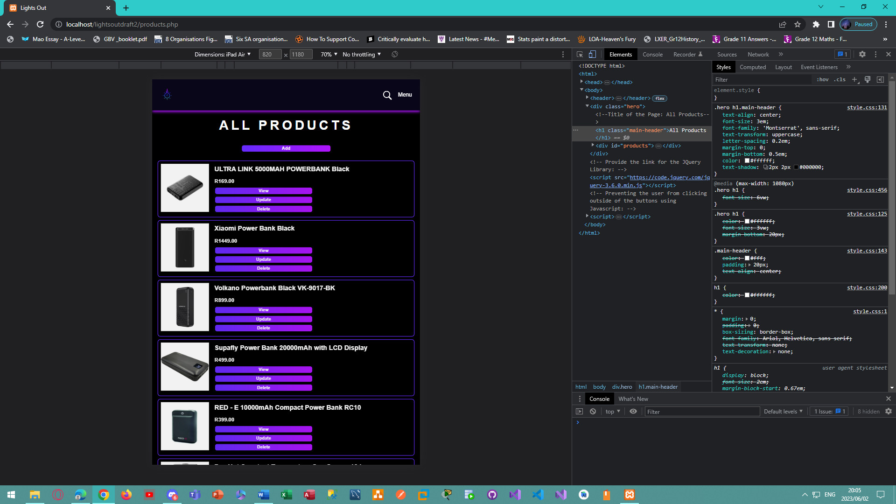

*Figure 107 - Tablet view of the product page for administrators to view, add, update, and delete products.*

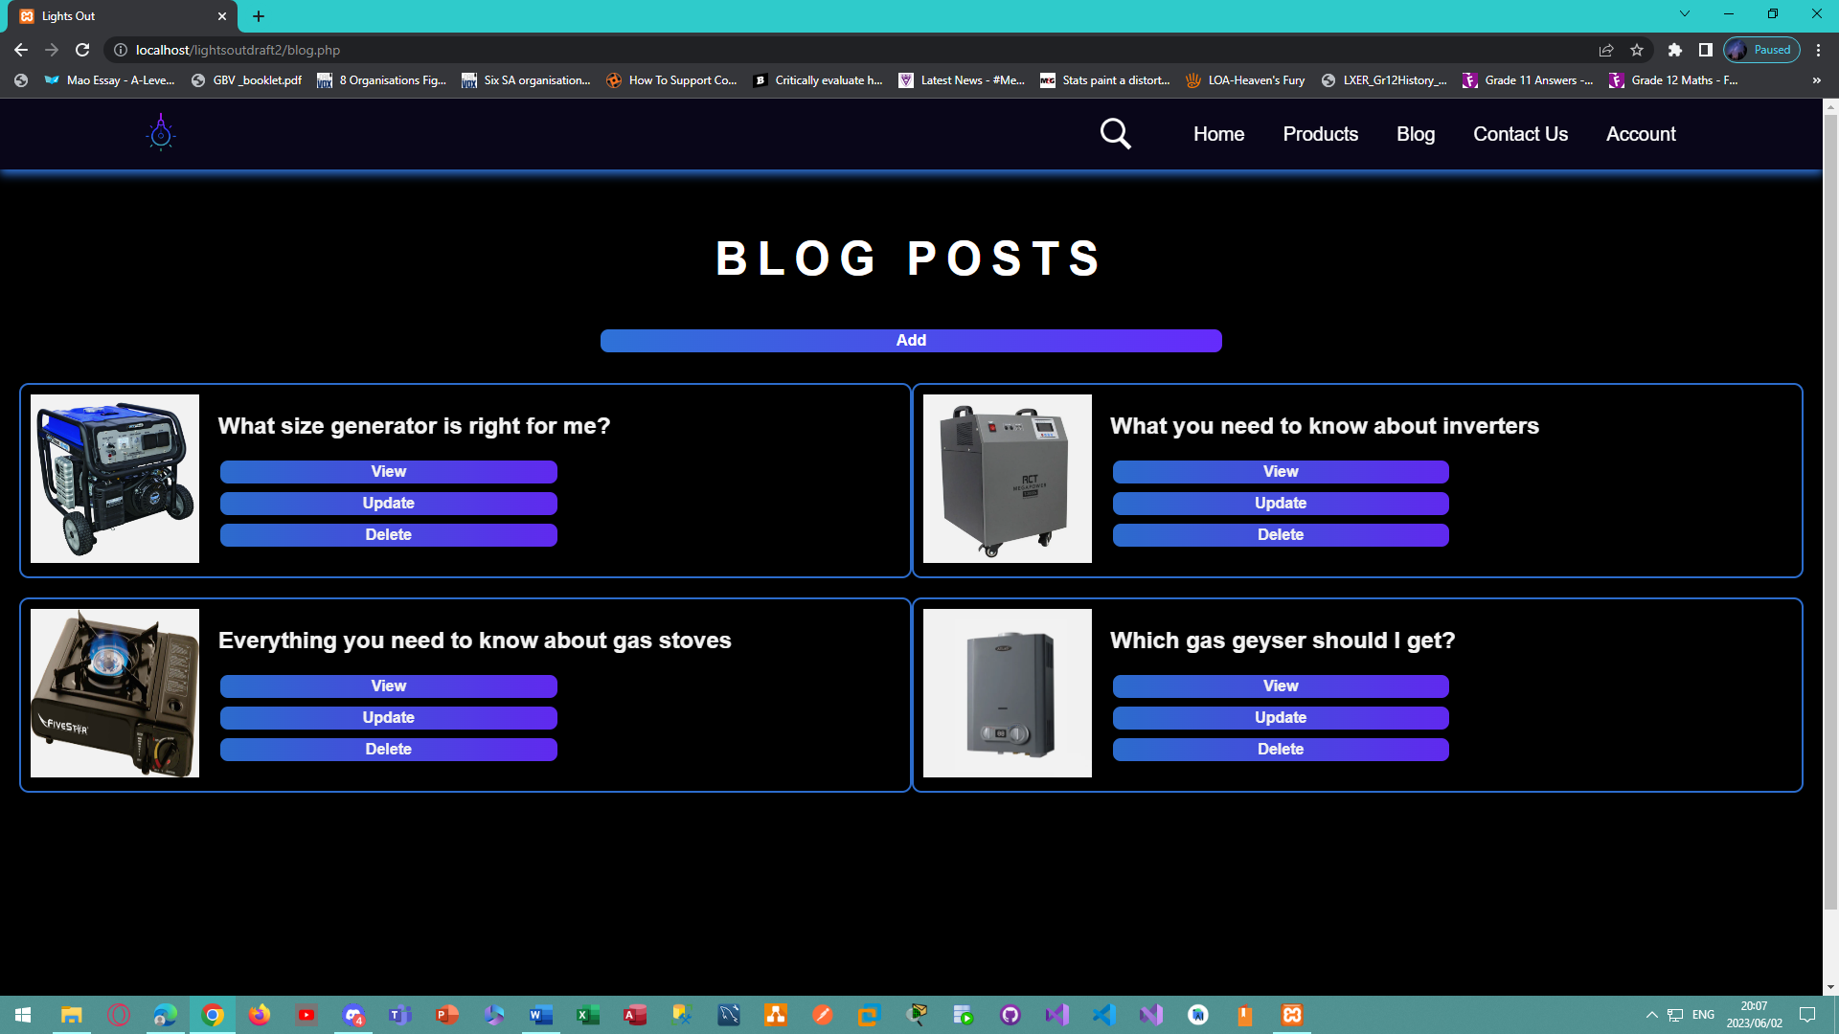

*Figure 108 - Desktop view of the blog posts page for administrators to view, add, update, and delete blog posts.*

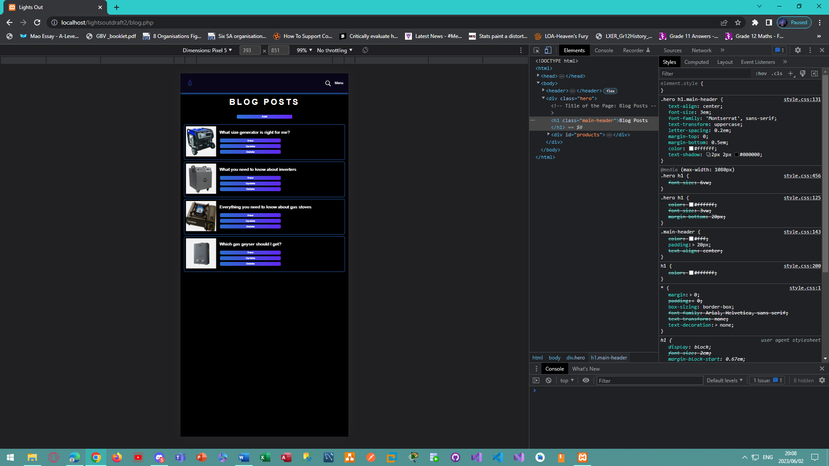

*Figure 109 - Mobile view of the blog posts page for administrators to view, add, update, and delete blog posts.*

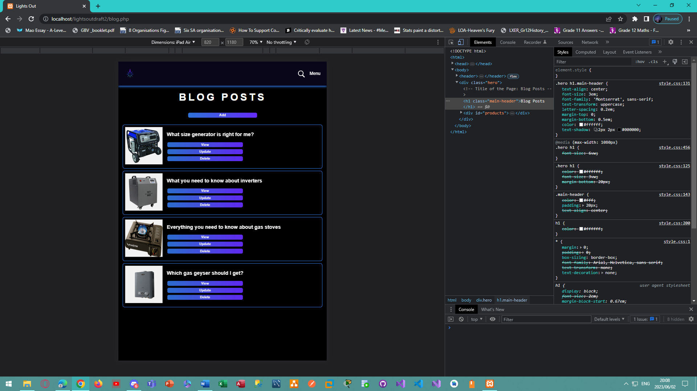

*Figure 110 - Tablet view of the blog posts page for administrators to view, add, update, and delete blog posts.*

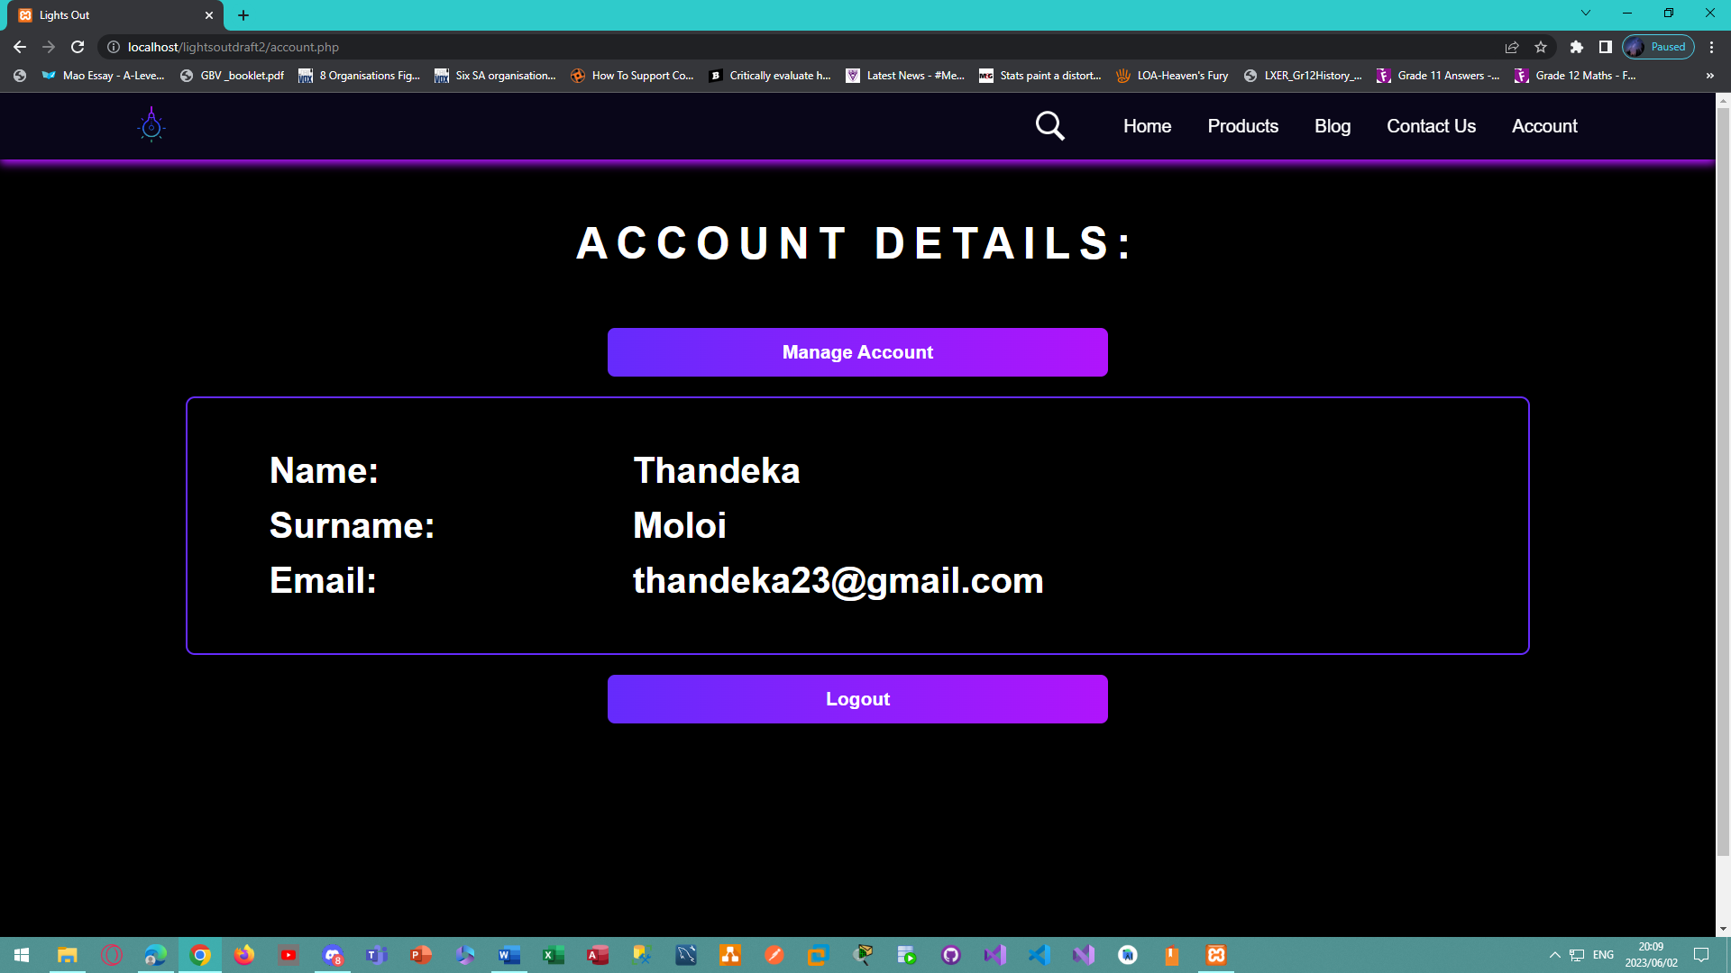

*Figure 111 - Desktop view of the account page for the Lights Out E-Commerce Website.*

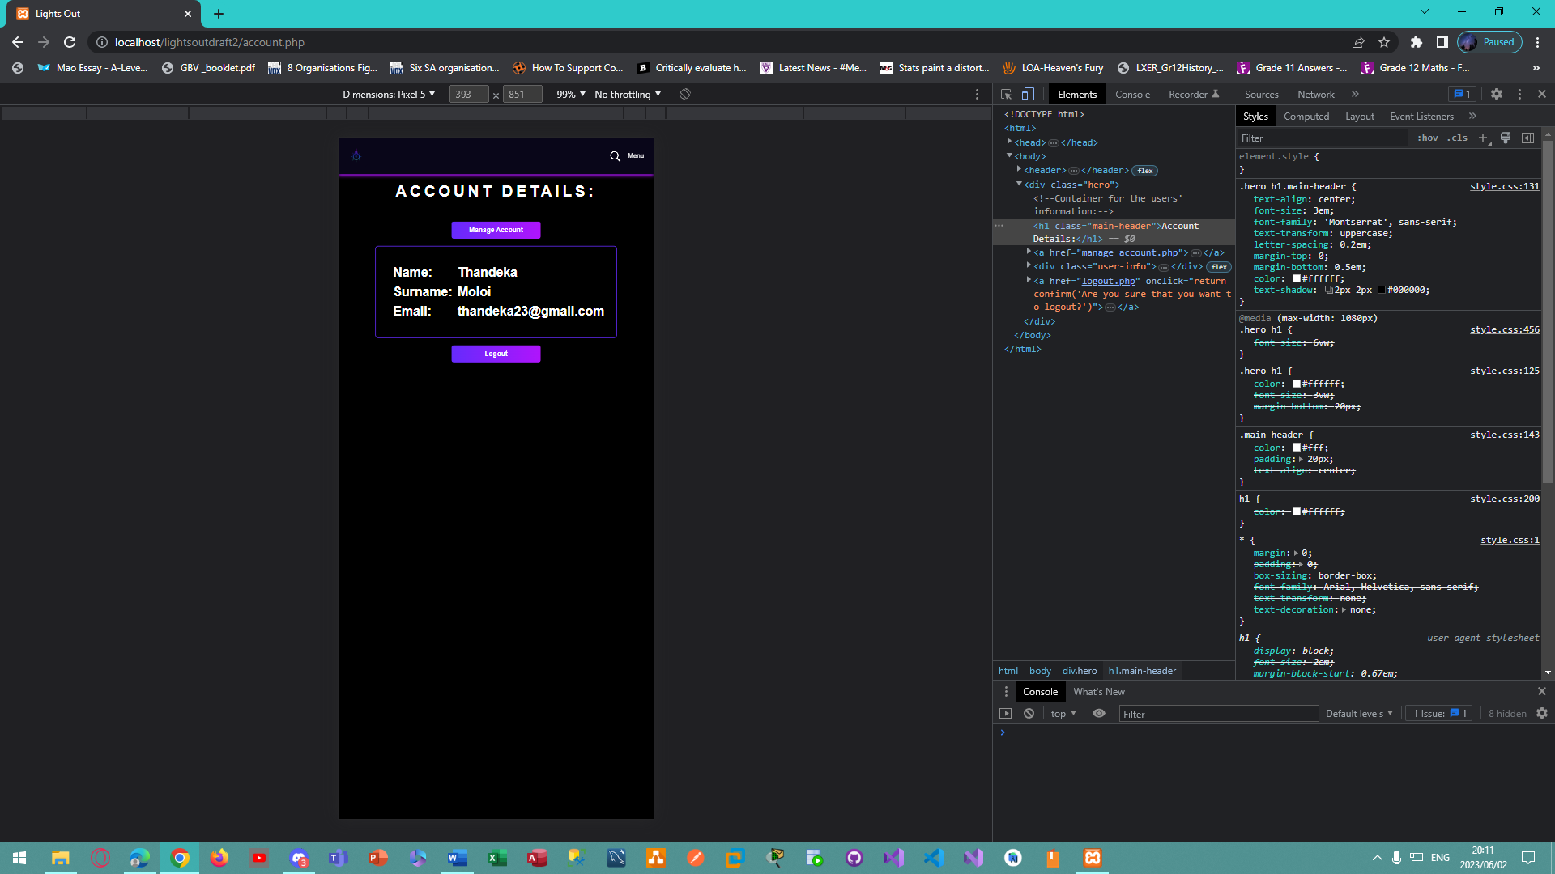

*Figure 112 - Mobile view of the account page for the Lights Out E-Commerce Website.*

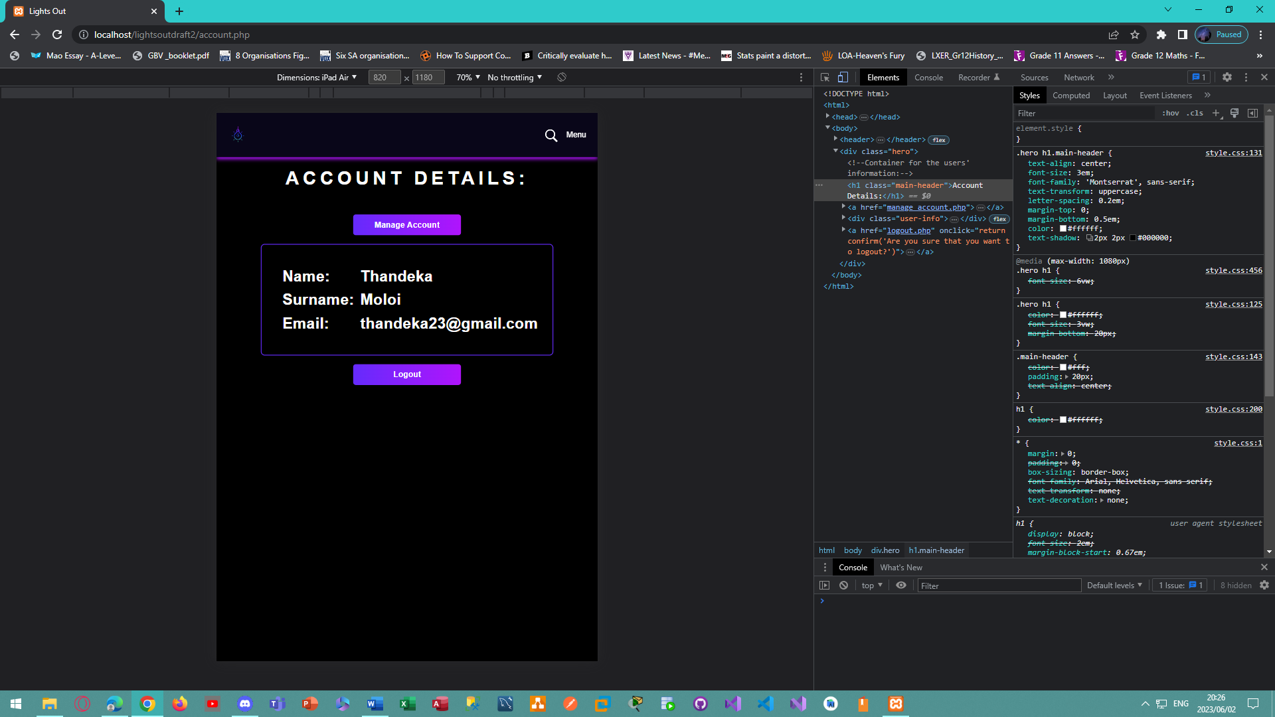

*Figure 113 - Tablet view of the account page for the Lights Out E-Commerce Website.*

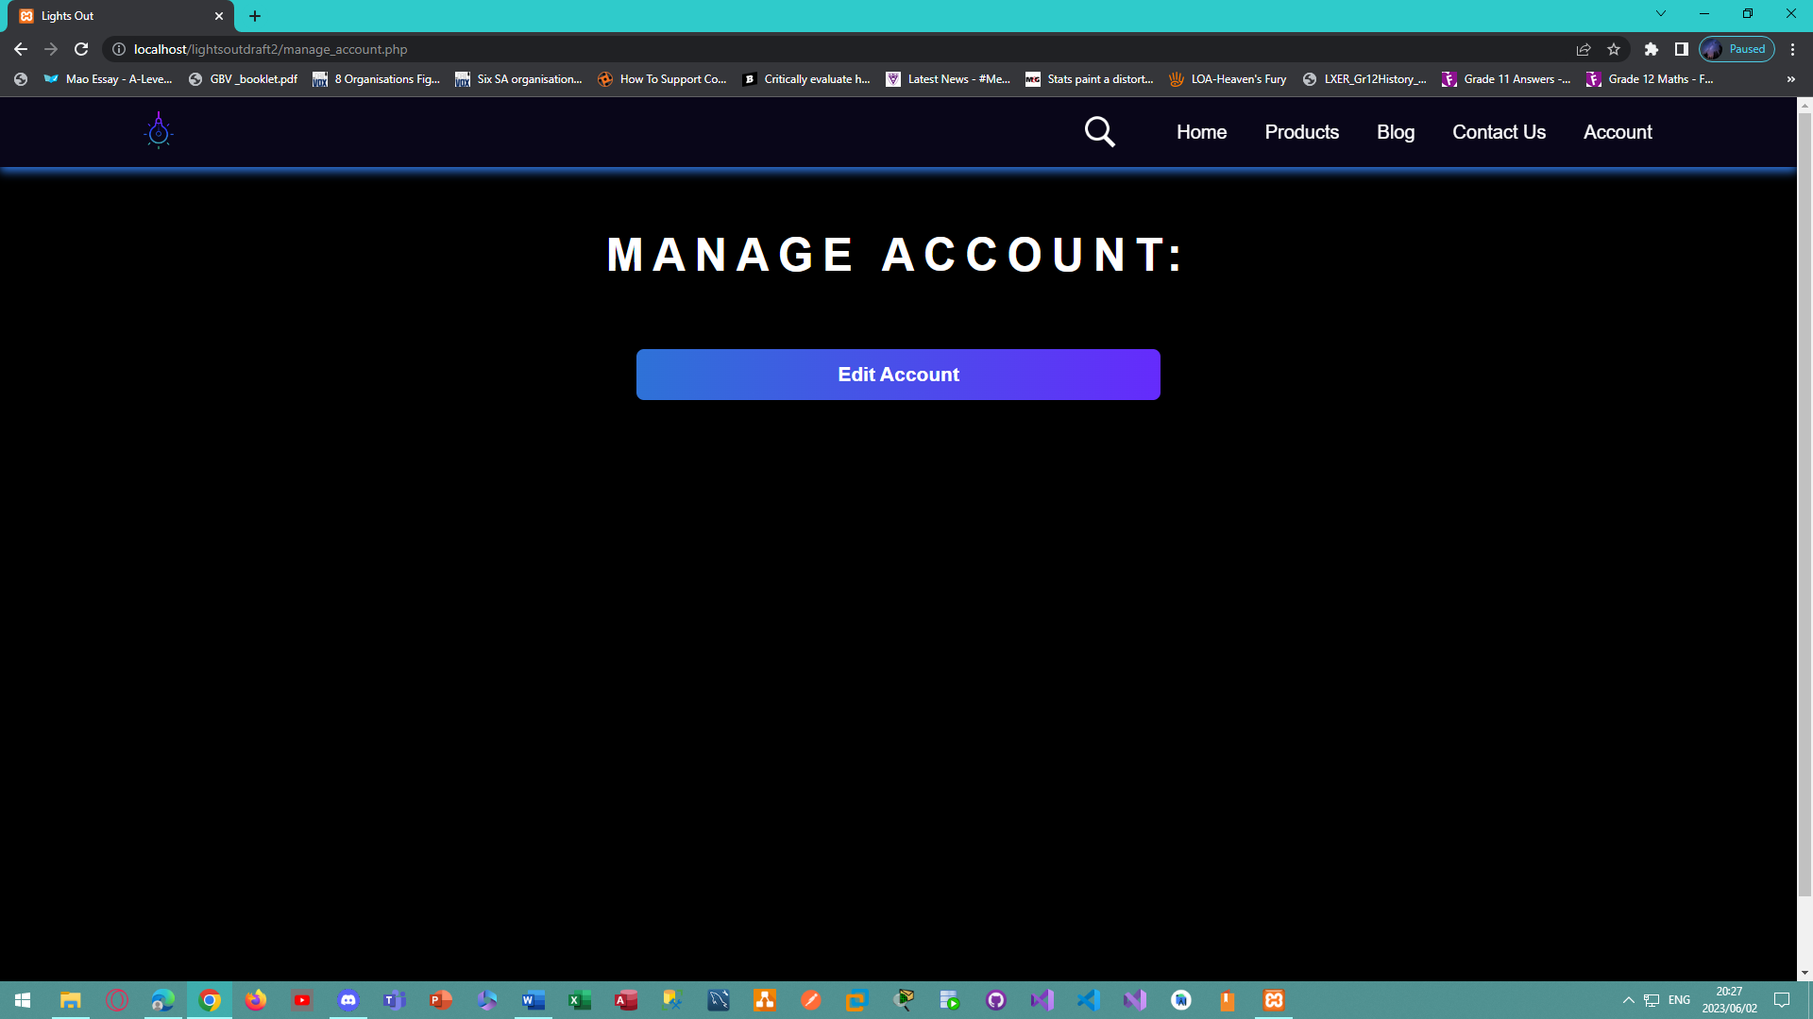

*Figure 114 - Desktop view of the manage account page for the Lights Out E-Commerce Website.*

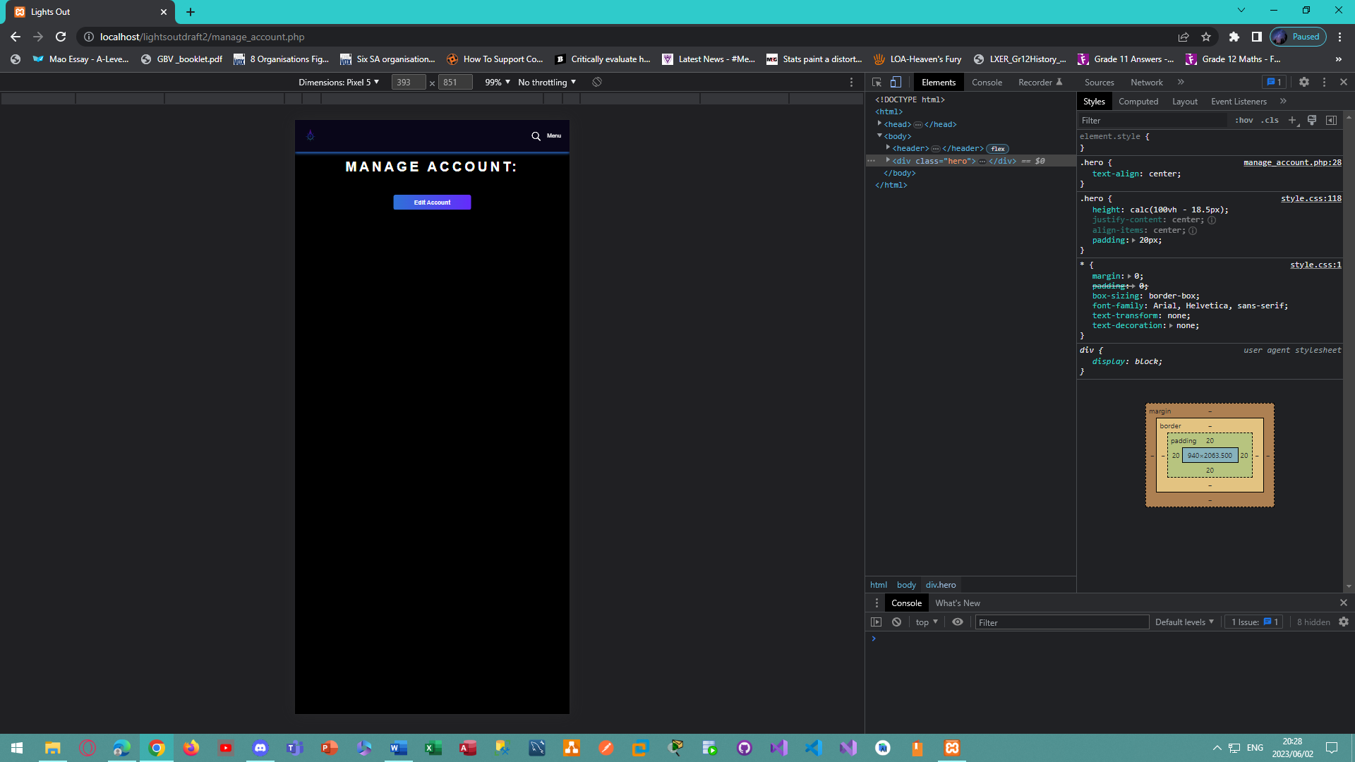

*Figure 115 - Mobile view of the manage account page for the Lights Out E-Commerce Website.*

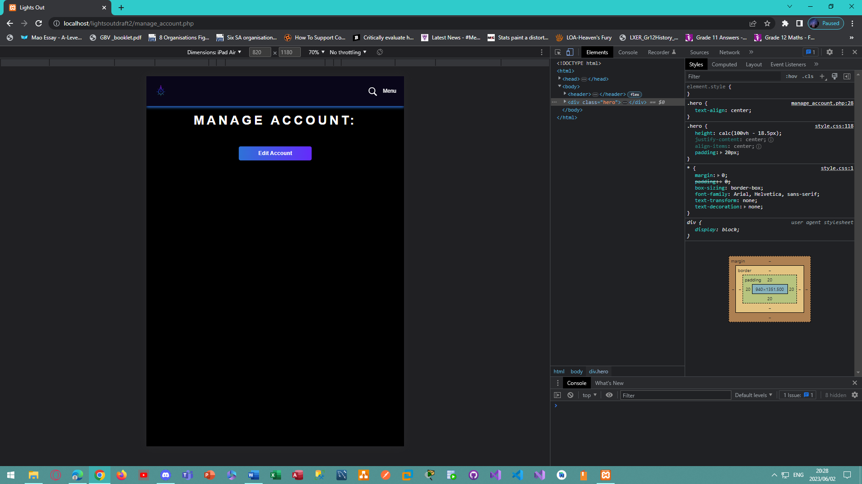

*Figure 116 - Tablet view of the manage account page for the Lights Out E-Commerce Website.*

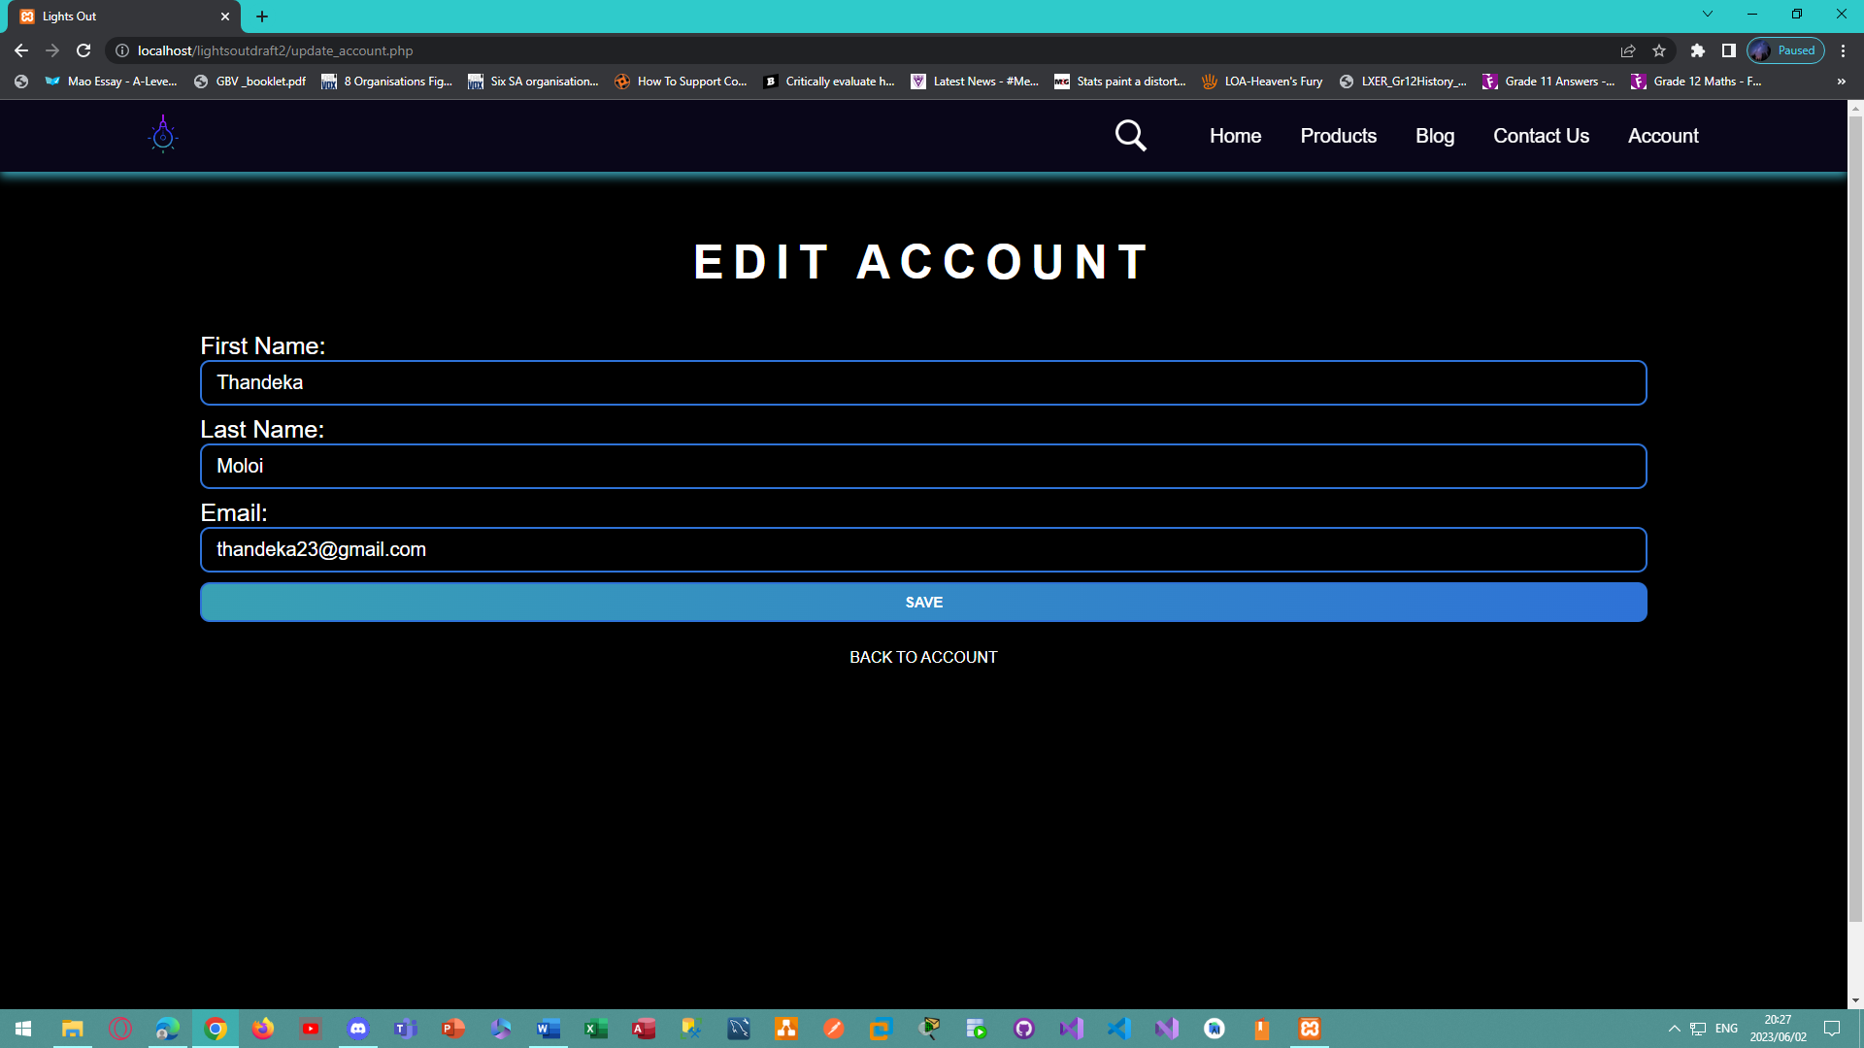

*Figure 117 - Desktop view of the edit account page for the Lights Out E-Commerce Website.*

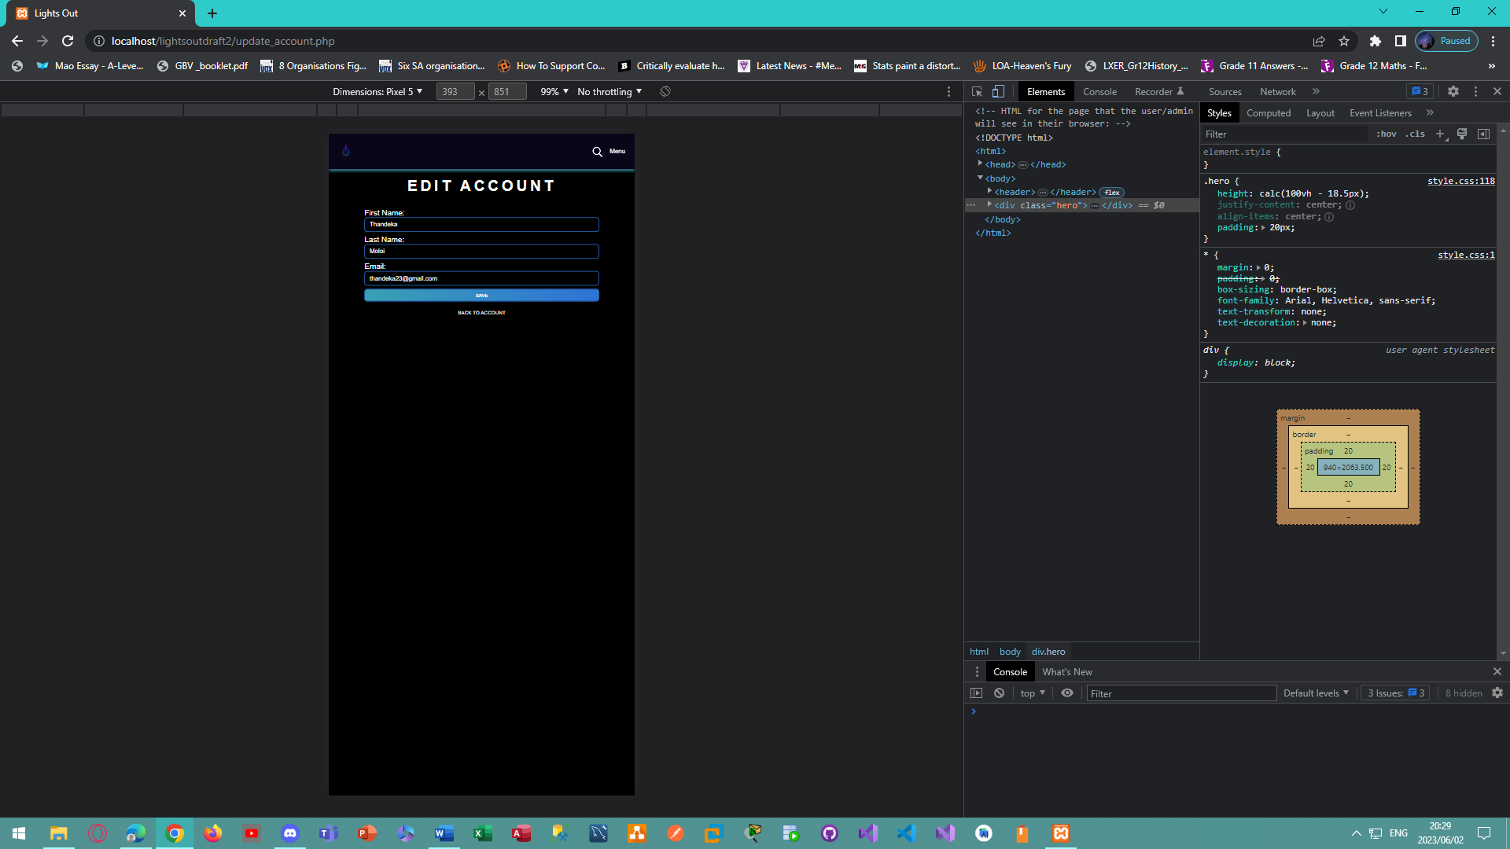

*Figure 118 - Mobile view of the edit account page for the Lights Out E-Commerce Website.*

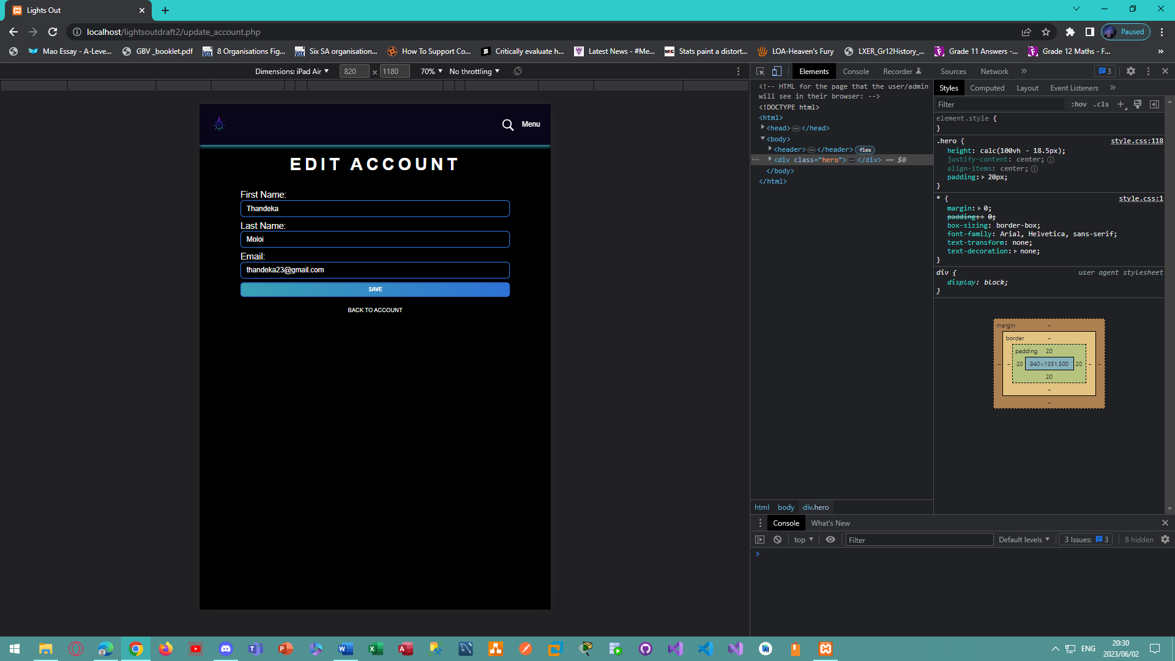

*Figure 119 - Tablet view of the edit account page for the Lights Out E-Commerce Website.*

## Sample PHP Code

The code below belongs to the **register.php** file, which is used to post the users details to the database so that they can be registered on the website:

<?php

    //Using the database configuration file:

    require_once('db_config.php');

    //This code is executed when the user clicks the submit button in the registration form:

    if(isset($_POST['submit'])) {

        //Retrieving the data from the form and storing it:

        $first_name = $_POST['first_name'];

        $last_name = $_POST['last_name'];

        $email = $_POST['email'];

        $pass = $_POST['pass'];

        $confirm_pass = $_POST['confirm_pass'];

       /* Hasing passwords for security purposes: */

        $hash_password=password_hash($pass, PASSWORD_DEFAULT);

        //Creating a connection to the database:

        $connect = mysqli_connect(DB_HOST,DB_USER,DB_PASSWORD,DB_NAME);

        if(!$connect) {//If the connection fails display an error:

            die("Connection failed! " . mysqli_connect_error());

        }

        /* Checking if the email entered already exists in the user table or vendor table before inserting: */

        /* Prepare the statement: */

        $email_exists=$connect->prepare("

        SELECT email

        FROM users

        WHERE email=?

        UNION ALL

        SELECT email

        FROM vendor

        WHERE email=?

        ");

        $email_exists->bind_param("ss",$email, $email); /* Bind the parameter: */

        $email_exists->execute(); /* Execute the statement: */

        $result=$email_exists->get_result(); /* Get the result: */

        /* If the email already exists, display an error message to the user: */

        if($result->num_rows>0){

            echo '<script>alert("This email address has already been used. Please use a different one.")</script>'; //Display an error message to the user:

            header('Refresh: 1; url=login.php'); //Redirect the user to the registration page after failing to register:

        }else{

            /* If the email does not exist, check if the password entered in both boxes are the same:  */

            if($pass===$confirm_pass){

                /* Insert into the users table: */

                //Prepare the statement for the users table:

                $create_user=$connect->prepare("

                INSERT INTO users (

                first_name,

                last_name,

                email,

                password

                )

                VALUES (?,?,?,?)

                ");

                $create_user->bind_param("ssss",$first_name,$last_name,$email,$hash_password); //Bind the parameters:

                //Execute the statement:

                /* If connection is successful and a row was affected, display a success message and redirect to the login page: */

                if($create_user->execute()){

                    if(mysqli_affected_rows($connect)>0){

                        echo '<script>alert("Thank you for registering with us!")</script>';

                        header('Refresh: 1; url=login.php');

                    }else{ //If the statement cannot be executed, display an error message and redirect to the login page:

                        echo "<div class='center-text'>";

                        echo    "<h2 style='color:#80eeff;'>Failed To Register. Please Try Again.</h2>";

                        echo "</div>";

                        header('Refresh: 1; url=login.php');

                    }

                }

                else{  //If executing the statement fails for any other reason, display an error message and redirect to the login page:

                    echo "<div class='center-text'>";

                    echo    "<h2 style='color:#80eeff;'>Failed To Register. Please Try Again.</h2>";

                    echo "</div>";

                    header('Refresh: 1; url=login.php');

                }

                //Closing the prepared statement:

                $create_user->close();

            }else{  /* Password and Confirm Password Do not Match, display an error message and redirect to the login page: */

                echo '<script>alert("The passwords you entered do not match. Please try again.")</script>';

                header('Refresh: 1; url=login.php');

            }

        }

        //Closing the prepared statement and the database connection:

        $email_exists->close();

        $connect->close();

    }

?>

The code above does the following:

1. It checks if the user clicked on the submit button, if they did then it executes the code.
2. It retrieves the data from the form and stores it in variables.
3. For security purposes, the password is hashed.
4. It connects to the database using the database details provided in the **db_config.php** file.
5. For security purposes prepared statements with parameterized queries are used. This is done so that any user input is automatically escaped, and it is used to prevent SQL injection attacks.
6. It checks if the email exists in the user table and the vendor table. If it exists, it will display an error message to the user and prompt the user to try and register again. If the email does not exist, then the password entered in the password and confirm password boxes are checked to see if they match. If both passwords match, then the data is inserted into the database. The user will receive a thank you message and be redirected to the login/register page.
7. If the code fails for any other reason, an error message is displayed to the user. The user will then be redirected back to the login/register page so that they can try again.
8. At the end of the file, the database connection and prepared statement are closed.

## Sample HTML Code

The code below belongs to the **login.php** file, which shows the login and register form, and enables users to switch between the two:

<!DOCTYPE html>

<html>

    <head>

        <!--Title of Web Page: Lights Out-->

        <title>Lights Out</title>

        <!--Referencing a CSS style sheet for the page-->

        <link rel="stylesheet" href="style.css">

        <style>

        body{ /* Adding a background image to the page: */

            width: 100%;

            padding: 20px;

            background-image: url(images/purple_and_gold.jpg);

            background-position:center;

            background-size:cover;

            background-attachment: fixed;

        }

        p{

            color: #fff;

            font-size: 25px;

        }

        .forgot_password{

            color: #ffffff;

            font-size: 17px;

            bottom:-30px;

            position: relative;

        }

        </style>

    </head>

    <body>

        <header>

            <!-- Including the file that contains the menu: -->

            <?php

                include 'menu.php';

            ?>

        </header>

        <div class="form_page"> <!-- The body of the page: -->

            <div class="form-box"> <!-- The login and register form: -->

                <div class="register_login_btn_box"> <!-- The buttons that switches between both the login and register form: -->

                    <div id="btn"></div>

                    <button type="button" class="toggle_register_login_btn" onclick="login()">Login</button> <!-- When the Login button is clicked call the login() function: -->

                    <button type="button" class="toggle_register_login_btn" onclick="register()">Register</button> <!-- When the Register button is clicked call the register() function: -->

                </div>

                <!--Create a login form for a user to enter their email and password:-->

                <form class="login_input_group" id="login" name = "login_form" action="vendor_and_user_login.php" method="POST">

                    <!-- Email Address: -->

                    <input type = "email" class="input_field" name = "email" placeholder = "Email address" required/>

                    <!-- Password: -->

                    <input type = "password" class="input_field" name = "password" placeholder = "Password" required/><br><br><br>

                    <!-- Button to submit the details to the database: -->

                    <button type="submit" name="submit" class="submit_btn">Login</button>

                    <div class="center-text">

                        <!-- Forgot Password:-->

                        <a href="forgot_password.php"><span class="forgot_password">Forgot Password?</span></a>

                    </div>

                </form>

                <!--Create a registration form that sends the information to the database:-->

                <form class = "login_input_group" id="register" name = "register_form" action = "register.php" method = "POST" onsubmit = "return(validate_registration());">

                    <!-- First Name: -->

                    <input type = "text" class="input_field" name = "first_name" placeholder = "First name" required/>

                    <!-- Last Name: -->

                    <input type = "text" class="input_field" name = "last_name" placeholder = "Last name" required/>

                    <!-- Email Address: -->

                    <input type = "email" class="input_field" name = "email" placeholder = "Email address" required/>

                    <!--Password:-->

                    <input type = "password" class="input_field" name = "pass" placeholder = "Password" required/>

                    <!-- Confirm Password: -->

                    <input type = "password" class="input_field" name = "confirm_pass" placeholder = "Confirm password" required/>

                    <!-- Agree to terms and conditions checkbox -->

                    <input type="checkbox" class="check_box" id="agree_checkbox"><span class="remember_password" required>I agree to the terms & conditions</span>

                    <!--Button to submit the form:-->

                    <button type="submit" name="submit" class="submit_btn">Register</button>

                </form>

            </div>

            <footer> <!-- Have a terms and conditions appear at the bottom of the page: -->

                <div class="center-text">

                <p><i>Terms & Conditions: By creating an account you agree to share your full name and email address with the Lights Out company.</i></p>

                </div>

            </footer>

        </div>

        <!--Use an external javascript file named validate.js to validate the form:-->

        <script src="validate.js"></script>

    </body>

</html>

The code does the following:

1. It creates two forms (a login form and register form) with a button on the top of the page to switch between the two. JavaScript is used for this animation.
2. The login form enables users to log in using the account that they created on the website. It uses a class called ‘login_input_group’ so that it can be styled using CSS. It uses a name called ‘login_form’ so that it can be uniquely identified from other forms that are present in the code folder. Its action is set to ‘vendor_and_user_login.php’
3. The register form enables users to register an account on the website. It uses a class called ‘login_input_group’ so that it can be styled using CSS. It uses a name called 'register_form’ so that it can be uniquely identified from other forms that may be present in the code folder. Its action is set to ‘**register.php**’, this means that when the submit button is clicked, the **register.php** file will be executed.
4. All textboxes are marked as required; this is to ensure that no empty values are submitted to the database.
5. The email textbox uses ‘input type=”email” ’, this is to ensure that only valid email addresses are being used.
6. The password textbox uses ‘input type=”password” ’, this is to ensure that when users enter their password, it is hidden.
7. An additional hyperlink is added to the bottom of the login form, it is responsible for redirecting the user to the ‘forgot password page’ if they want to reset their password.
8. A checkbox is added to the bottom of the registration form, this is to ensure that users agree to the terms and conditions before creating an account.

The login.php page is shown below:

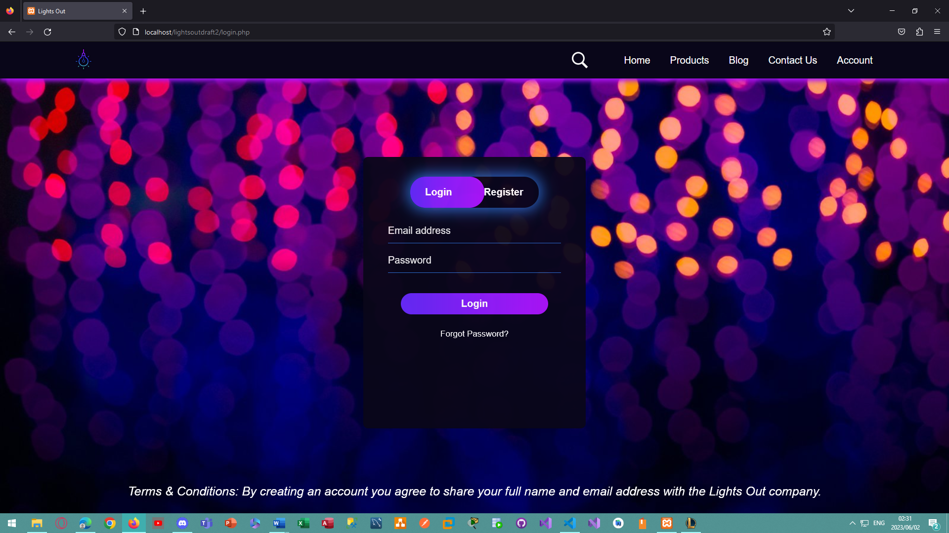

*Figure 120 - The login page for the Lights Out E-Commerce Website.*

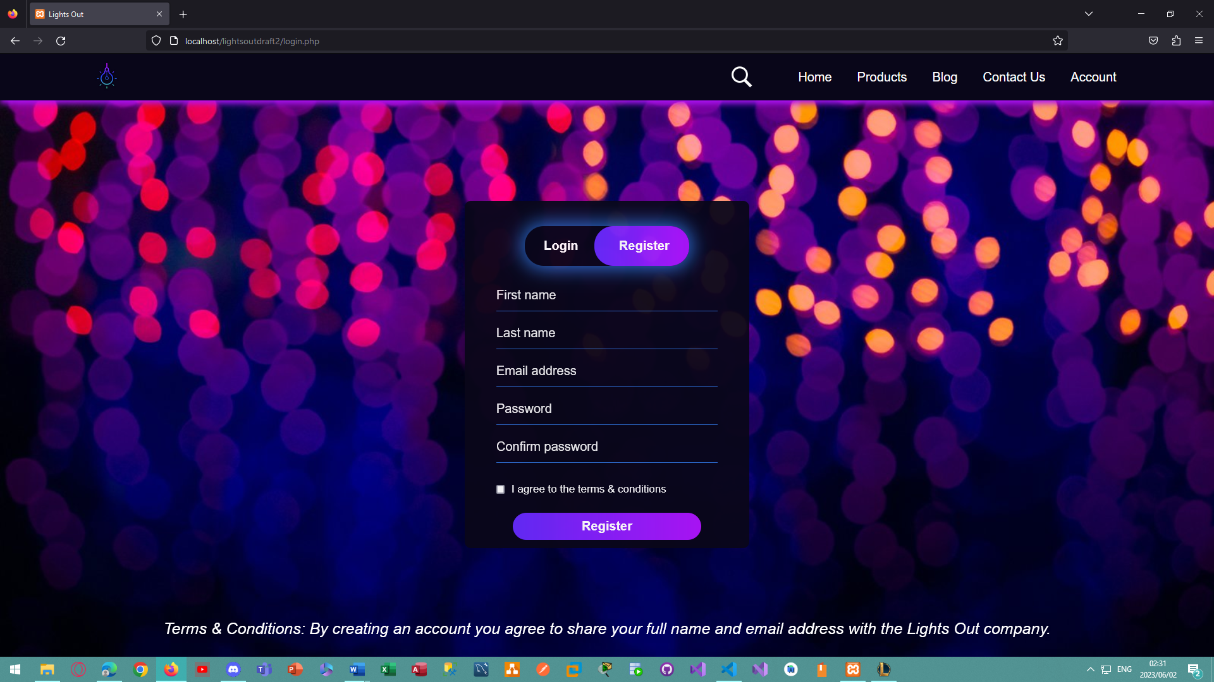

*Figure 121 - The register page for the Lights Out E-Commerce Website.*

## Sample JavaScript Code

This code belongs to an external JavaScript file named **validate.js** and is responsible for:

* Validating the user input in the contact us form on the website. Trim is used to remove whitespaces at the start and end of the line, this is done so that users cannot submit an empty form.
* Shifting the Login and Register form based on what button the user clicks on.
* Providing a check to ensure that users click on the checkbox and accept the terms and conditions before creating an account.

//Validate the contact us form before sending the details to the database:

function contactValidate()

{

    if(document.contactus.firstname.value.trim() == ""){//If First Name is empty:

        alert("Please enter your first name");

        document.contactus.firstname.focus();

        return false;

    }

    if(document.contactus.lastname.value.trim() == ""){//If Last Name is empty:

        alert("Please enter your last name");

        document.contactus.lastname.focus();

        return false;

    }

    if(document.contactus.email.value.trim() == ""){ //If Email is empty:

        alert("Please enter your email address");

        document.contactus.email.focus();

        return false;

    }

    if(document.contactus.comments.value.trim() == ""){ //If Comments are empty:

        alert("Please enter any comments or suggestions");

        document.contactus.comments.focus();

        return false;

    }

}

/* Using Javascript to shift between both forms in the login.php file based on if the user clicks on the Login or Register button:  */

var x=document.getElementById("login");

var y=document.getElementById("register");

var z=document.getElementById("btn");

function login(){ /* If the user clicks on Login, shift the form into view and hide the other form: */

    x.style.left="50px";

    y.style.left ="450px";

    z.style.left = "0";

}

function register(){ /* If the user clicks on Register, shift the form into view and hide the other form: */

    x.style.left="-400px";

    y.style.left ="50px";

    z.style.left = "110px";

}

//Validate the registration form before sending the details to the database:

function validate_registration(){

    var agree_checkbox=document.getElementById("agree_checkbox"); /* Store the agree to the terms and conditions checkbox from the regisration form: */

    if (!agree_checkbox.checked){ /* If the box is left unchecked upon submission display an alert to the user: */

        alert("Please agree to the terms and conditions before registering.");

        return false; //Prevent the form from being submitted:

    }

    return true; //Alow the form to be submitted once the checkbox is checked:

}

## Sample CSS Code

This code belongs to an external file named **style.css** and is responsible for styling the forms, pages, menu, account, and products on the website:

*{

    margin: 0;

    padding: 0;

    box-sizing: border-box;

    font-family: Arial, Helvetica, sans-serif;

    text-transform: none;

    text-decoration: none;

}

body{

    margin-top: 100px;

    background-color:rgb(0, 0, 0);

}

header{

    position: fixed;

    top:0;

    left:0;

    right:0;

    background:rgb(9,6,25,1); /* Color of the menu :) */

    box-shadow: 0 5px 10px rgb(176,20,252,1);

    padding:0px 7%;

    display: flex;

    align-items: center;

    justify-content: space-between;

    z-index: 1000;

}

header .logo{ /* Styling the logo */

    font-weight: bolder;

    font-size: 25px;

    color: #000000;

    width:70px;

    height:auto;

    border-radius: 10px;

}

header .cart{ /* Styling the cart icon */

    margin-top: -10px;

    font-weight: bolder;

    font-size: 25px;

    color: #000000;

    width:40px;

    height:auto;

    border-radius: 10px;

}

.menu-item{

    display: flex;

    align-items: center;

}

header .navbar ul{

    list-style: none;

}

header .navbar ul li{

    position: relative;

    float:left;

}

header .navbar ul li a{

    font-size: 20px;

    padding:20px;

    color: #ffffff;

    display: block;

}

header .navbar ul li a:hover{

    background: #000000;

    color:rgb(101,43,252,1);

}

header .navbar ul li ul{

    position: absolute;

    left:0;

    width: 200px;

    background: #000000; /* changes colour of sub menu */

    display:none;

}

header .navbar ul li ul li{

    width: 100%;

    border-top: 1px solid rgb(0, 0, 0);

}

header .navbar ul li ul li ul{

    left: 200px;

    top:0;

}

header .navbar ul li:focus-within > ul, header .navbar ul li:hover > ul{

    display: initial;

}

#menu-bar{

    display: none;

}

header label{

    font-size: 20px;

    color:#ffffff;

    cursor: pointer;

    display:none;

}

.hero{

    height: calc(100vh - 18.5px);

    justify-content: center;

    align-items: center;

    padding: 20px;

}

.hero h1 {

    color: #ffffff;

    font-size: 3vw;

    margin-bottom: 20px;

}

.hero h1.main-header {

    text-align: center;

    font-size: 3em;

    font-family: 'Montserrat', sans-serif;

    text-transform:uppercase;

    letter-spacing: 0.2em;

    margin-top: 0;

    margin-bottom: 0.5em;

    color: #ffffff;

    text-shadow: 2px 2px #000000;

}

.main-header{

    color:#fff;

    padding: 20px;

    text-align: center;

}

input::placeholder, textarea::placeholder{ /* The text that appears inside the blocks in the forms*/

    position: absolute;

    left: 20px;

    top: 0px;

    padding-top: 5px;

    color: #ffffff;

    opacity: 95%;

    font-size: 20px;

}

.contactus-form, .login-form, .register-form, .update-form, .addproduct-form, .update-blog-form, .update-account-form{

    margin: 0 auto;

    width: 80%;

}

.contactus-form input, .contactus-form textarea, .login-form input, .login-form textarea, .register-form input, .register-form textarea, .update-form input, .update-form textarea, .addproduct-form input, .addproduct-form textarea, .update-blog-form input, .update-blog-form textarea, .update-account-form input, .update-account-form textarea{

    width: 100%;

    padding:10px 15px;

    margin-bottom: 10px;

    border: 2px solid rgb(46,114,215,1);

    border-radius: 10px;

    background-color: transparent;

    color: rgb(255, 255, 255);

    font-size: 20px;

}

.contactus-form button, .login-form button, .register-form button, .update-form button, .addproduct-form button, .update-blog-form button, .update-account-form button{

    width:100%;

    padding: 10px 15px;

    border: 2px solid rgb(46,114,215,1);

    border:none;

    margin-bottom: 50px;

}

.contactus-form textarea, .login-form textarea, .register-form textarea, .update-form textarea, .addproduct-form textarea, .update-blog-form textarea, .update-account-form textarea{

    resize:none;

    height:80px;

}

.center-text{

    text-align: center;

}

.form-content{

    width:100%;

    background-color: #000000;

    color:#000000;

    padding:10px;

    opacity: 95%;

    border-radius: 20px;

}

h1{

    color: #ffffff;

}

label {

    color:#ffffff;

    font-family: Arial, Helvetica, sans-serif;

}

.button {

    transition-duration: 0.4s;

    text-transform: uppercase;

}

.button:hover{

    background-color: #d1edf6;

    color: #101516;

    text-transform: uppercase;

}

input[type=submit]{

    background-color: rgb(53,149,189,1);

    color: rgb(255, 255, 255);

    font-weight:bold;

    font-size: 15px;

    text-transform: uppercase;

}

.products { /*Default style for all device screen sizes*/

    display:flex;

    flex-wrap:wrap;

    justify-content: space-between;

}

.products ul{

    list-style:none;

    margin: 0;

    padding:0;

    display:flex;

    flex-wrap:wrap;

    justify-content: space-between;

}

.products li {

    flex: 0 0 19%;

    border: 2px solid #ffffff;

    border-radius: 10px;

    margin-bottom: 1.5em;

    display:flex;

    flex-direction: column;

    align-items: center;

    text-align: center;

    height: 450px;

    padding: 20px;

    margin: 5px;

}

h3 {

    font-size: 24px;

    margin: 10px 0;

    color:#ffffff;

}

h5{

    font-size: 1.5em;

    color:#ffffffa3;

}

/* Products Page: Added on 10 May 2023: */

.products-row{ /* Code to style the products from the database */

    display:flex;

    flex-wrap: wrap;

}

.product{

    width:50%;

    padding:10px;

    box-sizing: border-box;

    display: flex;

    border: 2px solid rgb(46,114,215,1);

    border-radius: 10px;

    justify-content: space-between;

    margin-bottom: 20px;

}

.product-img{ /* Images displayed with each product*/

    width:11em;

    max-width: 11em;

    height: 11em;

}

.product-info {

    display: flex;

    flex-direction: column;

    justify-content: center;

    margin-left: 20px;

    flex:1;

}

.product-title{

    margin-top:0;

    margin-bottom:10px;

}

.product-price-discount{

    margin-top: 10px;

    font-family: Montserrat, sans-serif;

    font-size: 1.2em;

    font-weight: bold;

    color: #ffffff;

}

.product_details_description{

    font-size:1.5em;

    color: rgb(255, 255, 255);

    margin-bottom: 10px;

    text-align: justify;

}

.product_details_page{

    display: flex;

    justify-content: space-between;

    align-items: center;

    margin-top: 50px;

}

.product_details_image_box{

    flex: 0 0 40%;

}

.product_details_img{

    width:35em;

    max-width: 35em;

    height: 35em;

    border-radius: 10px;

    margin-left:150px;

}

.product_details_info{

    flex: 0 0 60%;

    display: flex;

    flex-direction: column;

    justify-content: center;

}

.product_details_price{

    font-family: Montserrat, sans-serif;

    font-size: 2em;

    font-weight: bold;

    color: rgb(255, 255, 255);

    margin: 10px 0;

}

.viewbutton, .addbutton, .updatebutton, .deletebutton, .extrabutton, .register-btn, .login-btn, .guest-btn { /* Button when clicking on products */

    cursor: pointer;

    display: block;

    padding: 3px;

    width:50%;

    background-color: rgb(101,43,252,1);

    color: #ffffff;

    opacity: 100%;

    font-size: 16px;

    font-weight: bold;

    text-align: center;

    border: 2px solid rgb(0, 0, 0);

    border-radius: 10px;

    transition: background-color 0.3s ease-in-out;

    text-decoration: none;

}

a.viewbutton, a.addbutton, a.updatebutton, a.deletebutton{

    display: inline-block;

    text-decoration: none;

}

/*Styling for smaller screens:*/

@media (max-width: 1080px){ /* Screens with a width of 1080px: */

    header{

        padding:20px;

        display: flex;

        align-items: center;

    }

    header label{

        display:initial;

        margin-right: 10px;

    }

    header .navbar{

        position: absolute;

        top:100%;

        left:0%;

        right:0%;

        background:#000000;

        border-top: 2px solid rgba(176,20,252,1);

        border-bottom: 2px solid rgba(176,20,252,1);

        display:none;

    }

    header .navbar ul li{

        width:100%;

    }

    header .navbar ul li ul{

        position:relative;

        width: 100%;

    }

    header .navbar ul li ul li{

        background: #000000;

    }

    header .navbar ul li ul li ul{

        width: 100%;

        left:0;

    }

    #menu-bar:checked ~ .navbar{

        display: initial;

    }

    .product{

        width:100%;

        height:13em;

        margin-bottom: 10px;

    }

    .product-info{

        margin-left:1;

    }

    .product_details_page{

      flex-direction: column;

      align-items: center;

    }

    .product_details_image_box{

        margin-bottom: 20px;

    }

    .product_details_img{

        width: 25em;

        height: auto;

        margin-left: 0px;

    }

    .product_details_info{

        text-align: center;

    }

    .hero h1{

        font-size: 6vw;

    }

}

/* Adjusting for even smaller screens: */

@media(max-width:480px){ /* Screens with a width of 480px: */

    table{ /* Table to display the users' information on the account page */

        font-size:2em;

    }

}

@media(max-width:412px){ /* Screens with a width of 412px: */

    table{ /* Table to display the users' information on the account page */

        font-size:1.5em;

    }

    .back_to_products{

        margin-left:0;

    }

}

@media(max-width:320px){ /* Screens with a width of 320px: */

    table{ /* Table to display the users' information on the account page */

        font-size:1em;

    }

}

.scroll-menu{ /*scroll menu for the home page*/

    display:flex;

    gap:20px;

    overflow-x: auto;

    padding:15px;

    justify-content: flex-start;

    border: 2px solid rgb(57,161,180,1);

    background-color: transparent;

    border-radius: 20px;

}

.snaps-inline{ /*snapping for scroll menu*/

    scroll-snap-type: inline mandatory;

    scroll-padding-inline: var(1rem);

}

.snaps-inline >*{

    scroll-snap-align: start;

}

.scroll-menu img{ /*images on the home page*/

    height: 450px;

    line-height: 450px;

    text-align: center;

    margin-right:2px;

    border-radius: 10px;

    transition: all 0.3s ease-in-out;

}

.special-img{ /*images and their labels on the home page*/

    display:grid;

    grid-template-rows: min-content;

    gap: var(1rem);

    padding: var(1rem);

    background: var(--surface-2);

    border-radius: var(--radius-2);

}

.scroll-menu img:hover{ /*hovering over images on the home page*/

    transform: scale(1.02);

    box-shadow: 0px 0px 15px rgba(0, 0, 0, 0.7);

}

/* Account Page: Added on 26 May 2023 */

.user-info{

    width: 80%;

    background-color: #000000;

    border: 2px solid rgb(46,114,215,1);

    border-radius: 10px;

    margin: 0 auto;

    display: flex;

    flex-direction: column;

    align-items:center;

    justify-content:center;

    padding:30px;

    text-align: justify;

    padding: 50px;

}

table{ /* Table to display the users' information on the account page */

    border-collapse: collapse;

    color: #ffffff;

    font-family: 'Arial',sans-serif;

    font-weight: bold;

    width:100%;

    font-size:2.5em;

}

th,td{

    padding: 8px;

    text-align: left;

}

.back_to_products{

    display: block;

    padding:12px;

    color:rgb(255, 255, 255);

    font-size: 25px;

    margin-top: -20px;

    text-decoration: none;

    margin-left:50px;

}

.back_to_products:hover{

    color:rgb(101,43,252,1);

}

.next_page_button{

    display: block;

    text-align: center;

    margin-top:-10px;

    color:rgb(0, 0, 0)

}

.next_page_button a {

    display: inline-block;

    padding: 10px 20px;

    color:#ffffff;

    text-decoration: none;

    border-radius: 10px;

}

/* Styling for the login and register form: Added 31 May 2023*/

.form-box{ /* For the form */

    width: 450px;

    height:550px;

    position: relative;

    margin: 6% auto;

    background-color: rgb(9,6,25,1);

    opacity: 95%;

    border-radius: 10px;

    padding: 5px;

    overflow: hidden;

}

.register_login_btn_box{

    width: 260px;

    margin: 35px auto;

    position: relative;

    box-shadow: 0 0 30px 5px rgb(46,114,215,1);

    border-radius: 30px;

}

.toggle_register_login_btn{

    padding: 20px 30px;

    cursor: pointer;

    background: transparent;

    border: 0;

    outline: none;

    position: relative;

    color: #ffffff;

    font-weight: bold;

    font-size: 20px;

}

#btn{

    top:0;

    left: 0;

    position: absolute;

    width: 150px;

    height: 100%;

    background: linear-gradient(to right, rgb(101,43,252,1), rgb(176,20,252,1));

    border-radius: 30px;

    transition: .5s;

}

.login_input_group{

    top:120px;

    position: absolute;

    width: 350px;

    transition: .5s;

}

.login_input_group input{

    color: #ffffff;

    font-size: 25px;

}

.input_field{

    width:100%;

    padding: 10px 0;

    margin: 5px 0;

    border-left: 0;

    border-top: 0;

    border-right: 0;

    border-bottom: 1.5px solid rgb(46,114,215,1);

    outline: none;

    background: transparent;

}

.submit_btn{

    width: 85%;

    padding: 10px 30px;

    cursor: pointer;

    display: block;

    margin: auto;

    background: linear-gradient(to right, rgb(101,43,252,1), rgb(176,20,252,1));

    color: #ffffff;

    font-weight: bold;

    font-size: 20px;

    border: 0;

    outline: none;

    border-radius: 30px;

}

.check_box{

    margin: 30px 10px 30px 0;

}

.remember_password{

    color: #ffffff;

    font-size: 17px;

    bottom: 70px;

    position: absolute;

}

#login{

    left:50px

}

#register{

    left:450px

}

## Sample MySQL Table Screenshots

### Vendor Table:

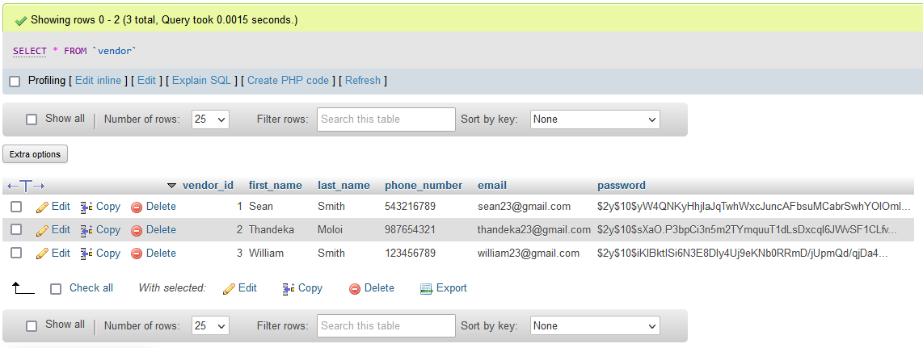

*Figure 122 - Data for the Vendor table in MySQL*

### Users Table:

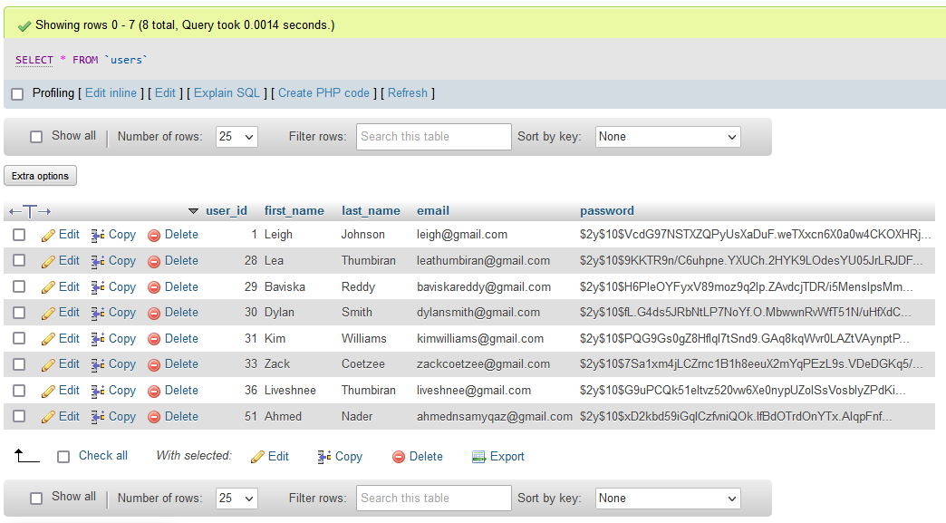

*Figure 123- Data for the Users table in MySQL*

### Products Table:

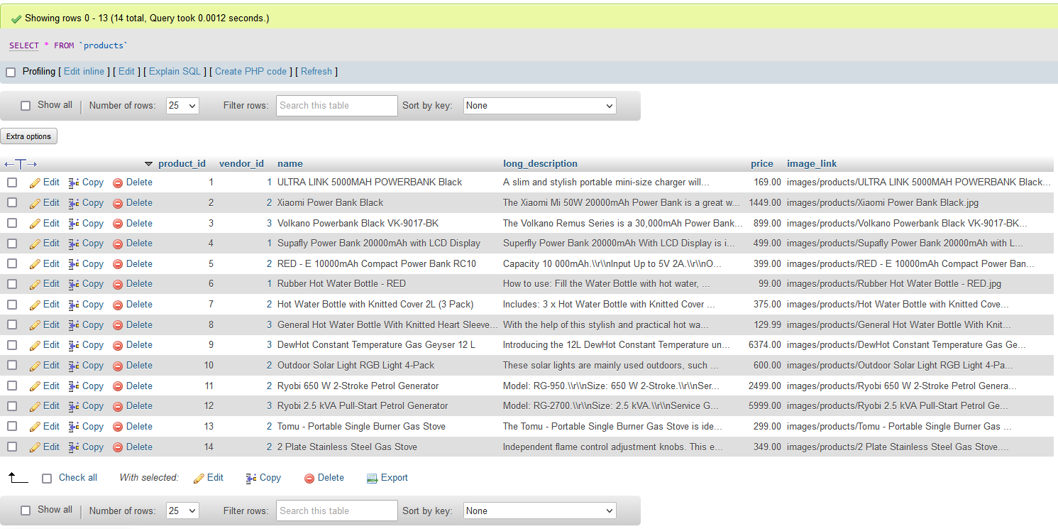

*Figure 124 - Data for the Products table in MySQL*

### Blog Post Table:

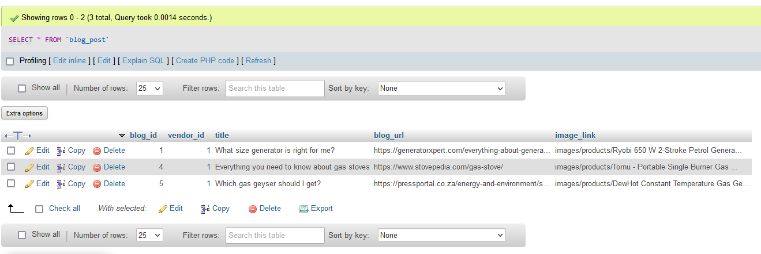

*Figure 125 - Data for the Blog Post table in MySQL*

### Cart Table:

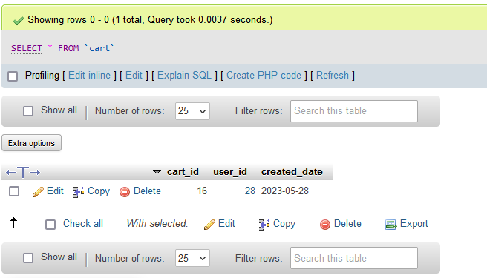

*Figure 126 - Data for the Cart table in MySQL*

### Cart Product Table:

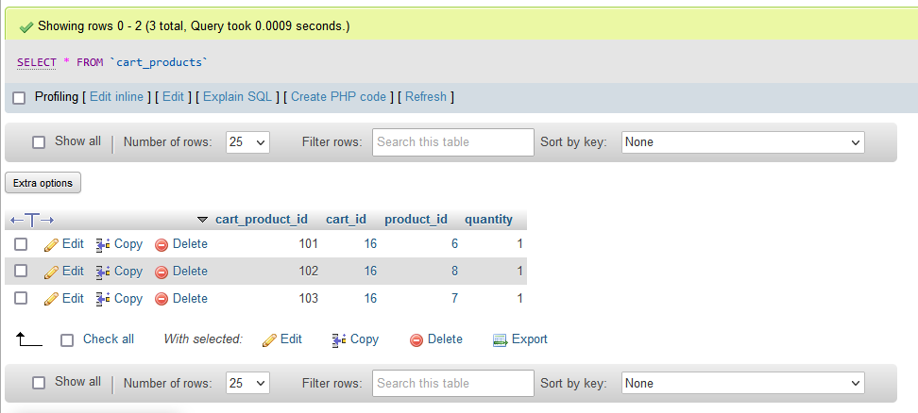

*Figure 127 - Data for the Cart Product table in MySQL*

### Feedback Table:

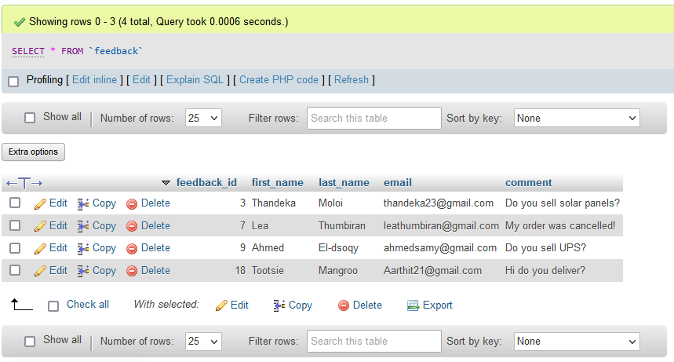

*Figure 128 - Data for the Feedback table in MySQL*

### Reference Numbers Table:

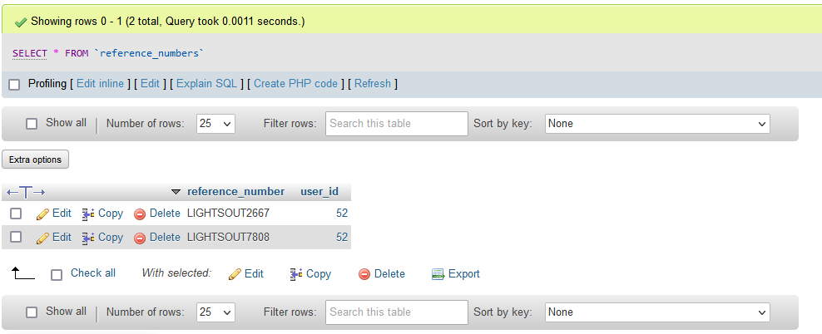

### Orders Table:

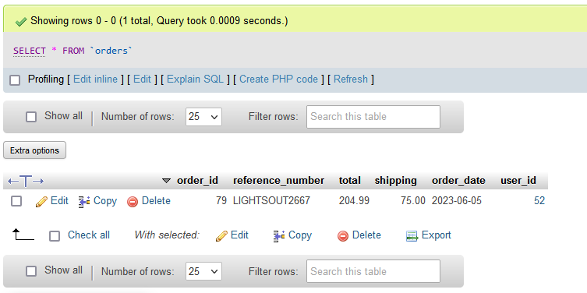

### Order Details Table:

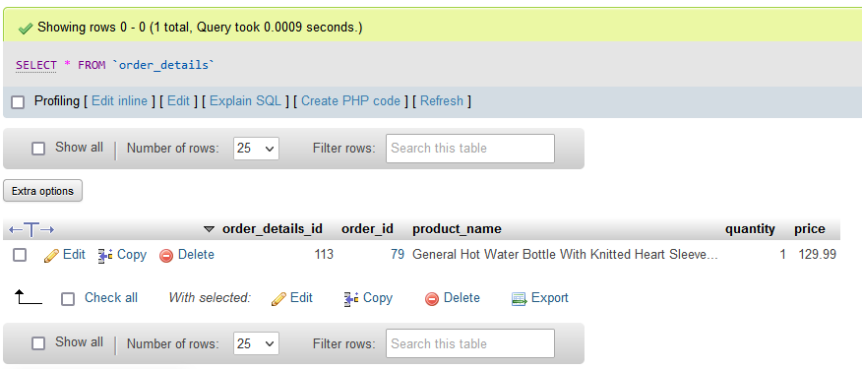

## Security Features for The Website

### SQL prepared statements:

SQL prepared statements can be viewed as templates for SQL (Structured Query Language) queries (TutorialRepublic, 2023). These statements contain placeholders (such as ‘?’) instead of the actual values for each parameter (TutorialRepublic, 2023).

This is shown below:

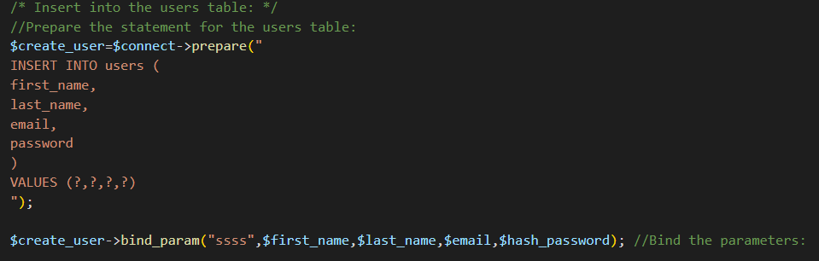

*Figure 129 - Showing a prepared statement used to insert data into the database so that users can register an account on the website.*

When the statement is executed, the placeholder values are sent to the database server instead of the entire SQL statement (TutorialRepublic, 2023). This can improve the efficiency of the website and minimize its bandwidth usage (TutorialRepublic, 2023).

SQL prepared statements further provide security benefits, such as preventing SQL injection attacks (TutorialRepublic, 2023). SQL injection attacks are a type of code injection technique used to retrieve user information or confidential data from websites, this is done by using SQL commands as statements (Kaur, 2018). Prepared statements can help prevent this type of attack as the parameter values are not embedded into the SQL query directly (TutorialRepublic, 2023). The parameter values are sent to the database server separately, so in other words, an attacker cannot manipulate the query or interfere with it (TutorialRepublic, 2023).

This e-commerce website ensures that all SQL statements are prepared.

### Hash Functions:

These are functions that use cryptographic algorithms to process data into a unique one-way message digest (McMillan, 2018). Message digests are used to represent the original data but cannot be reversed to recover that original data (McMillan, 2018). Since message digests are unique, they can be used to check the integrity of the data (McMillan, 2018).

The user passwords for this e-commerce website are hashed. This is shown below:

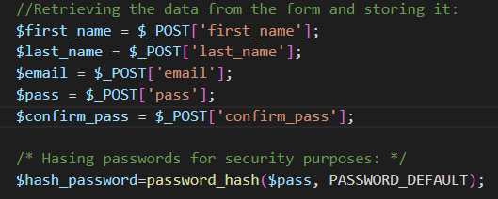

*Figure 130 - Fetching the users' account details from the registration form, then hashing their password.*

The cryptographic algorithm used to hash the user passwords is shown below:

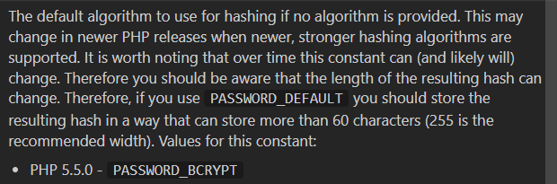

*Figure 131 - Details about the PASSWORD_DEFAULT algorithm to hash passwords.*

After the users’ password is converted into a hash value that has a fixed length, the hash value is then stored in the database (McMillan, 2018). This is shown below:

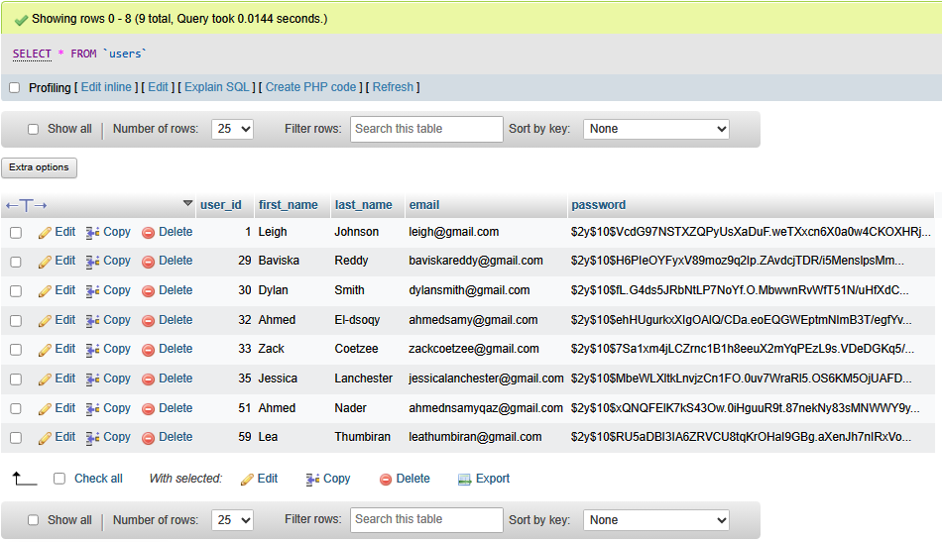

*Figure 132 The Hashed user passwords that are stored in the database.*

By hashing passwords, this ensures that even if the database or website becomes compromised, the attacker cannot interpret the users’ passwords (McMillan, 2018).

### TLS certificates:

Transport Later Security (TLS) certificates are used to secure online transactions and connections to the internet by encrypting the data (Proton, 2020). By encrypting this data, the chances of an attacker intercepting this data is reduced (Proton, 2020).

When a user clicks on this e-commerce website, they can view the status of their connection and can determine whether it is secure or not, this is seen below:

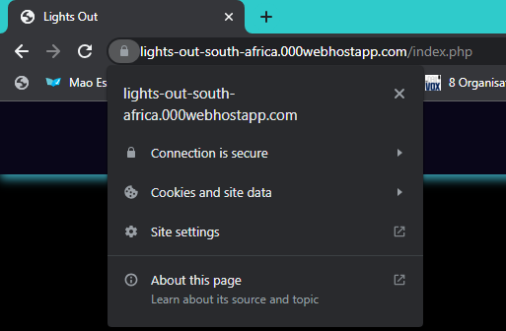

*Figure 133 - Displaying the status of the users’ connection to the e-commerce website.*

The user can click on ‘Connection is secure’ to view more details:

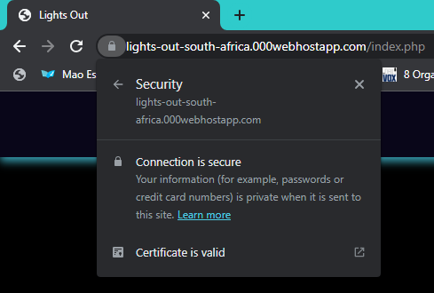

*Figure 134 - Displaying more details about the connection to the user.*

The user can view the certificate that was issued for the e-commerce website, as well as which organization issued it, the date it was issued and the date it will expire:

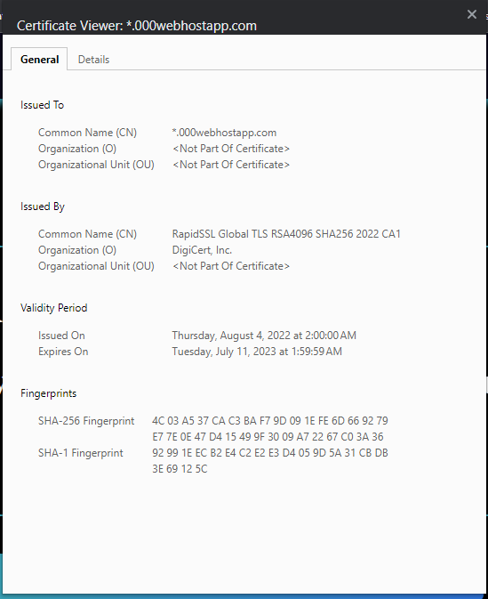

*Figure 135 – The TLS certificate details for the e-commerce website.*

# 2.5 Conclusion

After providing screenshots of prototype 1 and prototype 2 as well as design diagrams, code samples, screenshots of the website and screenshots of the database tables and security features for the Lights Out e-commerce website, the client selected prototype 2. The website is expected to be completed by 14 June 2023.

# 2.6 Sign-Off

|  |  |  |  |
| --- | --- | --- | --- |
|  |  |  |  |
| [Sean Smith,  Project Client    Date: 2023-06-07 |  |  | Lea Thumbiran, Developer/Project Manager    Date: 2023-06-07 |

# Bibliography

Ambler, S., 1998. *CRC Modeling: Bridging the Communication Gap Between Developers and Users An AmbySoft Inc. White Paper The Object Primer: The Application Developer’s Guide to Object-Orientation -and - Process Patterns: Building Large-Scale Systems Using Object Technology*. [Online] Available at: <http://www.uml.org.cn/umlapplication/pdf/crcmodeling.pdf> [Accessed 21 May 2023].

Babich, N., 2022. *Dropdown menu in Figma*. [Video] Available at: <https://youtu.be/MTKttcfEkKk> [Accessed 21 May 2023].

Bellekens, G., 2016. *How to create a UML use case diagram that has options for the same use case?* [Online] Available at: <https://stackoverflow.com/questions/12753683/how-to-create-a-uml-use-case-diagram-that-has-options-for-the-same-use-case> [Accessed 21 May 2023].

BoostMyTool, 2022. *[FIXED] XAMPP Error: MySQL shutdown unexpectedly | Repair Corrupted Database*. [Online] Available at: https://youtu.be/84IOtc05TuA [Accessed 2 June 2023].

Codelone, 2021. *SOLVED: Ftp_put(): Can’t open that file: No such file or directory in 000webhost file manager*. [Video] Available at: https://youtu.be/gGbuo2G74ko [Accessed 2 June 2023].

Connolly, T.M. and Begg, C.E., 2015. *Database systems : a practical approach to design, implementation, and management*. 6th ed. Harlow: Pearson Education Limited.

Cooper, T., 2011. *CSS opacity only to background color, not the text on it?* [Online] Available at: https://stackoverflow.com/questions/5135019/css-opacity-only-to-background-color-not-the-text-on-it [Accessed 2 June 2023].

Coronel, C. and Morris, S., 2016. *Database systems design, implementation, and management*. 12th ed. Boston: Cengage Learning.

Cubillas, E.J., 2019. *How to Upload a Website in 000webhost for FREE*. [Video] Available at: https://youtu.be/QpAJ5-hK-Hc [Accessed 2 June 2023].

Easy Tutorials, 2019. *How To Make Login & Registration Form Using HTML And CSS Step By Step*. [Online] Available at: https://www.youtube.com/watch?v=L5WWrGMsnpw [Accessed 2 June 2023].

edrawsoft, 2023. *What is an EER Diagram?* [Online] Edrawsoft. Available at: <https://www.edrawsoft.com/article/what-is-eer-diagram.html> [Accessed 21 May 2023].

educative.io, 2023. *How to connect an HTML form to a MySQL database in PHP*. [Online] Available at: <https://www.educative.io/answers/how-to-connect-an-html-form-to-a-mysql-database-in-php> [Accessed 28 May 2023].

FidelTech, 2023. *Login system for users from differents tables HTML+CSS+PHP+MYSQL*. [Video] Available at: <https://www.youtube.com/watch?v=OvreGm2peeA> [Accessed 21 May 2023].

Fortuin, J., 2021. *Load-shedding: 10 products to make your life easier*. [Online] Bloemfontein Courant. Available at: <https://www.bloemfonteincourant.co.za/load-shedding-10-products-to-make-your-life-easier/> [Accessed 21 May 2023].

Future Technical, 2022. *PHP errors in 000webhost that everyone have to face|| session variable not working*. [Video] Available at: https://youtu.be/pLK7m4s1fk8 [Accessed 2 June 2023].

GeeksForGeeks, 2019. *Refresh a page using PHP*. [Online] Available at: <https://www.geeksforgeeks.org/refresh-a-page-using-php/> [Accessed 28 May 2023].

GeeksForGeeks, 2020. *How to secure database passwords in PHP?* [Online] Available at: <https://www.geeksforgeeks.org/how-to-secure-database-passwords-in-php/> [Accessed 28 May 2023].

GeeksforGeeks, 2017. *Enhanced ER Model*. [Online] GeeksforGeeks. Available at: <https://www.geeksforgeeks.org/enhanced-er-model/> [Accessed 21 May 2023].

GeeksforGeeks, 2022. *How to style label associated with selected radio input and checked checkboxes using CSS ?* [Online] GeeksforGeeks. Available at: <https://www.geeksforgeeks.org/how-to-style-label-associated-with-selected-radio-input-and-checked-checkboxes-using-css/> [Accessed 21 May 2023].

gleek.io, 2021. *Diagram maker for developers*. [Online] Available at: <https://www.gleek.io/blog/enhanced-entity-relationship.html> [Accessed 21 May 2023].

Hassaan, M., 2020. *php password_hash and password_verify issues no match*. [Online] Available at: <https://stackoverflow.com/questions/19855715/php-password-hash-and-password-verify-issues-no-match> [Accessed 27 May 2023].

Jagger, E., 2023. *Simple guide to HTML Email Validation | Abstract*. [Online] Available at: <https://www.abstractapi.com/guides/html-email-validation> [Accessed 21 May 2023].

js.foundation, J.F. - , 2021. *$( document ).ready() | jQuery Learning Center*. [Online] Available at: <https://learn.jquery.com/using-jquery-core/document-ready/> [Accessed 28 May 2023].

Kamermans, M., 2020. *How to get an element from event target closest(name)*. [Online] Available at: <https://stackoverflow.com/questions/63046477/how-to-get-an-element-from-event-target-closestname> [Accessed 28 May 2023].

Karthik, V., 2014. *How to validate email id and password & confirm password in php*. [Online] Stack Overflow. Available at: <https://stackoverflow.com/questions/27216595/how-to-validate-email-id-and-password-confirm-password-in-php> [Accessed 22 May 2023].

Kaur, A., 2018. SQL Injection. [Online] Available at: https://www.geeksforgeeks.org/sql-injection-2/ [Accessed 7 June 2023].

Kumar, A., 2017. *Ftp_put(): Can’t open that file: No such file or directory*. [Online] Available at: https://www.000webhost.com/forum/t/ftp-put-cant-open-that-file-no-such-file-or-directory/77199 [Accessed 2 June 2023].

Kumarmishra, K., 2019. *How to pop an alert message box using PHP ?* [Online] Available at: <https://www.geeksforgeeks.org/how-to-pop-an-alert-message-box-using-php/> [Accessed 28 May 2023].

Laudon, K.C. and Traver, C.G., 2021. *E-COMMERCE 2020-2021 : business, technology and society, global edition.* 16th ed. Harlow: Pearson Education Limited.

Lee, K., 2021. *php - phpMyAdmin Failed to Connect to the MySQL Server*. [Online] Available at: <https://stackoverflow.com/questions/68320758/phpmyadmin-failed-to-connect-to-the-mysql-server> [Accessed 28 May 2023].

logoai, 2023. *My Logo - LogoAi.com*. [Online] Available at: <https://www.logoai.com/home> [Accessed 21 May 2023].

Lucid Software, 2018. *How to Make a UML Sequence Diagram*. [Video] YouTube. Available at: <https://youtu.be/pCK6prSq8aw> [Accessed 24 March 2023].

Mankar, R., 2017. *phpmyadmin - MySQL: making a column unique?* [Online] Available at: <https://stackoverflow.com/questions/6567500/mysql-making-a-column-unique> [Accessed 28 May 2023].

McMillan, T., 2018. *CCNA Security Study Guide: Exam 210-260.* Indianapolis: Sybex

Mortensen, P., 2014. *Refresh a page using PHP*. [Online] Available at: <https://stackoverflow.com/questions/12383371/refresh-a-page-using-php> [Accessed 28 May 2023].

Mr. Web Designer, 2021. *Simple Responsive Dropdown Navigation Menu Using Pure HTML And CSS Only*. [Video] Available at: <https://youtu.be/bk3Y4heVdFs> [Accessed 21 May 2023].

Ndeet, 2023. *The Unzipper*. [Online] Available at: https://github.com/ndeet/unzipper [Accessed 2 June 2023].

Nixon, R., 2021. *LEARNING PHP, MYSQL & JAVASCRIPT : a step-by-step guide to creating dynamic websites.* 6th ed. S.L.: O’reilly Media.

Oracle, 2023. *MySQL :: MySQL Workbench Manual :: 9.1.1.3 EER Diagrams*. [Online] Available at: <https://dev.mysql.com/doc/workbench/en/wb-eer-diagrams-section.html> [Accessed 21 May 2023].

OWASP, 2023. *Cross Site Scripting (XSS) Software Attack | OWASP Foundation*. [Online] Available at: <https://owasp.org/www-community/attacks/xss/#:~:text=Cross-Site%20Scripting%20%28XSS%29%20attacks%20are%20a%20type%20of> [Accessed 21 May 2023].

Powell, K., 2022. *Create a horizontal media scroller with CSS*. [Video] Available at: <https://youtu.be/3yfswsnD2sw> [Accessed 28 May 2023].

Proton, 2020. *What is a TLS/SSL certificate, and how does it work?* [Online] Proton. Available at: https://proton.me/blog/tls-ssl-certificate [Accessed 7 June 2023].

Stack Overflow, 2012. *What does bind_param() do?* [Online] Available at: <https://stackoverflow.com/questions/10874644/what-does-bind-param-do> [Accessed 28 May 2023].

STechies, 2017. *How to Display Alert Message Box in PHP?* [Online] Available at: <https://www.stechies.com/display-alert-message-box-dialogue-box-using-php> [Accessed 28 May 2023].

Stoeckli, M., 2016. *How to verify password generated by password_hash($password, PASSWORD_DEFAULT);* [Online] Available at: <https://stackoverflow.com/questions/39138296/how-to-verify-password-generated-by-password-hashpassword-password-default> [Accessed 28 May 2023].

SunStore, 2023. *How to select an inverter - type and size*. [Online] Available at: <https://sunstore.co.za/blogs/guide/what-size-solar-inverter-do-i-need> [Accessed 21 May 2023].

Talkerscode, 2023. *Password And Confirm Password Validation In PHP*. [Online] Available at: <https://talkerscode.com/howto/password-and-confirm-password-validation-in-php.php> [Accessed 21 May 2023].

Tilley, S., 2019. *Systems Analysis And Design.* 12th ed. S.L.: Cengage Learning.

Tilley, S.R. and Rosenblatt, H.J., 2017. *Systems analysis and design*. 11th ed. Boston: Cengage Learning.

TutorialRepublic, 2023. *Using Prepared Statements in MySQL with PHP - Tutorial Republic*. [Online] Available at: https://www.tutorialrepublic.com/php-tutorial/php-mysql-prepared-statements.php [Accessed 7 June 2023].

Tutorials Point, 2019. *JavaScript - Form Validation - Tutorialspoint*. [Online] Available at: <https://www.tutorialspoint.com/javascript/javascript_form_validations.htm> [Accessed 28 May 2023].

TutorialsPoint, 2023. *PHP mysqli_stmt_bind_param() Function*. [Online] Available at: <https://www.tutorialspoint.com/php/php_function_mysqli_stmt_bind_param.htm> [Accessed 28 May 2023].

TutorialsPoint, 2023. *PHP mysqli_stmt_execute() Function*. [Online] Available at: <https://www.tutorialspoint.com/php/php_function_mysqli_stmt_execute.htm> [Accessed 28 May 2023].

TutorialsPoint, 2023. *PHP mysqli_stmt_get_result() Function*. [Online] Available at: <https://www.tutorialspoint.com/php/php_function_mysqli_stmt_get_result.htm> [Accessed 28 May 2023].

Tutorialspoint, 2023. *How to change the color of the radio button using CSS*. [Online] Available at: <https://www.tutorialspoint.com/how-to-change-the-color-of-the-radio-button-using-css> [Accessed 21 May 2023].

Valacich, J.S., George, J.F. and Hoffer, J.A., 2012. *Essentials of systems : analysis and design*. 5th ed. Upper Saddle River, N.J.: Prentice Hall.

Villareal, A.J., 2021. *Create MySQL Database with Free 000WebHost | MyPhpAdmin | Upload Your Website on Free Web Hosting*. [Video] Available at: https://youtu.be/Zw3ehew_6LE [Accessed 2 June 2023].

W3Schools, 2019. *CSS Image Opacity / Transparency*. [Online] Available at: https://www.w3schools.com/css/css_image_transparency.asp [Accessed 2 June 2023].

W3Schools, 2019. *HTML footer Tag*. [Online] Available at: https://www.w3schools.com/tags/tag_footer.asp [Accessed 2 June 2023].

W3Schools, 2019. *HTML Responsive Web Design*. [Online] Available at: <https://www.w3schools.com/html/html_responsive.asp> [Accessed 28 May 2023].

W3Schools, 2019. *jQuery click() Method*. [Online] Available at: <https://www.w3schools.com/jquery/event_click.asp> [Accessed 28 May 2023].

W3Schools, 2019. *jQuery ready() Method*. [Online] Available at: <https://www.w3schools.com/jquery/event_ready.asp> [Accessed 28 May 2023].

W3Schools, 2019. *PHP mysqli affected_rows() Function*. [Online] Available at: <https://www.w3schools.com/php/func_mysqli_affected_rows.asp> [Accessed 28 May 2023].

W3Schools, 2019. *PHP mysqli fetch_assoc() Function*. [Online] Available at: <https://www.w3schools.com/PHP/func_mysqli_fetch_assoc.asp> [Accessed 28 May 2023].

W3Schools, 2019. *preventDefault() Event Method*. [Online] Available at: <https://www.w3schools.com/jsref/event_preventdefault.asp> [Accessed 28 May 2023].

W3Schools, 2019. *PHP FILTER_VALIDATE_URL Filter*. [Online] Available at: <https://www.w3schools.com/PHP/filter_validate_url.asp> [Accessed 27 May 2023].

W3Schools, 2019. *PHP empty() Function*. [Online] Available at: <https://www.w3schools.com/php/func_var_empty.asp> [Accessed 28 May 2023].

W3Schools, 2019. *PHP isset() Function*. [Online] Available at: <https://www.w3schools.com/php/func_var_isset.asp> [Accessed 28 May 2023].

W3Schools, 2019. *HTML input type=‘email’*. [Online] Available at: <https://www.w3schools.com/tags/att_input_type_email.asp> [Accessed 21 May 2023].